Blue MZ Propellant Takes Muzzleloading Performance to New Heights

Alliant Powder introduces new Blue MZ muzzleloader propellant delivering state-of-the-art performance to smokepoles.

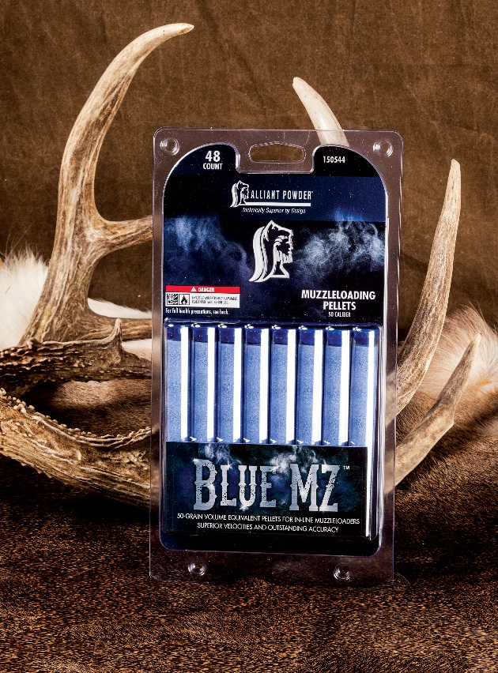
Next to keeping your barrel clean and powder dry, choosing the right propellant is paramount to getting the most from your muzzleloader. Indeed, choosing the perfect charge can help you enjoy world-class accuracy while avoiding the agony of epic failures, even under extreme weather conditions.

In recent years, muzzleloading enthusiasts have seen a steady procession of new and improved powders and projectiles. Longtime industry leader Alliant Powder furthers smokepole evolution with the development of its new Blue MZ.

In response to shooters’ pleas for more firepower, improved accuracy and freedom from the bondage of grueling cleaning procedures, the experts at Alliant Powder designed the promising new propellant to deliver explosive performance—including surefire ignition and seamless burns—no matter what Mother Nature throws at you.

On the ignition front, Blue MZ is a perfect match for 209 shotshell primers, and yields unflinching accuracy with a wide array of popular bullets, including Federal Premium’s B.O.R. Lock MZ System.

Blue MZ’s 50-grain equivalent pellets also raise the bar in firepower, producing higher velocities at safe pressures than competitive products can muster.

To accomplish such a feat of physics, Alliant engineers optimized Blue MZ pellets’ chemistry and geometry to deliver devastating energy in a progressive manner that keeps even heavyweight projectiles rocketing downrange long after other loads falter.

Ballistics back up such impressive claims. For example, Federal Premium’s hard-hitting 50-caliber, 270-grain Trophy Copper B.O.R. Lock MZ bullet was clocked at 1,699 feet per second with a two-pellet charge and 2,029 feet per second when fueled by three pellets, ignited by a Federal 209A primer.

And for hunters who want to wield a true hammer blow when gunning for the planet’s toughest big game, Blue MZ propels Federal B.O.R. Lock MZ 350-grain projectiles at 1,557 and 1,851 feet per second with two- and three-pellet on the wings of two- and three-pellet charges, respectively.

Credit such blistering yet incredibly accurate performance to Alliant’s longstanding commitment to creating industry-leading smokeless powder. Crafted over decades of smokeless powder manufacturing, the process includes an exhaustive lineup of checks and balances that compulsively controls the chemical composition, shape, size and density of every single grain of gunpowder that leaves the factory.

New Blue MZ also takes the misery out of muzzleloader maintenance. Marathon cleaning sessions spent slaving away with bore brushes, rags and harsh chemicals are a thing of the past, thanks to a cleaner formulation that is free from both sulfur and charcoal.

In fact, Blue MZ allows fast and easy service with water-based solvents—further proof that its technology leads away from the corrosive grit and grime of traditional black powder and early, barrel-fouling substitutes.

Adding to its user-friendliness, Blue MZ is available in handy clam-style packs that contain 48 of the super-charged little pellets tucked tightly into a series of small plastic tubes. Pellets are packed six to a tube, allowing easy transport afield while producing two to three shots per tube, depending on the shooter’s choice of charge.

Blue MZ won’t break the bank, either.

With a manufacturer’s suggested retail of just $19.99 per pack, it’s priced very competitively with products currently on the market—which is also quite an accomplishment for Alliant, considering Blue MZ takes muzzleloading performance and convenience to heights old-school propellants can’t touch.

For more details about this product, please visit the Alliant Powder website at http://www.alliantpowder.com/products/powder/bluemz.aspx

###

