Questions and Answers: Alliant Powder Blue MZ Propellant

Drawing on decades of gunpowder expertise, Alliant Powder scores a direct hit with muzzleloader fanatics by introducing its new Blue MZ muzzleloader propellant.

To give muzzleloading hunters an inside look at Blue MZ, we asked Alliant Powder Product Manager Ben Amonette to field the following questions about the new propellant’s origins, performance and applications.

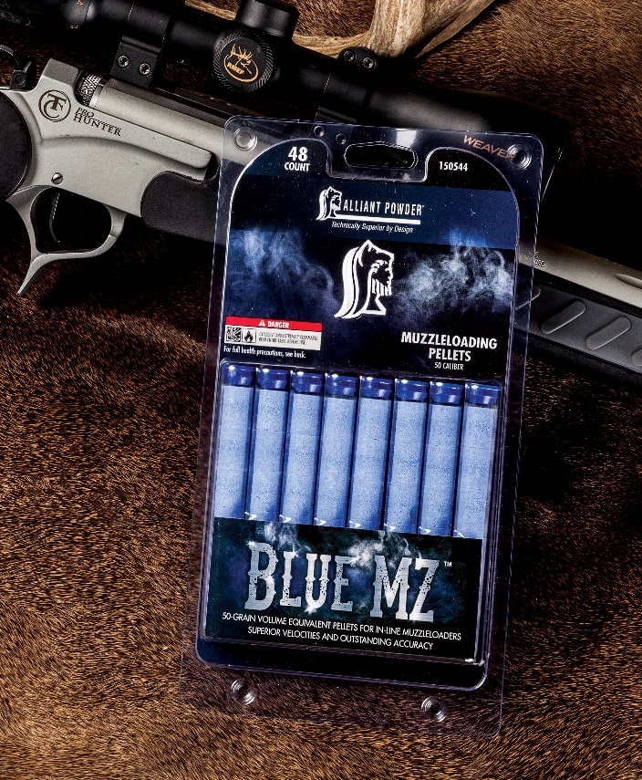
Q: What’s your take on the current state of muzzleloading powder technology?
A: We have seen an ongoing evolution away from the corrosive grit and grime of traditional black powder and early, barrel-fouling substitutes toward easy-to-clean, high-performance products. Blue MZ represents the next step in this process.

Q: What separates Blue MZ from typical muzzleloader powders?
A: It’s quite simply the next generation of modern muzzleloading pyrotechnics. Blue MZ delivers a blend of reliable ignition, consistent burn and outstanding accuracy with unrivaled ease of use.

Q: Tell us more about ignition.
A: Blue MZ’s superior ignition characteristics result in low standard deviations in velocity and pressure, which allow for superior accuracy with a wide range of projectiles. It’s a perfect match for 209 shotshell primers and works well with a number of popular bullets, including Federal Premium’s B.O.R. Lock MZ System.

Q: Blue MZ also boasts industry-leading velocities at safe pressures. How is this achieved, and what are the benefits to the shooter?

A: Alliant engineers optimized pellet chemistry and geometry to deliver devastating energy in a progressive manner that keeps even heavyweight projectiles speeding downrange long after other loads falter.

Q: That sounds great, but exactly what kind of ballistics are we talking about?
A: Federal Premium’s hard-hitting 50-caliber, 270-grain Trophy Copper B.O.R. Lock MZ bullet was clocked at 1,699 feet per second with a two-pellet charge and 2,029 feet per second when fueled by three pellets, ignited by a Federal 209A primer.

And for hunters who want to wield a true hammer blow when gunning for the planet’s toughest big game, Blue MZ propels Federal B.O.R. Lock MZ 350-grain projectiles at 1,557 and 1,851 feet per second with two- and three-pellet on the wings of two- and three-pellet charges, respectively.

Q: You said Blue MZ is easy to use. Please explain.
A: Blue MZ has a state-of-the-art formulation that takes the misery out of muzzleloader maintenance. Since the pellets are free from sulfur and charcoal, it allows fast and easy cleaning with water-based solvents, which means marathon sessions spent laboring with brushes, rags and harsh cleaning solutions are a thing of the past.

Q: Blue MZ is sold in 50-grain equivalent pellets. However, it’s packaged differently than the box-style packaging used by the competition. How come?
A: Adding to its user-friendliness, Blue MZ is available in handy clam-style packs that contain 48 of the super-charged little pellets tucked tightly into a series of small plastic tubes. Pellets are packed six to a tube, allowing easy transport afield while producing two to three shots per tube, depending on the shooter’s choice of charge.

Q: OK, Blue MZ is a breakthrough propellant. But does this also mean premium price?
A: Blue MZ definitely won’t break the bank. With a manufacturer’s suggested retail of just $19.99 per 48-pack, it’s priced very competitively with products currently on the market. And considering that it takes muzzleloading performance to new heights, Blue MZ is truly the best deal around.

For more details about this product, please visit the Alliant Powder website at http://www.alliantpowder.com/products/powder/bluemz.aspx

###

