Reloder TS 11
Craft more accurate, consistent varmint and benchrest loads with the new Reloder® TS 11 from Alliant Powder®. The propellant’s sophisticated TZ® technology manipulates the response of the material and resists the natural tendency to generate more pressure at higher temperatures and less pressure at lower temperatures. As a result, it delivers extremely consistent velocities across the temperature spectrum. Reloder TS 11 contains no dinitrotoluene or phthalate-based deterrents, so it is REACH-compliant. The patented decoppering agent helps keep copper from building up in the bore, so you shoot more and clean less.

Features & Benefits
- Extremely temperature stable
- Formulation is ideal for use in varmint loads
- Excellent burn speed for short-range benchrest applications
- Contains de-coppering agent
- Excellent lot-to-lot consistency
- REACH-compliant

Part No. Description MSRP
151004 Reloder TS 11 1-pound canister $44.99
151005 Reloder TS 11 8-pound canister $335.99
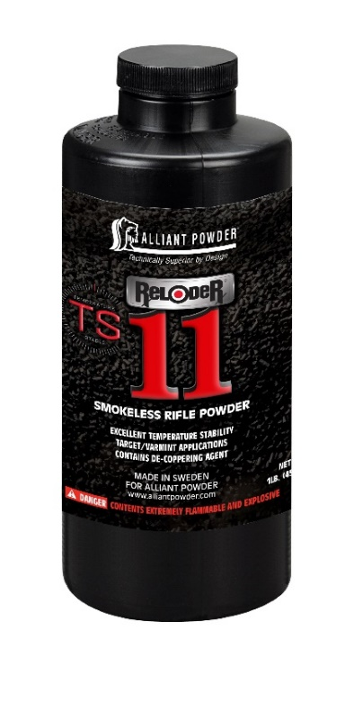
TZ is a registered trademark of EURENCO Bofors AB

