QuickMod™ Magazine Cases
Shooting competitions such as 3-gun matches have evolved into fast-paced events that require shooters to quickly and intuitively access multiple magazines for their pistols and modern sporting rifles. The new QuickMod magazine cases from BLACKHAWK!® perform flawlessly and offer fast, easy user adjustability in competition or on duty in law enforcement or military operations. Each holder features a quick-detach belt attachment with 360 degrees of angle adjustment. The cases are made of temperature and crush-resistant injection-molded polymer. The quick-detach system can adjust to different size belts and the cant angle can be set to fixed or movable. The pistol model fits both single- and double-stack magazines with built-in tension adjustment. The AR-15 magazine model holds most styles of 20- or 30-round AR magazines.

Features & Benefits
- Rotating and locking quick-detach belt attachment
- Adjustable to belts 1.5 to 2.25 inches wide
- Positive lock indicator for added security
- Can be rotated 360 degrees with 16 arrest positions

Part No. Description UPC MSRP
411600BK QuickMod Pistol Magazine Case 6 48018 21966 5 $39.99
411601BK QuickMod AR-15 Magazine Case 6 48018 21967 2 $49.99
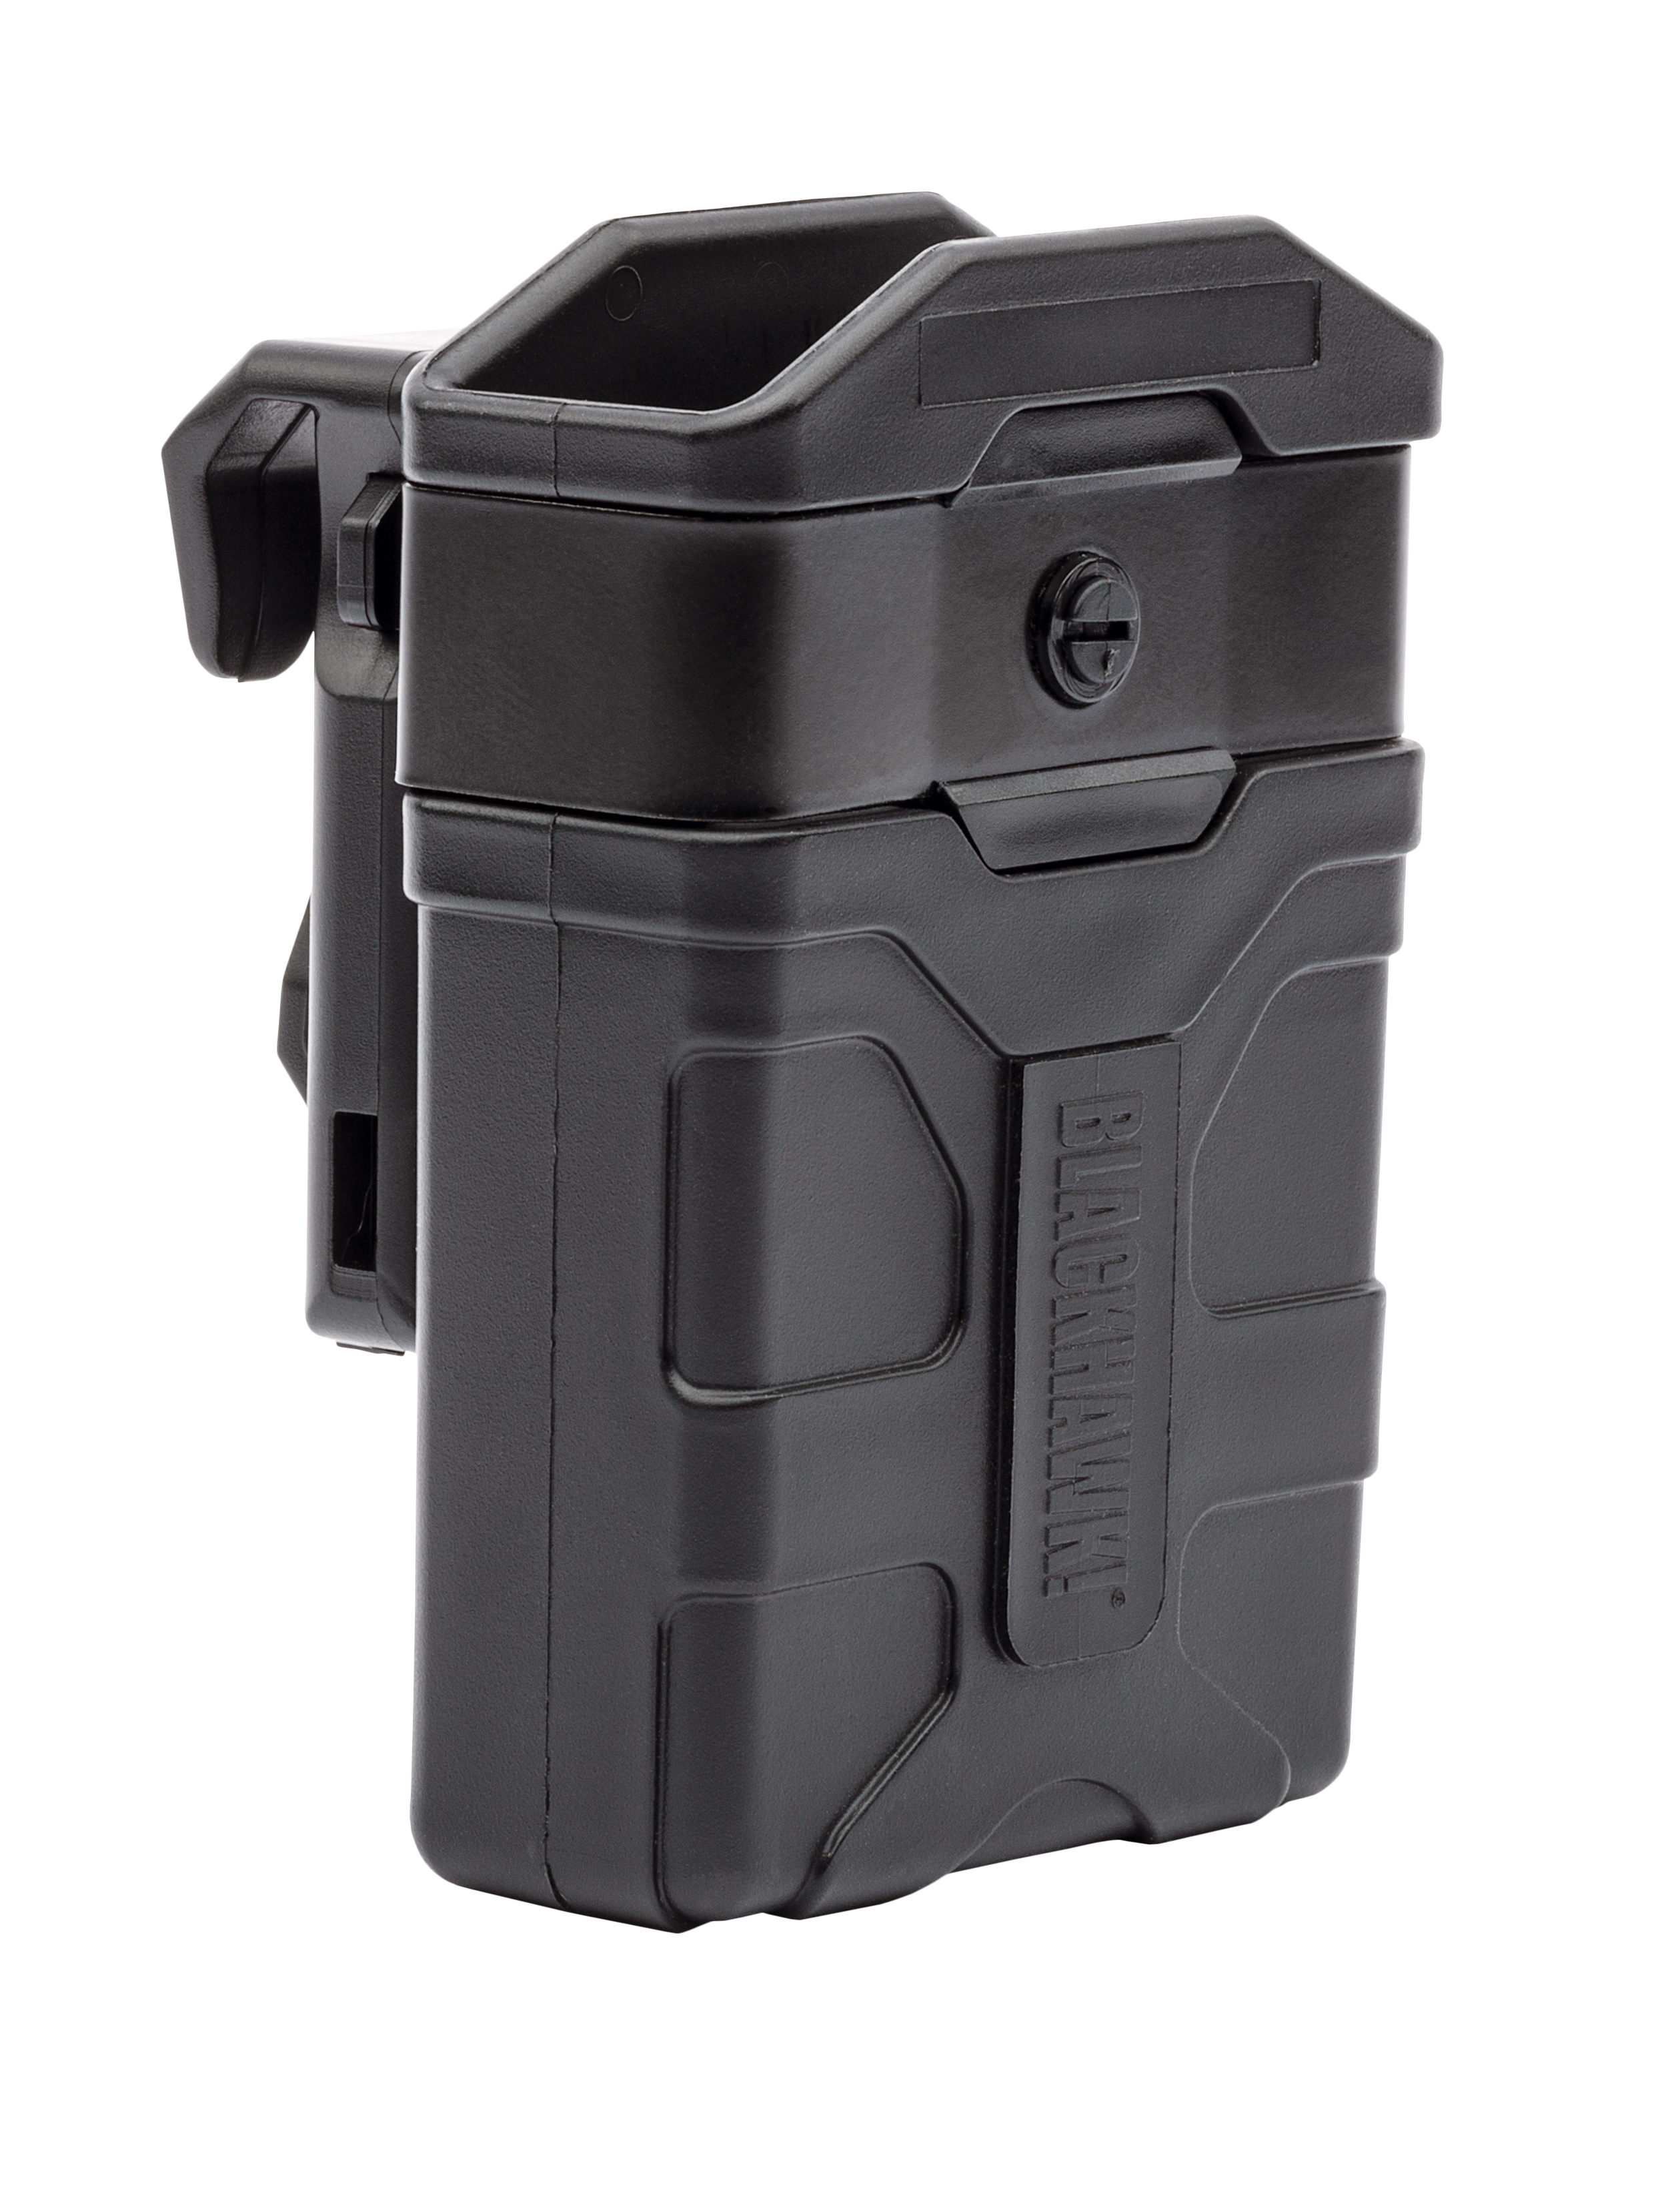
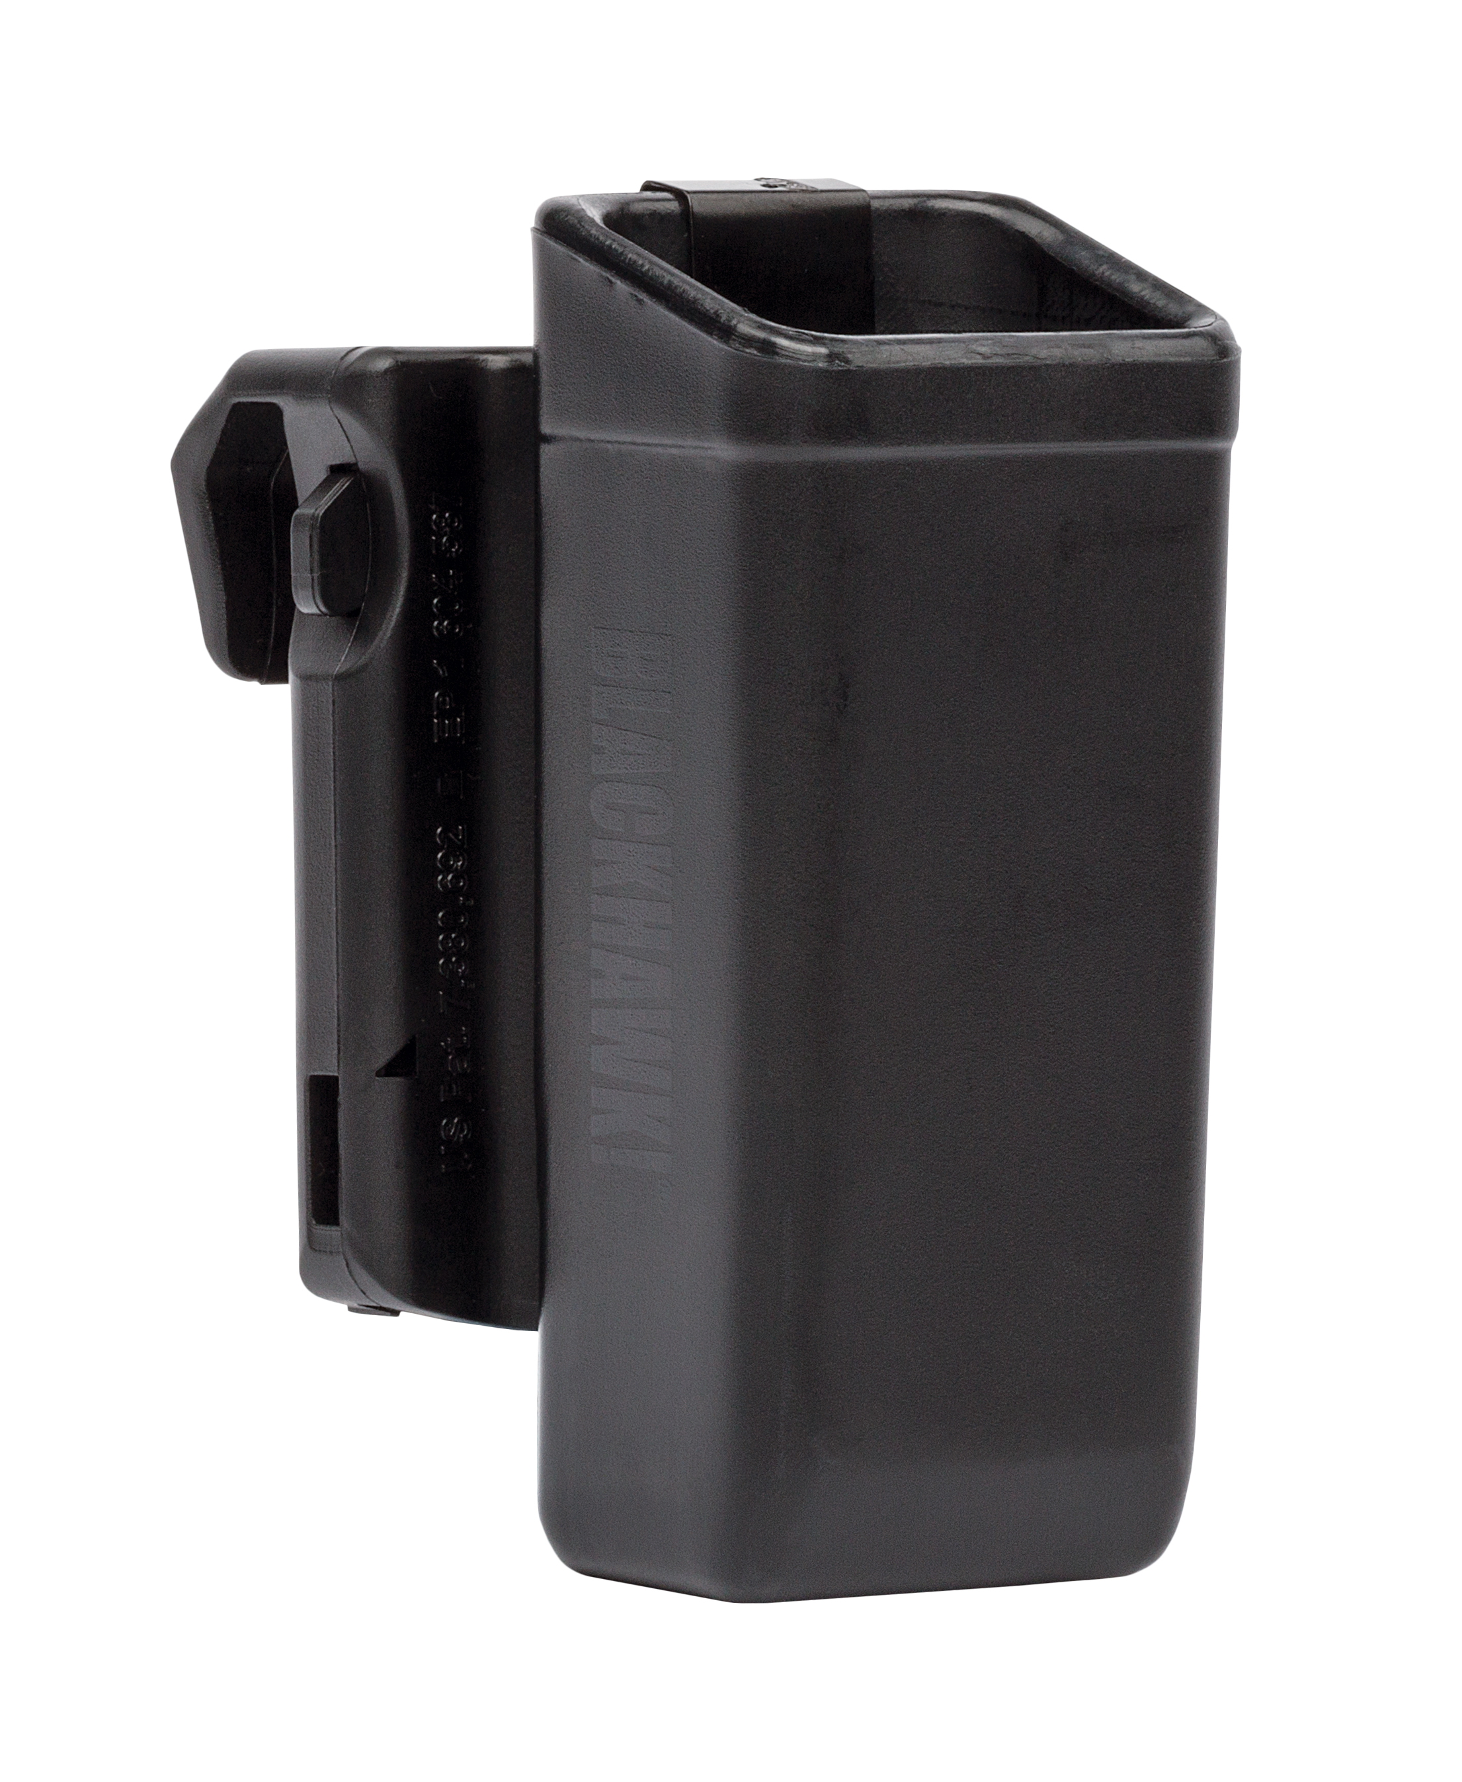

411600BK 11601BK

