MSR Tactical Bipod
Constructed of a lightweight polymer, the MSR Tactical Bipod is designed specifically for the modern sporting rifle. It attaches easily to a Picatinny rail and provides a steady aim for rock-solid performance. This sleek bipod design delivers rapid height adjustment, while a simple pivot action adapts to uneven terrain. Textured feet ensure a secure grip on all surfaces.

Features & Benefits
- Υνιθυε ινδυστριαλ δεσιγν ανδ αππεαρανχε
- Λιγητωειγητ, ρεινφορχεδ πολψμερ ανδ αλυμινυμ χονστρυχτιον
- Αλυμινυμ Πιχατιννψ ραιλ μουντ
- Σιδε−το−σιδε πιϖοτ δεσιγν ωιτη θυιχκ−αδϕυστ λεϖερ
- Ραπιδ ηειγητ αδϕυστμεντ (7 το 10 ινχηεσ)
- Στυρδψ λοχκινγ λεγσ
- Τεξτυρεδ, ϖαριαβλε συρφαχε χομποσιτε φεετ
- Μαδε ιν τηε Υ.Σ.Α.

Part No. Description UPC MSRP
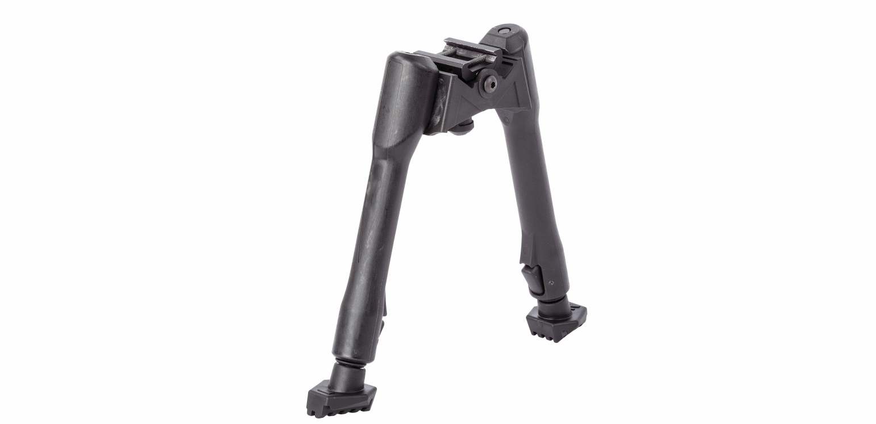
49009 MSR Tactical Bipod 0 76683 49009 4 $ 119.99

