Federal Premium Edge TLR: Features & Benefits Explained

Manufacturers have long been able to build extremely-tough, expanding bullets for hunting big game. They also make sleek, extremely accurate match-grade bullets for long-range target shooting. But combining both of those qualities into a single bullet has been impossible, until now. The new Edge TLR from Federal Premium Ammunition is the first bullet to combine both attributes.
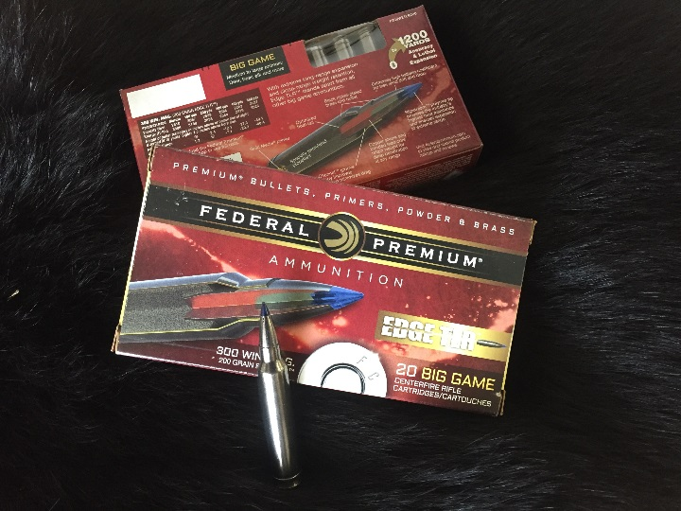
Edge TLR features bonded construction in a match-grade bullet with high ballistic coefficient, AccuChannel grooving and a new SlipStream heat-resistant ballistic tip. The result is both close-range and long-range terminal performance with both accuracy and reliability. And with its corrosion-resistant black-nickel bullet and case, as well as its neon blue ballistic tip, it’s a tough-looking, all-range bullet that’s sure to impress.
For 2018, new cartridges have been added to the lineup with 7mm Rem. Magnum 155-grain, 270 Win. 140-grain and 270 WSM 140-grain offerings.
The following is a detailed explanation on the features and benefits of Federal Premium’s all-new Edge TLR. The information is provided by Justin Carbone, Federal Premium Product Engineer for Rifle Ammunition.

Bonded Construction in a Match Bullet
The Edge TLR seamlessly mates a tough, bonded hunting bullet with a match-grade accurate bullet without sacrificing any aspect of performance. And, unlike other so-called long-range hunting bullets that can fail to perform on impact at lower velocities, the Edge TLR upsets as designed at close, mid and long ranges.
The all-new Edge TLR bullet design is based off Federal Premium’s proven Trophy Bonded Tip which originated from the famed Trophy Bonded Bear Claw and Trophy Bonded Sledgehammer solid. While each of these ammo lines differ, they share Federal Premium’s proven history of being some of the most effective cartridges on the market for hunters. The EDGE TLR continues this tradition. Its bullet has a tapered jacket, bonded lead core, and long, solid copper rear shank to gives shooters that bone crushing, hard-hitting performance they need for a hunting situation. In other words, the bullet retains its weight for consistent, lethal penetration at any range.
Its match-grade features include a secant ogive and AccuChannel groove technology for the best possible long-range ballistics. Its boat-tail angle and length are optimized for peak ballistic coefficient and stability. The bullet’s Slipstream polymer tip uses the exclusive hollow-core Slipstream polymer tip—which also features a small meplat* for better aerodynamics—aids in its excellent ballistics and accuracy. The tip’s hollow-cavity design also helps initiate expansion to ensuring expansion at long range when the bullet is slowing down to low velocities.

High Ballistic Coefficient
Extreme-range hunting and target shooting is getting more popular every day. Concurrently, shooters are giving more attention to their bullets’ ballistic coefficient (BC) than ever before.
While a lot of people know about ballistic coefficients, there is some common confusion about what it actually means. Simply put, ballistic coefficient is a measurement of how well the bullet cuts through air. The higher the BC, the better the bullet cuts through air. It can also define how well the bullet maintains its velocity downrange.
More velocity and energy equates to less wind drift, flatter trajectories and better terminal performance. For example, high ballistic-coefficient bullet design features include:

- Extremely small meplat diameter
- Secant ogive
- AccuChannel groove
- Max boat-tail length
- Optimized boat-tail angle
- Heavy-for-caliber bullet weights

Every aspect of the new Edge TLR bullet profile has been engineered to maximize ballistic coefficient. The 175-grain 308 caliber projectile has a .536 G1 BC, while the 200-grain 308 bullet offers a .625 G1 BC.
The Edge TRL delivers some of the highest ballistic coefficients in the industry for these bullet weights while still maintaining adequate bullet stability out of conventional twist rates in the field. All this equates to shooters getting the flattest trajectories, the least wind drift and the highest confidence to know they are going to make their shot.

AccuChannel Grooving
Grooving on a bullet shank improves accuracy across a greater range of rifles while reducing fouling and barrel wear. However, typical grooving can cause aerodynamic drag, resulting in more bullet drop and wind drift. AccuChannel groove technology used in Edge TLR is different.
When developing the bullet, Federal Premium engineers ran a series of accuracy experiments testing both the number and location of grooves.
During that series of experiments, these engineers made a breakthrough and discovered that by strategically placing one groove, they could achieve the same benefits and accuracy as multiple grooves. Conventional grooves causes approximately a 5 percent BC drop per groove. The one groove was a huge benefit.
To improve the groove even further, Federal Premium engineers used computation fluid dynamics modeling (CFD) to change the groove geometry to reduce drag. The industry’s average groove has 90 degree steep walls, whereas Federal Premium’s new AccuChannel has a sloped rear wall, which lets the air flow in and out of the groove, reduces the pressure on that point, and reduces drag on the bullet.
The result is a bullet that can perform better across a greater range of rifles without sacrificing wind drift or drop, making it easier than ever to make extreme range shots.

Slipstream Tip
Polymer tips are a common feature on modern bullets. But the Slipstream tip used in new Edge TLR is completely different than other designs, and it has a huge effect on what the bullet is able to do. Most importantly, Federal Premium has a patent on the tip’s hollow core that initiates expansion at long distance.
Federal Premium engineers arrived at the unique design after testing of other tipped bullets revealed they failed to expand consistently at distances past about 600 yards. A new approach was needed to ensure all-range performance.
The inspiration came when the Federal Premium engineering team drilled a hole all the way through the center of the tip. Upon impact, that hole would allow target media into the front end of the bullet to initiate expansion. The engineers tested that concept and it worked perfectly. It extended the performance range by a few hundred yards.
Further testing and development lead to another breakthrough—one that not only improved terminal performance but also improved accuracy and decreased drag. The engineers found out that they could actually close up the front end of the tip and still get a high BC. The bullet would still expand on those low velocity impacts, because the front end of the tip would break off and reveal the channel, allowing media to enter.
This discovery allowed Federal Premium engineers to maintain the small, aerodynamic meplat of a solid polymer tip while getting the same guaranteed expansion at distances where other bullets fail to open consistently.
The Slipstream Tip’s hollow core sets it apart from all other polymer tips on the market—but it’s also unique in its resistance to the elevated temperatures a bullet experiences during flight. The tip’s high-tech material is actually the same one Federal Premium has used for a decade in the popular Trophy Bonded Tip bullet. It has a glass transition temperature—or softening point—of 434 degrees Fahrenheit. This unmatched heat resistance gives shooters the extremely consistent ballistics needed to make accurate long-range shots.

Close-Range Terminal Performance
The idea of using a sleek, high-ballistic coefficient bullet for long-range big game hunting is nothing new, and some manufacturers have claimed their bullets are up to the task. However, to expand at extended ranges, these bullets have been built more like varmint projectiles, with light, thin jackets that easily peel open at low velocities.
So what happens when a buck or bull of a lifetime steps out at close range? Often times, these bullets will completely blow apart, giving shallow penetration, low weight retention and inadequate terminal performance.
Edge TLR is completely different. Its robust bonding and copper shank consistently provide 90 percent weight retention upon high-velocity, close-range impact for deep wound channels. With the Slipstream polymer tip, the design still expands reliably at the longest distances. There's no other bullet on the market that has this wide of a velocity spectrum, period.

Long Range Terminal Performance
Deadly terminal performance has to penetrate straight through its target and transfer energy along the way. But, lethal expansion doesn’t always look the same at every range, and a large expanded diameter is not always required for a bullet to make a clean kill. Bullets accomplish terminal performance not through sheer expansion but by opening the nose consistently and creating a uniform frontal surface. Most bullets don’t do this at extreme long range, however. A typical bullet will fail to expand symmetrically, causing it to veer off target within the animal, or tumble. The distance at which it begins to tumble is very unpredictable. Sometimes it will travel a ways before it does and sometimes it will tumble immediately.
The new Federal Premium Edge TLR is completely different. Its externally skived nose, exclusive hollow point shape and Slipstream polymer tip work together to expand immediately and consistently.
From the muzzle all the way out to 1,350 feet per second, Edge TLR gives frontal expansion. It’s why this ammunition stands apart from all other bullets, transferring its energy into the animal and carving straight, lethal wound channels that bring down big game at any range.

Probability of a Hit
With any shot you take, hitting the target is the result of overcoming a variety of variables. However, when dealing with extreme ranges, most shooters don’t realize how significant of a role these factors can play on whether they hit or miss.
Thanks to modern software, shooters can now quantify the effect of those variables for a given bullet, load and rifle combination and calculate the true probability of a hit. The results are eye opening. Software called Weapon Employment Zone Analysis by Applied Ballistics enables users to input shot variables and see the probability for making a shot.
This tool reveals the shooter’s weakest link (or factor that a shooter needs to work on in order to increase shot range). One of the top factors is wind-calling abilities. If a shooter can increase correct wind estimation, they can greatly increase their probability of hit.
Although it will always be up to the shooter to manage these variables and be responsible for every pull of the trigger, Edge TLR minimizes the effect of many of these factors—such as cutting the wind, because of its reduced drag, flatter trajectory and less drift.
Federal Premium’s all-new Edge TLR provides match-grade, long-range accuracy in a bonded hunting bullet truly delivering confidence and multifaceted performance in the field.
Learn more about Edge TLR ammunition at www.federalpremium.com.

###

