Syntech Action Pistol Is Born

Faster, smoother, cleaner and built for competitive shooters

Competitive handgun shooting is a sport unlike any other, so it’s no surprise that top-level shooters demand high-performance products to stay atop their game. Enter Syntech Action Pistol, by Federal Ammunition, a new load designed specifically for action shooting sports. Put simply, it offers the most reliable performance possible for high-volume competitive shooters.
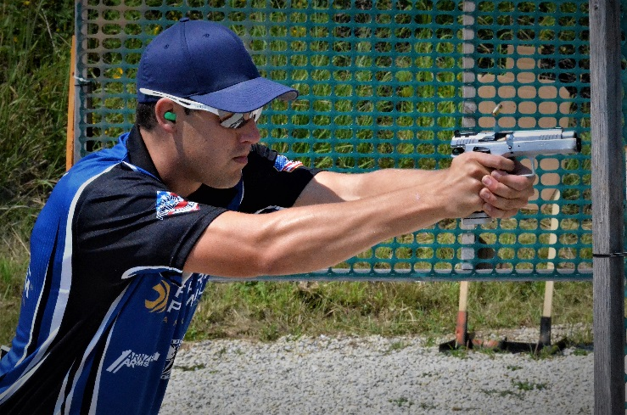
“Syntech Action Pistol utilizes all the same technology as the standard Syntech line but is tailored specifically to the competitive pistol application,” said John Swenson, Federal Premium handgun ammunition design engineer. “During extended matches, the reduced fouling and cooler gun temperatures allow competitors to keep their focus on their performance and the match rather than equipment maintenance.”
Swenson explained that the bullets and loads are designed to yield the least possible felt recoil while meeting power factor requirements and cycling reliably.
“Reduced recoil in these time-sensitive events means less muzzle rise and less time required for follow-up shots,” he said. “And that means more consistent hits and lower stage-completion times.”
Syntech Action Pistol builds off the success of original Syntech, which was designed to be easier on your gun and more fun to shoot, providing clean, smooth, consistent performance. Its development took years and centered on the exclusive Total Synthetic Jacket, a complete polymer coating that replaces the copper jacket in conventional full metal jacket target ammo. TSJ prevents metal-on-metal contact between the bullet and barrel, eliminating copper and lead fouling, reducing damaging heat and friction and extending barrel life.
New Syntech Action Pistol offers even better performance for competitive handgunners. It features the TSJ and is loaded to competition power-factor requirements. Its heavy, flatter-nose bullets provide more reliable knock-downs on steel targets in competition. Also, they drastically reduce splash-back on steel targets.
“Heavy bullets for a given power factor typically have less felt recoil,” Swenson said. “They also maintain momentum downrange better than a light bullet. The combination of flatter noses and higher momentum give improved momentum transfer to steel targets. The result is better likelihood of target activation, especially with marginal hits near the edge.”
Swenson said the nose design also helps competitors when shooting paper targets. “The flatter nose provides a larger-diameter perforation, making scoring clearer for hits that are near the edge of scoring zones rather than having to rely on the grease ring.”
In addition, Syntech Action Pistol uses clean-burning powders that minimize barrel residue, and its Catalyst lead-free primer provides consistent, reliable ignition.
“The primer and powder are just as important as the projectile,” Swenson said. “They are key to the reliable and repeatable performance needed for these highly competitive events. Pairing the Catalyst primer with these propellants yields consistent performance with a clean burn and reduced recoil.”
Designers configured Syntech Action Pistol to meet the needs of shooters who compete in the International Practice Shooting Confederation (IPSC) and United States Practical Shooting Association (USPSA). Federal Premium recently signed on as sponsor of the USPSA, and Syntech Action Pistol is the official sponsored ammo of the organization.
“We’re proud to be the first major ammunition manufacturer to enter this exciting arena,” said Justin Johnson, Federal Premium product line manager. “USPSA shooters demand very specific things from their ammunition. It needs to be accurate, consistent, reliable, and meet power-factor requirements. Until our launch of Syntech Action Pistol, reloading was the preferred way to achieve all of the above. With our factory-loaded ammunition, shooters have a simple, convenient and better solution.”
Adherence to power factor requirements is a major part of that solution. Power factor itself is a measurement that’s part of a system designed to even the playing field between competitors, the idea being that more powerful ammunition with more recoil is harder to control and make fast follow-up shots than less-powerful rounds. The figure is calculated by multiplying the bullet weight by velocity in feet per second and dividing by 1,000.
In USPSA events, ammunition and competitors are divided into minor and major and major must meet 165. Competitors shooting major power factor—typically 40 S&W and 45 Auto—are scored differently to account for the higher level of recoil compared to those in the same division shooting minor.
“By developing products that meet power factor and minimize felt recoil, we are allowing each competitor to optimize their individual performance while complying with the rules and limits of the competition,” Swenson said.
This performance advantage is already being seen in the top finishes of shooters using Syntech Action Pistol in matches. Casey Reed is one of them. He notched a 20th place overall finish while shooting 150-grain 9mm Luger Syntech Action Pistol in the Production Division at the 2017 IPSC Handgun World Shoot XVIII.
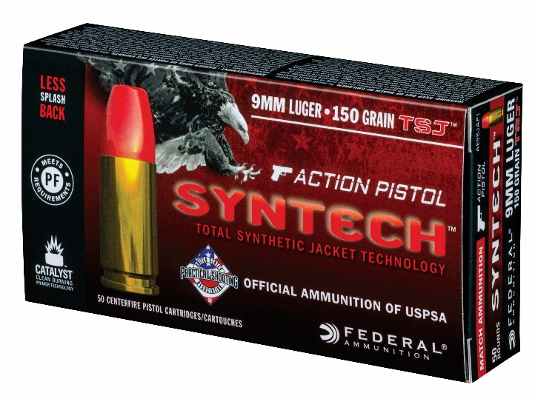
“It is specifically designed for the action shooting sports,” said Reed, a Federal Premium product development engineer who competes at IPSC and USPSA events in his free time and has quickly become one of the country’s best competitive shooters. “I’ll be relying on it for all my future competitions, and I know many other shooters will be choosing it.”
If the excitement of high-level handgun competitions and the ring of steel targets gets your blood pumping, Federal has your ammunition: Syntech Action Pistol, offered in 9mm Luger, 40 S&W and 45 Auto. It will help you shoot better and more comfortably, so all you have to do is focus on the next target — round after round.

