110 APEX HUNTER XP
SAVAGE ARMS 2018

110 APEX HUNTER XP

The complete package is finally here. Our all-new 110 Apex Hunter XP pairs a Model 110 rifle with a
  - x40mm Vortex® Crossfire II scope that comes mounted, bore-sighted and ready to hunt. The platform provides accuracy and adjustability like no other package rifle thanks to the Savage® AccuTrigger™, thread- in heasdpacing, floating bolt head and precision button-rifled barrel. Plus, its length-of-pull can be quickly adjusted to fit any hunter for better comfort and consistency. The Crossfire II Dead-Hold BDC reticle makes it easier to place accurate shots at extended range, and the optic is securely mounted to a one-piece EGW 0 MOA rail.

FEATURES:
    - Redesigned Model 110 rifle
    - 3-9x40mm Vortex Crossfire II scope, mounted and bore-sighted
    - Dead-Hold BDC reticle’s hashmark design reduces guesswork on holdover and windage
    - Vortex Hunter medium rings and one-piece EGW 0 MOA rail
    - User-adjustable AccuTrigger
    - Adjustable length-of-pull
    - Modern ergonomics
    - Detachable box magazine
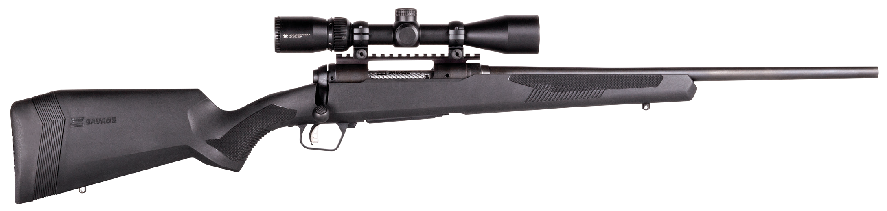
    - Available in left hand models and with Muddy Girl stock

MANUFACTURER | SAVAGE ARMS
IMPORTER | N/A
ACTION TYPE | BOLT
FINISH | MATTE BLACK
SIGHTS | N/A
TRIGGER PULL WEIGHT | 2.5 LBS. – 6 LBS.
STOCK | SYNTHETIC STOCK WITH ADJ. LOP
ACCESSORIES | LENGTH-OF-PULL INSERTS
OVERALL LENGTH | 40.25” - 44.25”
WEIGHT | 7.67 - 7.96 LBS.
110 APEX HUNTER XP
PART NO. CALIBER TWIST BARREL CAPACITY UPC MSRP RATE LENGTH
57301 | 204 RUGER | 1 IN 12” | 20” | 4+1 | 0-11356-57301-8 | $684
57300 | 223 REM. | 1 IN 9” | 20” | 4+1 | 0-11356-57300-1 | $684
57302 | 22-250 REM. | 1 IN 12” | 20” | 4+1 | 0-11356-57302-5 | $684
57303 | 243 WIN. | 1 IN 9.25” | 22” | 4+1 | 0-11356-57303-2 | $684

110 APEX HUNTER XP
SAVAGE ARMS 2018
110 APEX HUNTER XP
PART NO. CALIBER TWIST BARREL CAPACITY UPC MSRP RATE LENGTH
57310 | 25-06 REM. | 1 IN 10” | 24” | 4+1 | 0-11356-57310-0 | $684
57304 | 6.5 CREEDMOOR | 1 IN 8” | 24” | 4+1 | 0-11356-57304-9 | $684
57311 | 6.5X284 NORMA | 1 IN 8” | 24” | 3+1 | 0-11356-57311-7 | $684
57306 | 260 REM. | 1 IN 8” | 24” | 4+1 | 0-11356-57306-3 | $684
57312 | 270 WIN. | 1 IN 10” | 22” | 4+1 | 0-11356-57312-4 | $684
57308 | 270 WSM | 1 IN 10” | 24” | 2+1 | 0-11356-57308-7 | $684
57305 | 7MM-08 REM. | 1 IN 9.5” | 20” | 4+1 | 0-11356-57305-6 | $684
57314 | 7MM REM. MAG | 1 IN 9.5” | 24” | 3+1 | 0-11356-57314-8 | $684
57307 | 308 WIN. | 1 IN 10” | 20” | 4+1 | 0-11356-57307-0 | $684
57313 | 30-06 SPRG. | 1 IN 10” | 22” | 4+1 | 0-11356-57313-1 | $684
57309 | 300 WSM | 1 IN 10” | 24” | 2+1 | 0-11356-57309-4 | $684
57315 | 300 WIN. MAG. | 1 IN 10” | 24” | 3+1 | 0-11356-57315-5 | $684
57316 | 338 WIN. MAG. | 1 IN 10” | 24” | 3+1 | 0-11356-57316-2 | $684

110 APEX HUNTER XP (LH)
PART NO. CALIBER TWIST BARREL CAPACITY UPC MSRP RATE LENGTH
57317 | 223 REM. | 1 IN 9” | 20” | 4+1 | 0-11356-57317-9 | $684
57318 | 22-250 REM. | 1 IN 12” | 20” | 4+1 | 0-11356-57318-6 | $684
57319 | 243 WIN. | 1 IN 9.25” | 22” | 4+1 | 0-11356-57319-3 | $684
57323 | 25-06 REM. | 1 IN 10” | 24” | 4+1 | 0-11356-57323-0 | $684
57320 | 6.5 CREEDMOOR | 1 IN 8” | 24” | 4+1 | 0-11356-57320-9 | $684
57324 | 270 WIN. | 1 IN 10” | 22” | 4+1 | 0-11356-57324-7 | $684
57321 | 7MM-08 REM. | 1 IN 9.5” | 20” | 4+1 | 0-11356-57321-6 | $684
57326 | 7MM REM. MAG | 1 IN 9.5” | 24” | 3+1 | 0-11356-57326-1 | $684
57322 | 308 WIN. | 1 IN 8” | 20” | 4+1 | 0-11356-57322-3 | $684
57325 | 30-06 SPRG. | 1 IN 10” | 22” | 4+1 | 0-11356-57325-4 | $684
57327 | 300 WIN. MAG. | 1 IN 10” | 24” | 3+1 | 0-11356-57327-8 | $684

110 APEX HUNTER XP MUDDY GIRL
PART NO. CALIBER TWIST BARREL CAPACITY UPC MSRP RATE LENGTH
57336 | 243 WIN. | 1 IN 9.25” | 22” | 4+1 | 0-11356-57336-0 | $729
57337 | 6.5 CREEDMOOR | 1 IN 8” | 24” | 4+1 | 0-11356-57337-7 | $729
57338 | 7MM-08 REM. | 1 IN 9.5” | 20” | 4+1 | 0-11356-57338-4 | $729
57339 | 308 WIN. | 1 IN 10” | 20” | 4+1 | 0-11356-57339-1 | $729

