2015 new products

Rifles

338 Federal Models
Since its introduction in 2006, the 338 Federal has established itself has an extremely versatile, high-performance big game cartridge. Built on the .308 case and “necked-up” to hold a .338 diameter bullet, this load offers hunters a faster muzzle velocity than the 308 Win. but with a heavier bullet. As a result, the short-action cartridge provides magnum energy for devastating performance on game, without magnum recoil. These qualities have inspired Savage Arms™ to chamber six of its most popular big game rifles in the caliber. They include the 11 Long Range Hunter, 11 Hog Hunter, 16 FCSS, 16 Bear Hunter, 11 Trophy Hunter XP and 16 Trophy Hunter XP.

Features & Benefits
- Short-action 338 Federal chambering
- Higher muzzle velocity than the 308 Win. with a .338 diameter bullet
- Devastating terminal performance with less felt recoil than typical magnum calibers
- Available in six of Savage Arms’ most popular big game rifle platforms

Part No. Description UPC MSRP
22450 11 Long Range Hunter, 338 Federal 0-11356-22450-7 $1,104
22455 11 Hog Hunter, 338 Federal 0-11356-22455-2 $560
22453 16 FCSS, 338 Federal 0-11356-22453-8 $885
22454 16 Bear Hunter, 338 Federal 0-11356-22454-5 $1,035
22451 11 Trophy Hunter XP, 338 Federal 0-11356-22451-4 $612
22452 16 Trophy Hunter XP, 338 Federal 0-11356-22452-1 $740

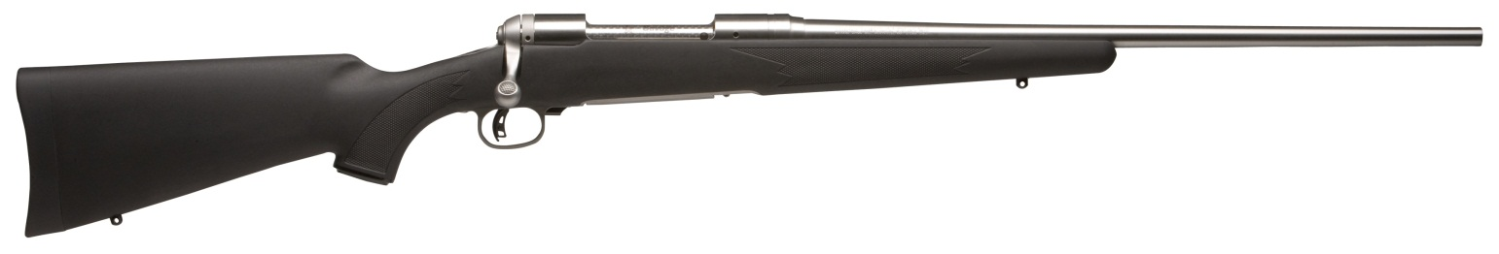Savage Arms 16 FCSS

