2016 new products

ShotGuns

555 Compact
Stevens has made its 555 over-and-under line even more versatile with the new 555 Compact. The stylish shotgun has a mid-length fore-end and a compact, 13.25-inch length-of-pull, making it perfect for smaller-framed shooters. Like the original 555, it features a light aluminum receiver that’s scaled to gauge. A steel insert reinforces the breech, minimizing weight and maximizing strength. The 555 Compact sports a Turkish walnut stock and fore-end, shell extractors, a manual safety, and a single, selective mechanical trigger—all at a superb price. Five interchangeable choke tubes allow the fast-handling gun to meet any shooting need.

Features & Benefits
- Mid-length forearm and compact 13.25-inch length of pull
- Lightweight aluminum receiver scaled to gauge
- Single, selective mechanical trigger
- Turkish walnut stock and fore-end
- Chrome-lined barrels
- Tang-mounted safety

Technical Specifications
View product details page: www.savagearms.com (TBD)

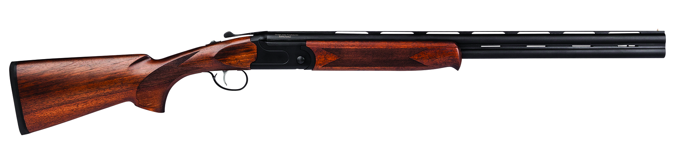

Part No. | Description | Barrel Length | UPC | MSRP
22154 | 555 Compact, 20-Gauge | 24” | 011356-22154-4 | $692
22155 | 555 Compact, 28-Gauge | 24” | 011356-22155-1 | $692
22156 | 555 Compact, .410-Gauge | 24” | 011356-22156-8 | $692

