Savage Arms Expands Revolutionary A17 Rimfire Autoloader Lineup

Savage Arms introduces new stylish yet hard-hitting A17 autoloaders.

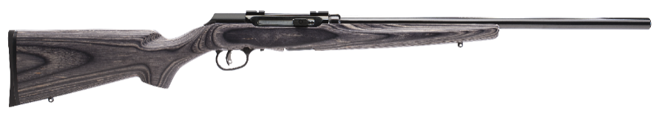
A17 Target Sporter

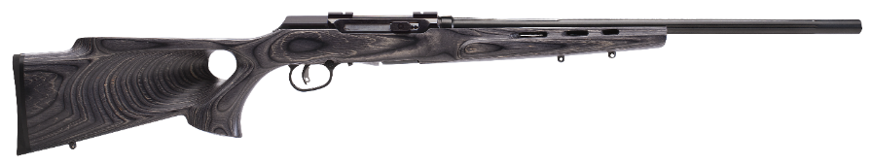
A17 Target Sporter Thumbhole

Long known for gun-making breakthroughs, Savage Arms has upped the ante in the target rifle market by expanding its revolutionary A17 autoloader selection with three new stylish yet hard-hitting straight shooters destined for range greatness.

The new A17 Sporter, A17 Target Sporter and A17 Target Sporter Thumbhole join the original A17, which in 2015 scored a victory for shooters seeking a high-performance rimfire autoloader capable of flawlessly handling the 17 HMR cartridge. All three models rely on Savage’s unique delayed-blowback action to deliver reliable semi-automatic operation with the powerful, low-recoil cartridge.

It’s no small feat, considering that past efforts by various gunmakers to build a smooth-cycling and affordable semi-automatic chambered for fiery 17 HMR loads have faltered.

Savage engineers made it happen by scrapping the standard straight-blowback approach, which ejects spent casings via overpressure during firing. In its place, they opted for an innovative interrupter lug that locks down the bolt until peak pressure has passed when a round is fired.

The timing system prevents the bolt from opening prematurely, effectively putting an end to ruptured cases. By doubling as a firing pin block, it also prevents out-of-battery firing with an open action. Gains in control and accuracy further sweeten the deal.

Developed in 2002, the 17 HMR is a stellar choice for everything from small game and varmint hunting to serious target shooting and all-round plinking. It descends from a necked-down 22 Magnum case to accept a 17-caliber bullet, and offers advantages including a flatter trajectory, longer range, higher muzzle velocities and less risk of short-range ricochet thanks to bullet breakup.

To further heighten the shooting experience, Savage collaborated with sister company CCI to create the A17 Varmint Tip—a lightning-fast, flat-shooting load that extends range, improves terminal performance and takes accuracy to new heights. As a plus, the faster, higher-pressure ammunition aids in reliable bolt cycling regardless of mitigating factors such as elevation, field conditions or temperature.

The 17-grain, polymer-tipped varmint bullet provides rapid expansion, clocks in at a blistering 2,650 fps out of the muzzle and 2,000 fps at 100 yards, and delivers 265 foot-pounds of firepower at the muzzle and 151 at 100 yards. Although the round is tailor-made to Savage’s A17 family, all three models also easily accommodate standard 17 HMR loads.

Both new A17 Target/Sporter models offer all A17 standard features, including Savage’s adjustable AccuTrigger technology, which lets shooters easily fine-tune trigger pull to match their personal taste.

Other notable attributes include an extended charging handle for effortless loading, hard-chrome, stabilized bolt with oversized handle, and a flush-fitting, 10-round, rotary magazine with a dual-controlled feeding mechanism. Plus, the rear cover engenders fast field stripping for easy cleaning.

Designed to uphold Savage Arm’s longstanding commitment to bulletproof performance, the A17s also feature thread-in barrel headspace similar to the company’s legendary centerfires. Case-hardened receivers and 22-inch, button-rifled steel barrels are also standard issue, and all are sold drilled and tapped for scope mounts.

In a nod to safer shooting, the A17s feature a bolt stop that easily locks the bolt in an open position when needed, along with a dual-safety trigger that blocks both hammer and trigger, preventing accidental discharge.

The A17 Sporter and A17 Target Sporter (heavy barrel) add a flat-combed, gray wood-laminate stock to the amenities, while the A17 Target Sporter, Thumbhole sports a heavy fluted barrel and, as the name implies, a gray wood-laminate thumbhole stock.

Like the original A17, which has a suggested retail of just $465, the three new models won’t trigger sticker shock. The A17 Target Sporter lists for $571, while the Target Sporter Thumbhole retails for $631. The A17 Sporter (non-heavy barrel) retails for $554.

Such price points are infinitely more affordable than custom magnum autoloaders of the past, and put Savage’s revolutionary delayed blowback technology and 17 HMR performance within easy reach of serious shooters from all walks of life.

###

