2016 new products

Magnum Rimfire Series

A17 17 HMR Target/Sporter Models
Savage Arms™ has added two new Target Sporter models to its A17™ lineup. The platform is the first high-performance semi-automatic rimfire specifically designed for the 17 HMR cartridge, and its unique delayed-blowback action provides safe, reliable operation with standard 17 HMR loads. Standard features such as a hard chrome bolt, case-hardened receiver, 10-round rotary magazine and button-rifled barrel boost performance even further, while the user-adjustable AccuTrigger™ provides a crisp, light pull for the best possible accuracy. The new Target Sporter models feature heavy barrels and gray wood laminate stocks for updated styling and increased accuracy. For peak performance, pair with CCI® A17 Varmint Tip ammunition

Features & Benefits
- First semi-automatic rimfire specifically designed from the ground-up for the 17 HMR
- Two versions of gray wood-laminate stocks; standard and thumbhole
- Delayed-blowback action ensures safe, reliable cycling
- Hard chrome bolt with oversized bolt handle
- Case-hardened receiver and 22-inch button-rifled barrel
- 10-round rotary magazine
- User-adjustable AccuTrigger

Get technical specifications on Firearms List page at savagearms.com.
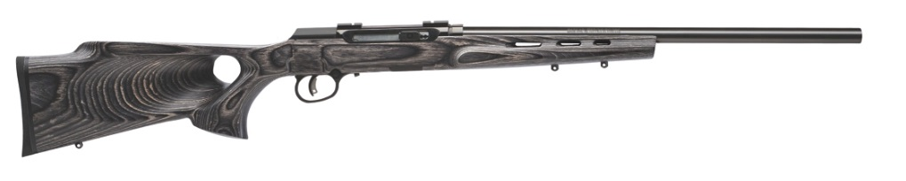

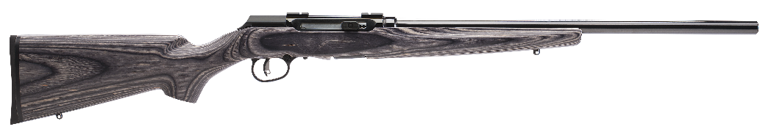

Part No. Description UPC MSRP
47005 A17 Target Sporter Thumbhole, 17 HMR 0-11356-47005-8 $631
47006 A17 Target Sporter, 17 HMR 0-11356-47006-5 $571
47007 A17 Heavy Barrel, 17 HMR 0-11356-47007-2 $494
47008 A17 Sporter, 17 HMR 0-11356-47008-9 $554

