Savage Adds Semi-Auto 22 Long Rifle To High-Performance A Series
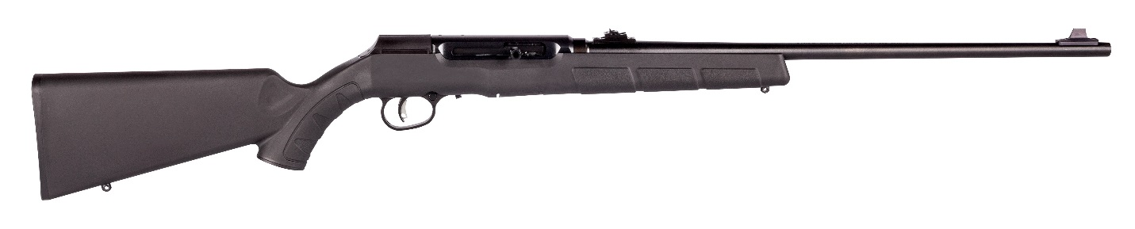
Tearing a page from the playbook that produced the high-performance A17 and A22 Magnum autoloaders, Savage expanded its wildly popular A Series with a sweet new semi-auto rimfire chambered for 22 LR.
Built to be equally at home afield or on the range, Savage’s new A22 semi-automatic, 22 LR is flush with features engineered to give 22 fans the same reliability, accuracy and sleek modern stylings of its larger A-Series magnum siblings.
For starters, it’s driven by a smooth-cycling, straight-blowback action that reliably feeds a variety of 22 caliber ammunition from the magazine to the chamber. That in itself is no small feat for any rimfire autoloader, but Savage’s exhaustive testing, conducted by engineers in their factory, also revealed the A22 action is up to three times more reliable than rifles from competitive brands.
Of course, the action is only as reliable as the magazine that feeds it. In a victory for surefire performance, the A22 chamber is fed by the company’s proprietary, 10-round, flush-fitting rotary magazine. The design is easy to use and delivers a flawless flow of firepower. Plus, its compact stature ensures the magazine won’t catch on grass, brush and branches in the field, making the A22 22 LR the perfect companion for quietly stalking a variety of small game.
In a nod to shooters seeking a more prodigious supply of ammunition, Savage also partnered with shooting accessories supplier Butler Creek to increase the rifle’s ammo capacity by creating an equally reliable 25-round, spring-fed aftermarket magazine.
The easy-handling, fun-to-shoot A22 also features Savage Arms’ accuracy-boosting adjustable AccuTrigger. This revolutionary technology lets shooters fine-tune trigger pull to match their personal taste, allowing for the crispest, cleanest, lightest release possible, without sacrificing safety or paying a gunsmith to do it. Savage also considers AccuTrigger standard issue on the A22, while other companies levy significant upgrade charges for their enhanced trigger systems.
Like the A17 and A22 Magnum, the A22 also features thread-in, zero tolerance headspace similar to the company’s celebrated centerfire platforms. Further fueling its downrange exploits, the rifle’s 22-inch carbon steel barrel is button-rifled for increased accuracy and finely balanced with the rugged yet easy-shouldering black matte synthetic stock.
The receiver that cradles the A22 precision inner workings is machined from a single billet of case-hardened steel—a major upgrade from the inexpensive die-cast receivers of competitors’ rimfires, which adds to the rifle being more reliable than other brands.
With a total length of 41½ inches and weight of 5.63 pounds, the A22 is light and easy to handle for shooters of all shapes and sizes. The rifle comes equipped with adjustable open steel sights, so it’s ready to shoot right out of the box. But it is also drilled and tapped for scope mounts, allowing shooters to easily add their favorite optic.
The rifle’s sleek, ergonomic stylings also beat the old-fashioned look other rifles still sport. And with a manufacturer’s suggested retail of just $281, Savage’s A22 is an extremely affordable option. It’s ideal for rimfire enthusiasts seeking a high-performance autoloading .22 for everything from backyard plinking to serious target shooting and small game hunting.

###

