A 22 FSS
SAVAGE ARMS 2018

A22 FSS

Accuracy, reliability and durability all come together in the A22 Stainless from Savage®. The semi- automatic 22 LR upgrades the original A22 platform with a 22-inch stainless steel sporter barrel, as well as two-piece bases. It features a gray synthetic stock, user-adjustable AccuTrigger™ and reliable straight- blowback action.

FEATURES:

Straight-blowback semi-automatic rimfire in 22 LR
- 22-inch stainless steel sporter barrel
- User-adjustable AccuTrigger
- Two-piece bases
- 10-round rotary magazine

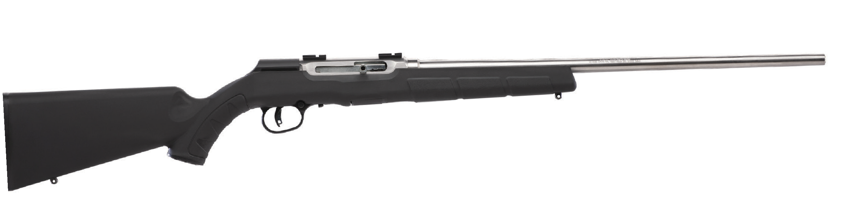

MANUFACTURER | SAVAGE ARMS
IMPORTER | N/A
ACTION TYPE | BOLT
FINISH | STAINLESS STEEL BARREL
SIGHTS | NONE
TRIGGER PULL WEIGHT | 2.5 LBS. – 6 LBS.
STOCK | BLACK SYNTHETIC STOCK
ACCESSORIES | N/A
DROP AT COMB | 1.10”

PART NO. | CALIBER | TWIST RATE | BARREL LENGTH | OVERALL LENGTH | WEIGHT (LBS) | CAPACITY UPC |  | MSRP
47216 | 22 LR | 1 IN 16” | 22” | 41.5” | 5.63 | 10 | 0-62654-47216-9 | $414

savagearms.com Copyright © 2017 Vista Outdoor

