A XIS
SAVAGE ARMS 2019

AXIS

When the AXIS was first introduced, it totally changed what hunters should expect from an entry-level rifle. The redesigned AXIS is even better. In addition to a fresh look with improved ergonomics, it’s loaded with features that deliver Savage’s legendary accuracy, including thread-in headspacing, button rifling and a floating bolt head. The AXIS is offered in the complete spectrum of popular hunting calibers, in full-size, compact and left-hand models.

FEATURES:

Rugged synthetic stock with new ergonomic design
- Sporter barrel contour
- Carbon steel barreled action with matte black finish
- Detachable box magazine
- Also available in left hand and compact models
- Weaver®-style two-piece bases
- Recoil pad

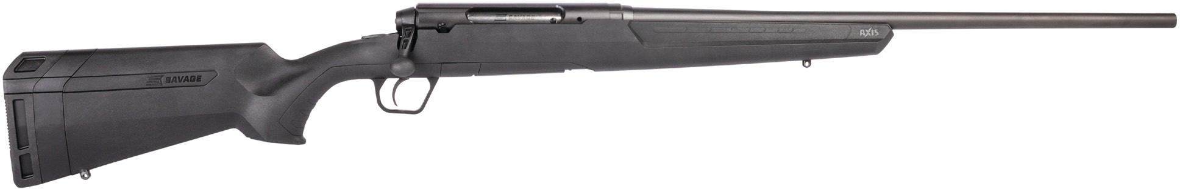

MANUFACTURER | SAVAGE ARMS
IMPORTER | N/A
ACTION TYPE | BOLT-ACTION
FINISH | MATTE BLACK
RIFLING
SIGHTS | N/A
TRIGGER PULL WEIGHT | 4-7 POUNDS, SET BY FACTORY; NON-ADJUSTABLE
STOCK | BLACK SYNTHETIC
OVERALL LENGTH | 42 1/2”, 39 1/2” (COMPACT)
WEIGHT | 6.3 POUNDS, 6.255 POUNDS (COMPACT)
AXIS
PART NO. | CALIBER | TWIST RATE | BARREL LENGTH | CAPACITY | UPC | MSRP
57233 | 223 REM. | 1 IN 9” | 22” | 4+1 | 0-11356-57233-2 | $375
57234 | 22-250 REM. | 1 IN 12” | 22” | 4+1 | 0-11356-57234-9 | $375
57235 | 243 WIN. | 1 IN 9.25” | 22” | 4+1 | 0-11356-57235-6 | $375
57239 | 25-06 REM. | 1 IN 10” | 22” | 4+1 | 0-11356-57239-4 | $375
57236 | 6.5 CREEDMOOR | 1 IN 8” | 22” | 4+1 | 0-11356-57236-3 | $375
57240 | 270 WIN. | 1 IN 10” | 22” | 4+1 | 0-11356-57240-0 | $375
57237 | 7MM-08 REM. | 1 IN 9.5” | 22” | 4+1 | 0-11356-57237-0 | $375
57238 | 308 WIN. | 1 IN 10” | 22” | 4+1 | 0-11356-57238-7 | $375
57241 | 30-06 SPRG | 1 IN 10” | 22” | 4+1 | 0-11356-57241-7 | $375

A XIS
SAVAGE ARMS 2019

AXIS LEFT-HAND
PART NO. | CALIBER | TWIST RATE | BARREL LENGTH | CAPACITY | UPC | MSRP
57247 | 223 REM. | 1 IN 9” | 22” | 4+1 | 0-11356-57247-9 | $375
57248 | 22-250 REM. | 1 IN 12” | 22” | 4+1 | 0-11356-57248-6 | $375
57249 | 243 WIN. | 1 IN 9.25” | 22” | 4+1 | 0-11356-57249-3 | $375
57253 | 25-06 REM. | 1 IN 10” | 22” | 4+1 | 0-11356-57253-0 | $375
57250 | 6.5 CREEDMOOR | 1 IN 8” | 22” | 4+1 | 0-11356-57250-9 | $375
57254 | 270 WIN. | 1 IN 10” | 22” | 4+1 | 0-11356-57254-7 | $375
57251 | 7MM-08 REM. | 1 IN 9.5” | 22” | 4+1 | 0-11356-57251-6 | $375
57252 | 308 WIN. | 1 IN 10” | 22” | 4+1 | 0-11356-57252-3 | $375
57255 | 30-06 SPRG | 1 IN 10” | 22” | 4+1 | 0-11356-57255-4 | $375

AXIS COMPACT
PART NO. | CALIBER | TWIST RATE | BARREL LENGTH | CAPACITY | UPC | MSRP
57244 | 223 REM. | 1 IN 9” | 20” | 4+1 | 0-11356-57244-8 | $375
57245 | 243 WIN. | 1 IN 9.25” | 20” | 4+1 | 0-11356-57245-5 | $375
57246 | 7MM-08 REM. | 1 IN 9.5” | 20” | 4+1 | 0-11356-57246-2 | $375

AXIS COMPACT LEFT-HAND
PART NO. | CALIBER | TWIST RATE | BARREL LENGTH | CAPACITY | UPC | MSRP
57242 | 243 WIN. | 1 IN 9.25” | 20” | 4+1 | 0-11356-57242-4 | $375
57243 | 7MM-08 REM. | 1 IN 9.5” | 20” | 4+1 | 0-11356-57243-1 | $375

