Savage Unveils New Model 110 Series
Savage refreshes existing Model 110 product line with introduction of the AccuFit System
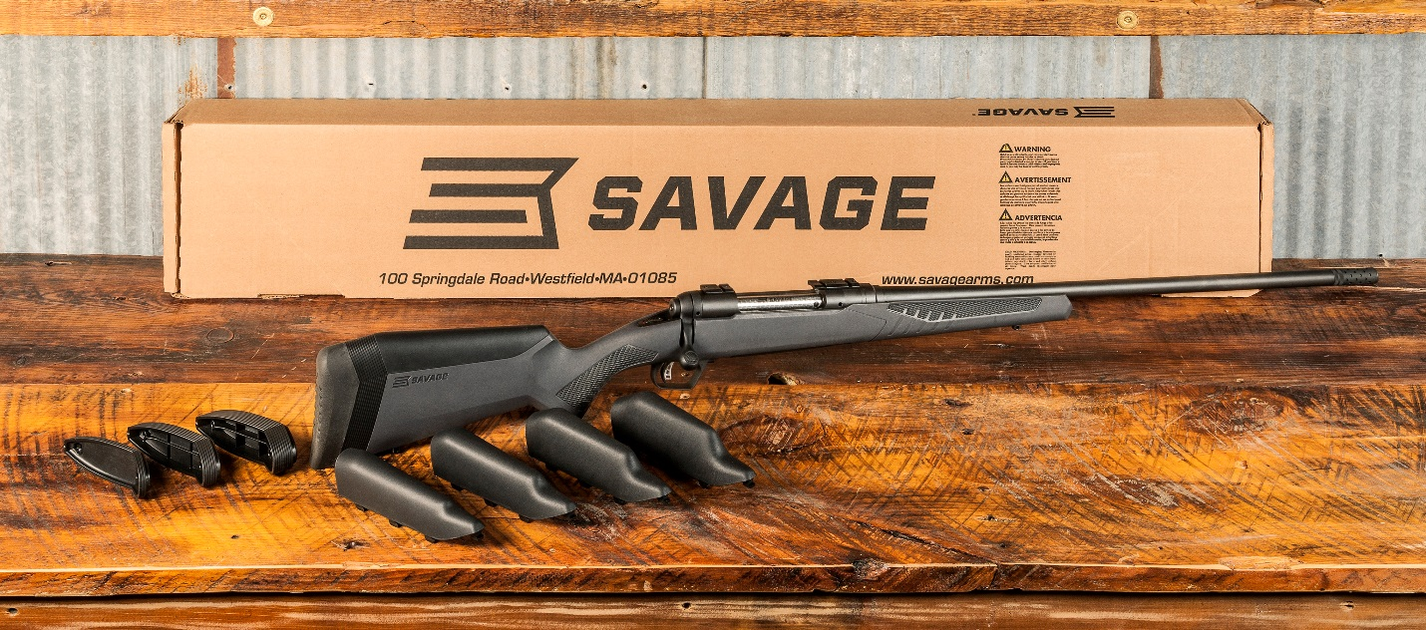
Savage’s legendary Model 110 rifles just went under the knife. First, the iconic firearm manufacturer gave the storied series an extreme makeover that includes a fresh look. Next came the launch of the all-new user-adjustable AccuFit system, which allows shooters to customize fit to make the most of their rifle’s accuracy potential—without a trip to a gunsmith.
Savage created the Model 110 in 1958 to give hunters a hard-hitting, accurate rifle that was also lightweight and economical. Today it owns the distinction of being the oldest continuously manufactured bolt-action rifle in North America—and its fans are legion.
Esteemed Field & Stream gun writer David E. Petzal summed up its appeal and prevalence in a recent article, calling the model 110 the “pre-eminent rifle, both in pure factory form and as the basis for custom guns.” He added, “I can’t think of anything equivalent in the shooting sports. If you walk down the firing line of F-Class competitions, the overwhelming majority of what you see will be out-of-the-box Savages or modified Savages, or true custom rifles built on the Savage action.”
The Model 110 design has been enhanced over the years, including the addition of the AccuTrigger and AccuStock. The line also leverages the technologies that set all Savage centerfire rifles apart, including a floating bolt head, zero-tolerance headspacing and precision button-rifled barrels.
Considering its proven track record, Savage didn’t take the task of tweaking the popular platform lightly. The company took a hard look at every facet of the Model 110. As a result, the project blossomed from a simple cosmetic facelift to a full-fledged redesign that saw teams of engineers and designers engaged in a two-pronged pursuit of the next plateau in fit, form and function.
An Accurate Fit
“The conversation started with style and aesthetics,” explains Beth Shimanski, Savage Arms Senior Marketing Manager. “Everyone agreed we needed to freshen up the Model 110. As we got further into the process, however, we started thinking a lot more about the individual shooter—what their unique needs are and what drives them to ultimately go to a gunsmith. That’s when we decided to really raise the bar and make the gun fit better too, and the AccuFit system was born.”
As serious target shooters can attest, proper fit is paramount to consistent accuracy. “Competitive shooters wouldn’t dream of shooting a rifle that doesn’t fit them properly,” says Shimanski. “In contrast, most hunters are content with a one-size-fits-all philosophy—which explains why fit remains one of the major obstacles standing in their way of enjoying more consistent shooting.”
A form-fitting rifle offers more benefits than feeling good when you throw it up to your shoulder. The right length of pull and comb height give you a solid cheek-to-stock connection, proper eye relief and comfortable, personalized fit—which collectively add up to improved, repeatable shooting form.
“There’s nothing magical about fit that mechanically makes a rifle shoot any more accurately,” says Shimanski. “But proper fit allows you to shoulder the gun and align your eye with the sights in a consistent manner, without having to move your head around to compensate for being the wrong height and distance from the scope. And better shooting form boosts accuracy.”
Shimanski draws a comparison to archery. “When you pull back a bow, you settle on an anchor point. If that point moves from one shot to another, you won’t be very consistent. The same thing is true with a rifle. If you’re not shouldering the firearm consistently from shot to shot, there will be differences in where your shots land downrange. It won’t punish you as severely as with a bow, but your accuracy with a rifle will suffer.”
She also notes that the dynamics of hunting often demand quick shots taken from a variety of positions. “The ability to quickly shoulder the rifle and confidently take the shot, versus struggling to find your anchor point and line up the scope, can mean the difference between tagging a trophy and missing,” she says. “Savage’s AccuFit system lets you dial in the perfect fit, so there’s less room for error at the moment of truth.”
How AccuFit Works
AccuFit features adjustable components that allow hunters to custom-fit both comb height and length of pull without taking their rifle to the gunsmith. In fact, the only tool needed is a Phillips-head screwdriver.
Comb height is controlled by five riser settings, adjustable in 1/8-inch increments. “Simply select the riser that creates cheek-to-stock contact and aligns your line of sight parallel to the barrel or scope,” Shimanski explains.
Length of pull (LOP), the distance from the shooter’s inner elbow to the middle of the trigger finger, is likewise fully adaptable to the shooter’s stature by using up to four inserts included with the rifle.
“Add or remove the inserts to ensure proper eye relief and establish a comfortable fit,” says Shimanski, noting that establishing the correct length of pull means faster target acquisition, better control and improved accuracy.
No matter which combination of adjustments you make, the Savage Model 110 won’t become unbalanced. “The system was engineered to maintain proper balance with the barrel, even at the highest riser setting and longest stock extension, so the rifle won’t become tail-heavy,” she says.
While target shooters might compulsively tweak their guns on the range, Shimanski says far fewer refinements are required for hunting situations. “Once the rifle is set, you shouldn’t have to make changes for different shooting positions and conditions,” she says. “But it is easy to make seasonal adjustments as needed—such as shortening the stock to accommodate wearing bulkier clothing during cold-weather hunts.”
Shimanski also points out that Savage was careful to consider hunter-centric concerns not addressed by other adjustable guns on the market.
“For example, some rifles have external knobs for adjusting the cheek piece,” she says. “But these can snag on brush and clothing. AccuFit was built to be snag-free, so it won’t hang up, even if you’re belly-crawling through the grass.”
The Model 110 also looks like a hunting rifle. “Other adjustable guns out there look like they’re built for tactical and long-range competitive shooting,” she says. “This is a custom-fit hunting rifle that has all the elements of a precision target stock, but still looks and feels like it belongs in the field.”
Improve Your Game
Shimanski is convinced the Model 110 will help hunters and shooters of all stripes hit the mark. “There’s no doubt in my mind that shooters of all ability levels are going to be more consistent with the Model 110 than the rifles they’re using now—even if those guns are older Model 110s,” she says “Those are great rifles built off of an accurate and reliable action, but AccuFit is a game-changer that will allow hunters to confidently make the toughest shots in all conditions.
And together with the AccuTrigger and AccuStock, the rifles address the top three things shooters usually have gunsmiths do—right out of the box.

Sidebar:
Meet the New Model 110s
Savage’s revamped Model 110 rifles are available in in a variety of finishes and feature packages within its Big Game Hunting and Specialty series, ensuring there’s a rifle for every kind of hunter and application.
In addition to the AccuFit System, all Model 110s also offer Savage’s patented user-adjustable AccuTrigger, which offers a light, crisp trigger pull with no creep and prevents the firearm from discharging if jarred or dropped. An AccuStock chassis is also standard. The rigid rail system, firmly embedded in the stock through the fore-end of the rifle, engages the action along its entire length, instead of simply at one or two points, yielding increased rigidity for better accuracy.
Each new Model 110 also sports new cosmetics and enhanced ergonomics, including improved pistol grip and fore-end shaping, plus soft-touch gripping surfaces. Other Savage hallmarks include zero-tolerance headspace control, achieved by carefully threading each barrel into place with its action and bolt, plus free-floating, button-rifled barrels and floating bolt heads.
110 Hunter
The Model 110 Hunter has a blued action and barrel, detachable box magazine, sturdy build and hard-hitting features to match your personal shooting style. Available in 204 Ruger, 223 Rem., 22-250 Rem., 243 Win., 25-06 Rem., 270 Win., 7mm-08 Rem., 7mm Rem. Mag., 308 Win., 30-06 Sprg. and 300 Win. Mag.
110 Storm
The Model 110 Storm is available in right- and left-hand configurations. It’s built off the same 110 action as the Model 110 Hunter, with a detachable box magazine, stainless steel action, and stainless steel matte-finish barrel to stand up to punishment from the most brutal weather conditions. Right-hand models are available in 223 Rem., 22-250 Rem., 243 Win., 25-06 Rem., 6.5 Creedmoor, 6.5 x 284 Norma, 270 Win., 270 WSM, 7mm-08 Rem., 7mm Rem. Mag., 308 Win., 30-06 Sprg., 300 Win. Mag., 300 WSM, 338 Federal and 338 Win. Mag. The left-hand version comes in 223 Rem., 22-250 Rem., 243 Win., 270 Win., 7mm-08 Rem., 7mm Rem. Mag., 308 Win., 30-06 Sprg. and 300 Win. Mag.
110 Varmint
The Specialty Series Model 110 Varmint features a 26-inch, heavy carbon steel barrel, oversized bolt handle, detachable box magazine and synthetic stock with beavertail fore-end. Available in 204 Ruger, 223 Rem. and 22-250 Rem.
110 Tactical
The Model 110 Tactical is a proven member of Savage’s Tactical Series that comes in right- and left-hand versions. Both are suppressor-ready and fitted with a heavy, fluted, 24-inch barrel ideal for extreme accuracy in all conditions. A 20-inch barrel is also available in right hand only. Added features include three sling swivel studs, a one-piece scope mount, an oversize tactical bolt handle, and an AICS-compatible, 10-round detachable polymer magazine. Available in 308 Win.
110 Long Range Hunter
The Specialty Series Model 110 Long Range Hunter is optimized for extreme performance, exceptional accuracy and extended range. It features a 26-inch barrel with an on-off muzzle brake and hinged floorplate magazine. Available in 6.5 Creedmoor, 6.5 x 284 Norma, 260 Rem., 7mm Rem. Mag., 308 Win., 300 Win. Mag., 300 WSM, and 338 Federal. It’s also available in a 338 Lapua Magnum version with a 26-inch medium-contour barrel, muzzle brake, one-piece scope mount, and an AICS-compatible, detachable box magazine.
110 Predator
The Specialty Series Model 110 Predator is a middle-weight champion complete with a medium-contour, fluted barrel, oversized bolt handle, Realtree Max-1 camouflage synthetic stock and detachable box magazine. Available in 204 Ruger, 22-250 Rem., 223 Rem., 243 Win., 260 Rem. 6.5 Creedmoor and 308 Win.
110 Scout
This highly versatile member of Savage’s Tactical Series is flush with features, including a carbon steel barrel, muzzle brake and AICS-style detachable box magazine that holds 10 rounds. Its rugged synthetic stock, forward-mounted rail and adjustable iron sights are perfectly suited to the unique platform. Available in 223 Rem., 308 Win, 338 Federal and 450 Bushmaster.
110 Bear Hunter
The Specialty Series Model 110 Bear Hunter is a heavy hitter with a stainless fluted barrel, on-off muzzle brake, Mossy Oak Break-Up Infinity camouflage synthetic stock and engraved hinged floorplate magazine. Available in 300 Win. Mag., 300 WSM, 338 Federal, 338 Win. Mag. and 375 Ruger.
110 Wolverine
Chambered for the straight-walled 450 Bushmaster cartridge, the Savage 110 Wolverine offers both precision and power for deer, bears and hogs. It features a Magpul AICS magazine, as well as an 18-inch carbon steel heavy barrel with a ported muzzle brake and 11/16-24 threading. A one-piece 20 MOA rail mounted on the receiver makes it easy to set the rifle up to your unique needs.
Just The Beginning
These Big Game and Specialty Series rifles aren’t the only ones that have received a major update. The Trophy Series, which includes the 110 Engage Hunter XP, 110 Hog Hunter, 110 Brush Hunter and 110 Lightweight Storm now feature a modern, ergonomically enhanced stock that allows shooters to adjust the length-of-pull. The popular AXIS II platform will also offer an updated stock featuring stylish looks and better ergonomics. For complete details on all new 2018 rifles, visit savagearms.com.

