MSR 10 PRECISION

Complete and ready to compete. The Savage® MSR 10 Precision delivers match-winning accuracy with its stainless steel heavy barrel and 5R button rifling. We also made it competition-worthy right out of the box with upgrades like an 18-inch Arca handguard, Magpul PRS® stock and TangoDown™ Battlegrip Flip Grip, which quickly rotates from 24 degrees of rake to vertical. Its semi-automatic action is fed by a
+2 gas system that can be adjusted for optimal cycling of your specific ammunition.

FEATURES:

Stainless steel heavy barrel
- MSR 10 non-reciprocating side charging upper receiver
- Adjustable gas block with lock nut
- Two-stage trigger

- Magpul PRS stock
- 18-inch Arca handguard
- TangoDown Battlegrip Flip Grip
- Ambidextrous safety
- Red QD front sling mount

MSR 10 PRECISION
SAVAGE ARMS 2019

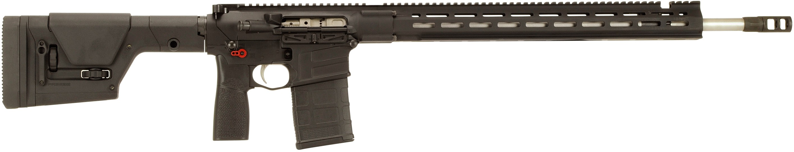

MANUFACTURER | SAVAGE ARMS
IMPORTER | N/A
ACTION TYPE | SEMI-AUTOMATIC
FINISH | STAINLESS STEEL
RIFLING | LISTED BELOW
SIGHTS | N/A
TRIGGER PULL WEIGHT | TAKE-UP – 2 POUNDS; BREAK – 4 POUNDS
STOCK | BLACK; MAGPUL PRS
OVERALL LENGTH | 44”
WEIGHT | 11.4 POUNDS

PART NO. | CALIBER | TWIST RATE | BARREL LENGTH | CAPACITY | UPC | MSRP
22975 | 6MM CREEDMOOR | 1 IN 7” 5R | 22.5” | 20 | 0-11356-22975-5 | $2,499
22974 | 6.5 CREEDMOOR | 1 IN 8” 5R | 22.5” | 20 | 0-11356-22974-8 | $2,499
22973 | 308 WIN | 1 IN 10” 5R | 22.5” | 20 | 0-11356-22973-1 | $2,499

savagearms.com Copyright © 2018 Vista Outdoor

