224 Valkyrie Defined

Brand-new MSR 15 cartridge pushes accuracy envelope to extreme distances

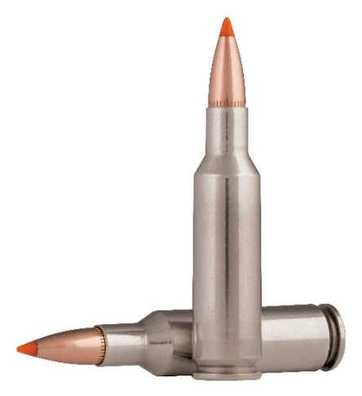
Federal Premium’s 224 Valkyrie takes the long-range precision and ballistic performance of the MSR 15 platform to unheard of heights. The results recorded by Federal Premium engineers during the cartridge’s extensive development and testing process speak for themselves. The 224 Valkyrie provides extremely flat trajectories, supersonic velocities at as far as 1,300 yards downrange, and match-grade accuracy.

It offers dramatically improved trajectories over all other MSR 15 cartridges, including the 22 Nosler, 223 Rem. and 6.5 Grendel—with roughly half the recoil of larger cartridges offering comparable ballistics, such as the 6.5 Creedmoor.

Built To Go the Distance
Loaded with a selection of high-performance projectiles, the 224 Valkyrie is the new first choice of long-range target shooters and hunters looking to extend the reach of their favorite MSR 15. Plus, even though the new 224 Valkyrie was designed for gas-driven MSR 15 actions, it’s also extremely effective from bolt guns. All of this is great news for shooters who’ve longed for practical, economical and exceptionally reliable 1,000-plus-yard performance.

The 224 Valkyrie is based on a 30 Rem./6.8 SPC case necked down to .224 caliber. This gives it similar geometry to the 22 Nosler—although the Valkyrie’s ingenious blend of case capacity and ample ogive space, coupled with a highly efficient, heavy-for-caliber .224 projectile, produces downrange exploits the 22 Nosler can’t touch.

It offers up to 127.88 inches less drop and 68.76 inches less wind drift at 1,000 yards than the 223 Rem and other short-action calibers like the 22 Nosler and 6.5 Grendel. Plus, its ballistics are comparable to much larger, harder-kicking calibers like the 6.5 Creedmoor—with as little as half the felt recoil.

To say the 224 Valkyrie is fast, even at long ranges, is an understatement. Testing conducted by Federal Premium engineers confirms its high-speed capabilities. For example, the 224 Valkyrie 90-grain Gold Medal Sierra MatchKing produces leaves the muzzle at 2,700 feet per second; it maintains a blistering 1,950 fps pace at 500 yards and 1,268 fps when crossing the 1,000-yard line. In fact, it remains supersonic out to 1,300 yards. Velocities are based on 24-inch test barrels with a 1:7 twist.

“Along with its ballistic benefits, the 224 Valkyrie also lowers the financial barrier of entry into shooting 1,000 yards for fun and competition,” said Federal Premium development engineer Jacob Burns. “Shooters can use the widely available and popular MSR 15 platform with high-performance yet economical ammunition that costs less than traditional long-range rounds like the 6.5 Creedmoor.”

Initial Lineup
Federal Premium’s new 224 Valkyrie cartridge will be initially available in four of its proven product lines, offering serious options for competitors, long-range target shooters and hunters pursuing varmints up to deer-sized game.

224 Valkyrie 90-grain Gold Medal Sierra MatchKing
Extract the full long-range potential from 224 Valkyrie with the 90-grain Sierra MatchKing. The bullet design has been shot to win more matches than any other, thanks to a uniform jacket that ensures consistent, long-range accuracy, and a sleek boat-tail that maximizes ballistic coefficient.

224 Valkyrie 60-grain Nosler Ballistic Tip Varmint
The 224 Valkyrie is built to defeat wind drift and drop, and the 60-grain Nosler Ballistic Tip Varmint maximizes these built-in ballistics with a sleek, thin-jacket, polymer-tipped bullet. Its explosive expansion provides a violent energy release on impact for quick kills on varmints and predators.

224 Valkyrie 90-grain Fusion MSR
Virtually every component in Fusion MSR is optimized for peak ballistic performance in modern sporting rifles. New 90-grain 224 Valkyrie extends range even further, offering devastating accuracy and terminal performance on medium game—with half the recoil of cartridges with similar ballistics.

224 Valkyrie 75-grain American Eagle TMJ
Train like never before with 224 Valkyrie and American Eagle rifle. The loads feature Federal brass, clean-burning powder, consistent primers and accurate 75-grain TMJ bullets. They're the ultimate range ammunition for the ultimate MSR 15 cartridge.

Join the Valkyrie Revolution
The easiest way to capitalize on the new cartridge is purchase a firearm from one of the many gun makers quickly jumping on the 224 Valkyrie bandwagon. You can also purchase a new upper and use with your existing lower.

A gunsmith or other person trained in the art of building MSRs can also make the necessary modifications using a barrel chambered in 224 Valkyrie, 224 Valkyrie headspace gauge, plus a 6.8 SPC bolt head and 6.8 SPC magazine. Consumers can expect to see widespread availability of new guns, uppers and barrels as the cartridge gains traction in the marketplace. Again, it is recommended that shooters who decide to go the modification route enlist gun-building expertise to complete the transformation.

Shooters can expect full technical specifications for the new round once it is approved by the Sporting Arms and Ammunition Manufacturers' Institute (SAAMI) in January at the 2018 SHOT Show in Las Vegas. At that time, information such as chamber specifications and cartridge pressure standards, including SAAMI's maximum average pressure (MAP), proof pressure range and barrel length/twist recommendations will be communicated. Cartridge and chamber dimensions, drawings and diagrams will also be available soon after SAAMI makes the cartridge official.

Reloading data will be available in spring of 2018, when SAAMI releases its load-building specifications. However, reloading die sets will be available from RCBS, and other ammo-building components will also be offered by several popular brands.

Ultimately, Federal Premium’s 224 Valkyrie will unleash a new era of 1,000-yard-plus accuracy and performance for gas-driven MSR 15s and short-action bolt guns, without the hefty recoil and price tag of larger caliber options. Thanks to the continuation of Federal Premium’s 95-year commitment to excellence, shooters can expect best-in-class ballistics, supersonic flight past 1,300 yards (GM224VLK1) and extreme long-range accuracy from this exciting new cartridge. And with the full array of high-performance projectiles available, it’s poised to deliver on virtually every shooter’s needs.

###

