MSR 15 RECON LRP
SAVAGE ARMS 2018

MSR 15 RECON LRP

Savage has added an adjustable gas block and longer barrel to stretch the out-of-the-box performance of its MSR 15 Recon platform even further. The Recon LRP features an 18-inch barrel to optimize velocities and accuracy, and its gas block can be customized to specific ammunition for the best possible cycling. Like the original MSR 15 Recon, it comes standard with upgrades such as a two-stage trigger, free-float handguard and Savage barrel. Its 5R rifling and a Melonite QPQ finish
ensure the most consistent, accurate performance in any conditions, while the custom-forged lower receiver and Hogue® pistol grip impart a look that stands out from the crowd.

FEATURES:

Melonite QPQ 18-inch barrel with 5R rifling
- Adjustable gas block
- Custom-forged lower receiver
- Chambered in the hottest MSR 15 calibers, including all-new 224 Valkyrie
- Magpul CTR buttstock
- Tunable muzzlebrake
- Two-stage trigger
- Mid-length gas system
- Free-float M-LOK® handguard
- Hogue pistol grip
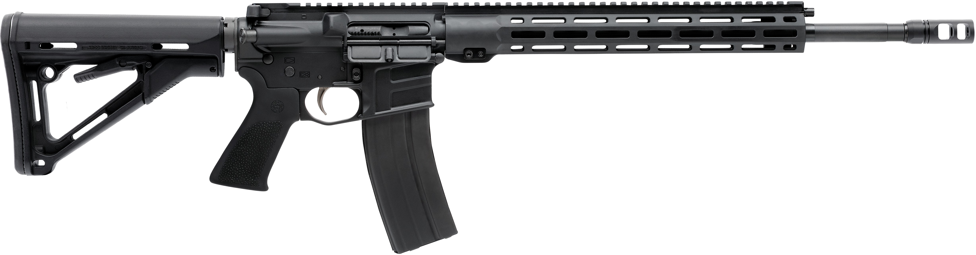

MANUFACTURER | SAVAGE ARMS
IMPORTER | N/A
ACTION TYPE | SEMI-AUTOMATIC
FINISH | MATTE BLACK
SIGHTS | NONE
TRIGGER PULL WEIGHT | 3 LBS.
STOCK | MAGPUL CTR
ACCESSORIES | N/A

PART NO. | CALIBER | TWIST RATE | BARREL LENGTH | OVERALL LENGTH | WEIGHT (LBS) | CAPACITY | UPC | MSRP
22931 | 224 VALKYRIE | 1 IN 7” | 18” | 35.25-38.5” | 7.5 | 25 | 011356-22931-1 | $1249
22922 | 22 NOSLER | 1 IN 7” | 18” | 35.25-38.5” | 7.5 | 25 | 011356-22922-9 | $1249
22932 | 6.8 SPC | 1 IN 7” | 18” | 35.25-38.5” | 7.5 | 25 | 011356-22932-8 | $1249

savagearms.com Copyright © 2017 Vista Outdoor

