MSR 15 VALKYRIE
SAVAGE ARMS 2018

MSR 15 VALKYRIE

The Savage® MSR 15 Valkyrie gets maximum performance from the all-new 224 Valkyrie cartridge, which was pioneered by Federal Premium® Ammunition to offer the best ballistics of any MSR 15 caliber. It delivers supersonic velocities at as far as 1,300 yards, extremely flat trajectories and match accuracy.
Plus it produces only half the recoil of larger cartridges needed to achieve comparable trajectories. The competition-ready MSR 15 Valkyrie gets the most from the cartridge’s unprecedented capabilities with an upgraded 18-inch barrel with 5R rifling and a crisp two-stage trigger. Its Elite Series FDE Cerakote finish forms a tough, protective layer on the upper and lower, and its adjustable mid-length gas system can be customized to specific ammunition for the most reliable cycling.

FEATURES:

MSR 15 Recon platform built around the new 224 Valkyrie, which offers the best performance of any MSR 15 cartridge
- Elite Series FDE Cerakote fore-end, upper and lower
- Two-stage trigger
- Hogue® pistol grip
- Magpul UBR Gen 2 buttstock
- Forward assist
- Tunable muzzle brake with 1/2x28, Class 3 barrel thread
- Adjustable gas block
- 18-inch barrel with 5R rifling
- Mid-length gas system
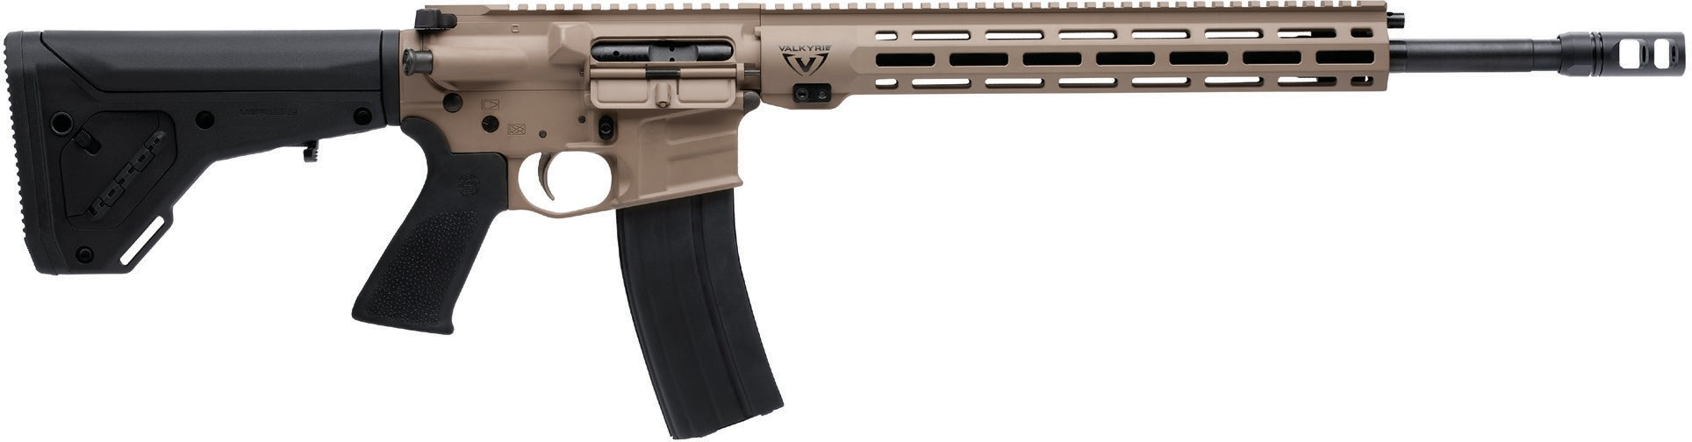

MANUFACTURER | SAVAGE ARMS
IMPORTER | N/A
ACTION TYPE | SEMI-AUTOMATIC
FINISH | ELITE SERIES FDE CERAKOTE
SIGHTS | NONE
TRIGGER PULL WEIGHT | 2.5 LBS. – 6 LBS.
STOCK | MAGPUL UBR GEN 2
ACCESSORIES | N/A

PART NO. | CALIBER | TWIST RATE | BARREL LENGTH | OVERALL LENGTH | WEIGHT (LBS) | CAPACITY | UPC | MSRP
22939 | 224 VALKYRIE | 1 IN 7” | 18” | 35.5-39” | 7.88 | 25 | 011356-22939-7 | $1499

savagearms.com Copyright © 2017 Vista Outdoor

