110 BEAR HUNTER
SAVAGE ARMS 2018

110 BEAR HUNTER

For hard-hitting performance against tough game and even tougher conditions, choose the Savage 110 Bear Hunter. Its AccuFit™ system lets shooters easily customize the length-of-pull and comb height for a personalized fit, while the user-adjustable AccuTrigger™ offers a crisp, clean pull and prevents the firearm from discharging if jarred or dropped. Together with the AccuStock™ which cradles the action
three-dimensionally along its entire length, the 110 Bear Hunter provides the fit and function of a custom rifle—right out of the box. Its 23-inch stainless steel fluted barrel is button-rifled, fitted with an adjustable muzzle brake and held within a Mossy Oak® Break-Up Country synthetic stock.

FEATURES:

AccuFit system lets shooters quickly adjust comb height and length-of-pull
- User-adjustable AccuTrigger
- AccuStock rail system secures the action three-dimensionally along its entire length
- Mossy Oak Break-Up Country synthetic stock
- 23-inch, stainless steel barrel with straight fluting and button rifling
- Adjustable muzzle brake
- Hinged floorplate magazine
- Soft grip fore-end and pistol grip surfaces
- New Model 110 design and ergonomics
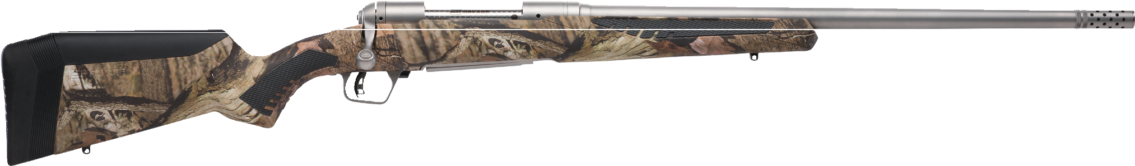

MANUFACTURER | SAVAGE ARMS
IMPORTER | N/A
ACTION TYPE | BOLT
FINISH | MATTE STAINLESS STEEL
RIFLING | 1 IN 10” OR 1 IN 12”
SIGHTS | NONE
TRIGGER PULL WEIGHT | 2.5 LBS. – 6 LBS.
STOCK | MOSSY OAK BREAK-UP COUNTRY ACCUSTOCK
ACCESSORIES | COMB HEIGHT INSERTS AND LENGTH OF PULL INSERTS
OVERALL LENGTH | 42.5” - 44.125”
WEIGHT | 7.5 - 8.39 LBS.
DROP AT COMB | 1.10 - 0.30”

PART NO. | CALIBER | TWIST RATE | BARREL LENGTH | CAPACITY | UPC | MSRP
57045 | 300 WSM | 1 IN 10” | 23 | 2+1 | 0-11356-57045-1 | $999
57046 | 338 FEDERAL | 1 IN 10” | 23 | 2+1 | 0-11356-57046-8 | $999
57069 | 300 WIN. MAG. | 1 IN 10” | 23 | 2+1 | 0-11356-57069-7 | $999
57070 | 338 WIN. MAG. | 1 IN 10” | 23 | 2+1 | 0-11356-57070-3 | $999
57047 | 375 RUGER | 1 IN 12” | 23 | 2+1 | 0-11356-57047-5 | $999

savagearms.com Copyright © 2017 Vista Outdoor

