110 LONG RANGE HUNTER
SAVAGE ARMS 2018

110 LONG RANGE HUNTER

Making an extreme range shot on the trophy of a lifetime requires not only a rifle built for accuracy, but a rifle built for you. The Savage 110 Long Range Hunter’s AccuFit™ system lets you easily customize the length-of-pull and comb height for a personalized fit, while the user-adjustable AccuTrigger™ offers a crisp, clean pull. Together with the AccuStock™, which secures the action three-dimensionally along its entire length, the 110 Long Range Hunter provides the fit and function of a custom rifle—right out of the box. Its 26-inch button rifled barrel provides the utmost precision and consistency, and is topped with an adjustable muzzle brake.

FEATURES:

AccuFit system lets shooters quickly adjust comb height and length-of-pull
- User-adjustable AccuTrigger
- AccuStock rail system secures the action three-dimensionally along its entire length
- Gray synthetic stock
- 26-inch button-rifled barrel with adjustable muzzle brake (fixed muzzle brake on 338 Lapua Magnum)
- Hinged floorplate magazine (detachable box magazine on 338 Lapua Magnum)
- Soft grip overmold fore-end and pistol grip surfaces
- New Model 110 design and ergonomics

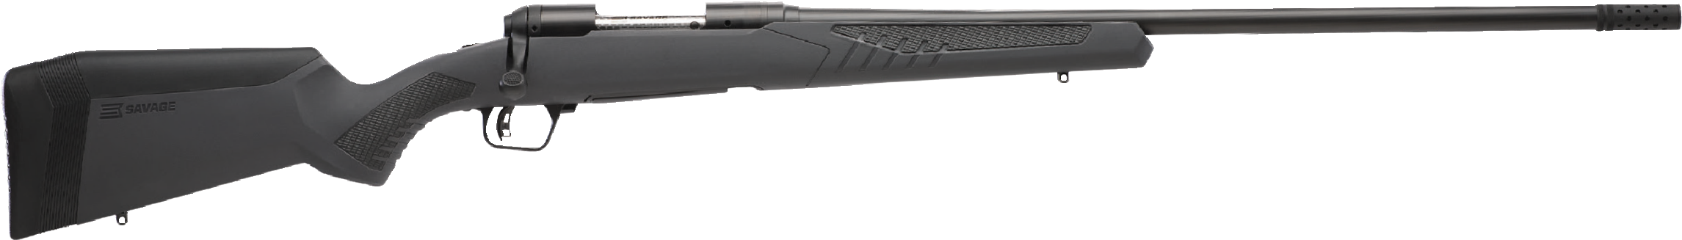

MANUFACTURER | SAVAGE ARMS
IMPORTER | N/A
ACTION TYPE | BOLT
FINISH | MATTE BLACK BARREL
SIGHTS | NONE
TRIGGER PULL WEIGHT | 2.5 LBS. – 6 LBS.
STOCK | GRAY SYNTHETIC STOCK
ACCESSORIES | COMB HEIGHT INSERTS AND LENGTH OF PULL INSERTS
OVERALL LENGTH | 45.5” - 49.5”
WEIGHT | 8.0 - 8.85 LBS.
DROP AT COMB | 1.10” - 0.30”

PART NO. CALIBER TWIST BARREL CAPACITY UPC MSRP
RATE LENGTH
57021 | 6.5 CREEDMOOR | 1 IN 8” | 26” | 4+1 | 0-11356-57021-5 | $1099
57022 | 260 REM. | 1 IN 8” | 26” | 4+1 | 0-11356-57022-2 | $1099
57023 | 308 WIN. | 1 IN 10” | 26” | 4+1 | 0-11356-57023-9 | $1099
57024 | 300 WSM | 1 IN 10” | 26” | 2+1 | 0-11356-57024-6 | $1099
57025 | 338 FEDERAL | 1 IN 10” | 26” | 4+1 | 0-11356-57025-3 | $1099

110 LONG RANGE HUNTER
SAVAGE ARMS 2018

PART NO. CALIBER TWIST BARREL CAPACITY UPC MSRP
RATE LENGTH
57034 | 6.5X284 NORMA | 1 IN 8” | 26” | 3+1 | 0-11356-57034-5 | $1099
57035 | 7MM REM. MAG. | 1 IN 9.5” | 26” | 3+1 | 0-11356-57035-2 | $1099
57036 | 300 WIN. MAG. | 1 IN 10” | 26” | 3+1 | 0-11356-57036-9 | $1099
57147 | 280 ACKLEY IMPROVED | 1 IN 9” | 26” | 4+1 | 0-11356-57147-2 | $1099
57037 | 338 LAPUA MAG. | 1 IN 9” | 26” | 5+1 | 0-11356-57037-6 | $1299

Note: 338 Lapua Magnum model has a detachable box magazine and fixed muzzle brake

