110 SCOUT
SAVAGE ARMS 2018

110 SCOUT
When a rifle is meant for making fast, accurate shots from a variety of shooting positions—including off- hand—it needs to be a natural extension of the shooter’s body. The Savage 110 Scout’s AccuFit™ system does this, letting shooters easily customize the length-of-pull and comb height for a personalized fit, while the user-adjustable AccuTrigger™ offers a crisp, clean pull. Together with the AccuStock™, which secures the action three-dimensionally along its entire length, the 110 Scout provides the fit and function of a custom rifle—right out of the box. It’s also flush with features, including a carbon steel barrel, muzzle brake and AICS-style detachable box magazine that holds 10 rounds. Its rugged synthetic stock, forward- mounted rail and adjustable iron sights are perfectly suited to the versatile platform.

FEATURES:

AccuFit system lets shooters quickly adjust comb height and length-of-pull
- User-adjustable AccuTrigger
- AccuStock rail system secures the action three-dimensionally along its entire length
- Synthetic stock
- 16 ½-inch matte-black button-rifled barrel with muzzle brake and adjustable iron sights
- Forward-mounted rail
- 10-round Magpul AICS-style detachable box magazine
- Soft grip fore-end and pistol grip surfaces
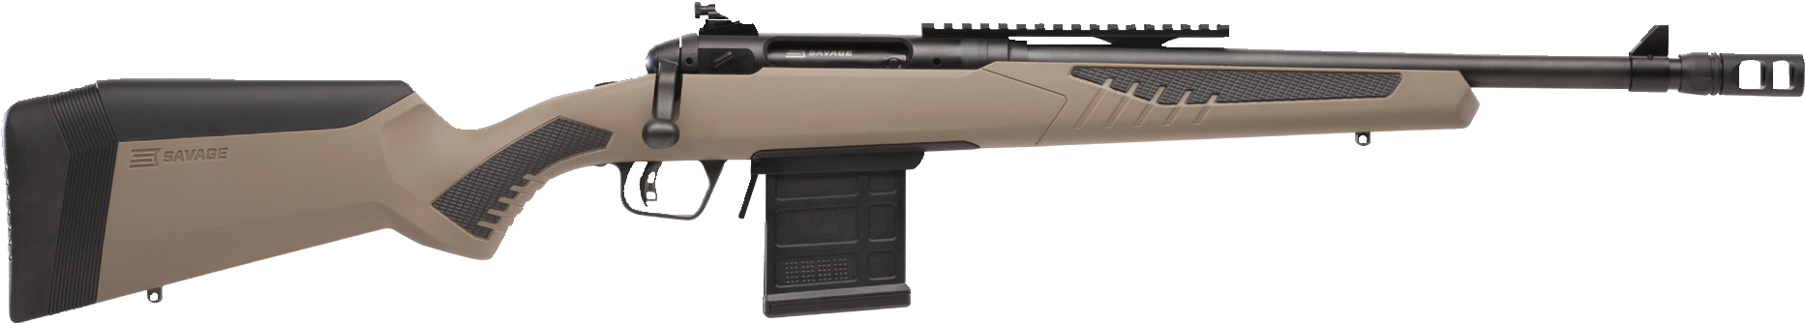
- New Model 110 design and ergonomics

MANUFACTURER | SAVAGE ARMS
IMPORTER | N/A
ACTION TYPE | BOLT
FINISH | BLACK MATTE BARREL
RIFLING | 1 IN 9” TO 1 IN 24”
SIGHTS | OPEN SIGHTS
TRIGGER PULL WEIGHT | 2.5 LBS. - 6 LBS.
STOCK | FLAT DARK EARTH SYNTHETIC ACCUSTOCK
ACCESSORIES | COMB HEIGHT INSERTS AND LENGTH OF PULL INSERTS
OVERALL LENGTH | 37.5” - 38.5”
WEIGHT | 7.72 LBS.
DROP AT COMB | 1.10 - 0.30”

PART NO. | CALIBER | TWIST RATE | BARREL LENGTH | CAPACITY | UPC | MSRP
57136 | 223 REM. | 1 IN 9” | 16.5” | 10+1 | 0-11356-57136-6 | $819
57026 | 308 WIN. | 1 IN 10” | 16.5” | 10+1 | 0-11356-57026-0 | $819
57138 | 338 FEDERAL | 1 IN 10” | 16.5” | 10+1 | 0-11356-57138-0 | $819
57139 | 450 BUSHMASTER | 1 IN 24” | 16.5” | 10+1 | 0-11356-57139-7 | $819

savagearms.com Copyright © 2017 Vista Outdoor

