110 VARMINT
SAVAGE ARMS 2018

110 VARMINT
The Savage Model 110 Varmint offers the impeccable accuracy needed to connect with small, distant targets. Its AccuFit™ system lets prairie doggers and other varmint hunters easily customize the length- of-pull and comb height for a personalized fit, while the user-adjustable AccuTrigger™ offers a crisp, clean pull. Together with the AccuStock™, which secures the action three-dimensionally along its entire length, the 110 Varmint provides the fit and function of a custom rifle—right out of the box. Its 26-inch heavy barrel is button rifled and held securely within a rugged synthetic stock. It features a detachable 4-round box magazine and fast-handling oversize bolt.

FEATURES:

AccuFit system lets shooters quickly adjust comb height and length-of-pull
- User-adjustable AccuTrigger
- AccuStock rail system secures the action three-dimensionally along its entire length
- Gray synthetic stock with Beavertail fore-end
- 26-inch black matte heavy barrel with precision button rifling
- 4-round detachable box magazine
- New Model 110 design and ergonomics

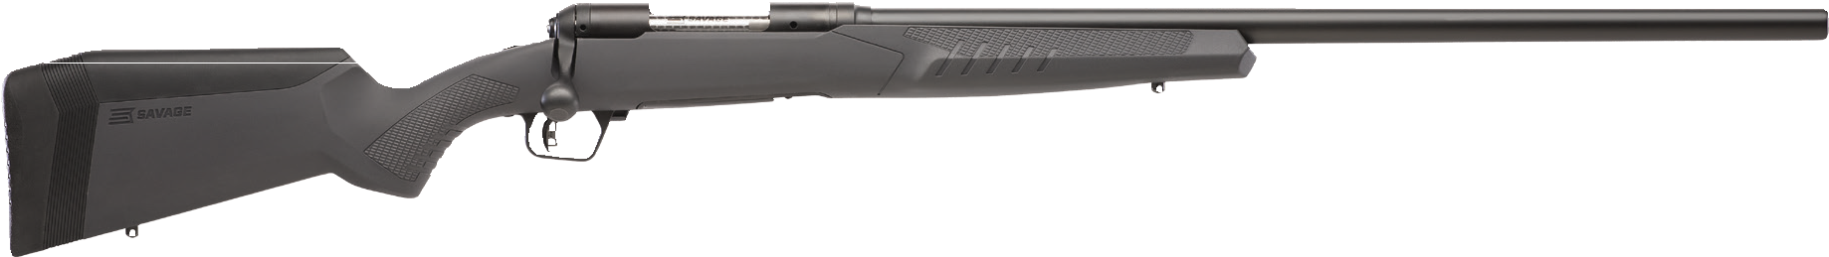

MANUFACTURER | SAVAGE ARMS
IMPORTER | N/A
ACTION TYPE | BOLT
FINISH | BLACK MATTE BARREL
RIFLING | 1 IN 9” TO 1 IN 12”
SIGHTS | NONE
TRIGGER PULL WEIGHT | 1.5 LBS. - 6 LBS.
STOCK | GRAY SYNTHETIC ACCUSTOCK
ACCESSORIES | COMB HEIGHT INSERTS AND LENGTH OF PULL INSERTS
OVERALL LENGTH | 45” - 46”
WEIGHT | 9.88 - 10 LBS.
DROP AT COMB | 1.10 - 0.30”

PART NO. | CALIBER | TWIST RATE | BARREL LENGTH | CAPACITY | UPC | MSRP
57066 | 223 REM. | 1 IN 9” | 26” | 4+1 | 0-11356-57066-6 | $749
57067 | 22-250 REM. | 1 IN 12” | 26” | 4+1 | 0-11356-57067-3 | $749
57068 | 204 RUGER | 1 IN 12” | 26” | 4+1 | 0-11356-57068-0 | $749

savagearms.com Copyright © 2017 Vista Outdoor

