110 WOLVERINE
SAVAGE ARMS 2018

110 WOLVERINE

Chambered for the straight-walled 450 Bushmaster cartridge, the Savage 110 Wolverine offers both precision and power for deer, bears and hogs. Its AccuFit™ system lets you easily tailor the length-of- pull and comb height for a perfect fit, while the user-adjustable AccuTrigger™ offers a crisp, clean pull. Together with the AccuStock™, which secures the action three-dimensionally along its entire length, the 110 Wolverine provides the fit and function of a custom rifle—right out of the box. It features a Magpul AICS magazine, as well as an 18-inch carbon steel heavy barrel with a ported muzzle brake and 11/16- 24 threading. A one-piece 0 MOA rail mounted on the receiver makes it easy to set up the rifle to your unique needs.

FEATURES:

AccuFit system lets shooters quickly adjust comb height and length-of-pull
- User-adjustable AccuTrigger
- AccuStock rail system secures the action three-dimensionally along its entire length
- Tough synthetic stock
- 18-inch carbon steel heavy barrel
- Ported muzzle brake and 11/16-24 threading
- 5-round Magpul AICS magazine
- One-piece 0 MOA rail mounted on the receiver
- Soft grip fore-end and pistol grip surfaces
- New Model 110 design and ergonomics
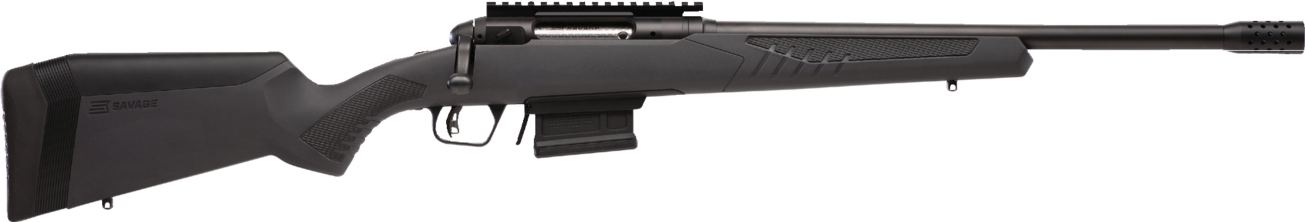

MANUFACTURER | SAVAGE ARMS
IMPORTER | N/A
ACTION TYPE | BOLT
FINISH | BLACK MATTE BARREL
SIGHTS | NONE
TRIGGER PULL WEIGHT | 2.5 LBS. – 6 LBS.
STOCK | GRAY SYNTHETIC STOCK
ACCESSORIES | COMB HEIGHT INSERTS AND LENGTH OF PULL INSERTS
OVERALL LENGTH | 37.5”- 38.5”
WEIGHT | 7.9 LBS.
DROP AT COMB | 1.10”-0.30”

PART NO. | CALIBER | TWIST RATE | BARREL LENGTH | CAPACITY | UPC | MSRP
57140 | 450 BUSHMASTER | 1 IN 24” | 18” | 4+1 | 0-11356-57140-3 | $899

savagearms.com Copyright © 2017 Vista Outdoor

