Competition Belts
Uncle Mike’s® takes shooting competition seriously. The new Competition Belts are engineered for maximum performance on the professional stage. They feature a combination of inner and outer belts for securing the system to the competitor’s waist. They allow for increased mobility, fast configuration and offer polymer reinforcement to ensure a strong platform for competition gear.

Features & Benefits
- Both the inner and outer belts are packaged together
- Polymer reinforcement handles the weight and strain of competition use
- Inner and outer belts secure together using hook and loop closure

Part No. Description UPC MSRP
87710 Competition Belt-S 0 43699 87710 2 $28.95
87711 Competition Belt-M 0 43699 87711 9 $28.95
87712 Competition Belt-L 0 43699 87712 6 $28.95
87713 Competition Belt-XL 0 43699 87713 3 $28.95
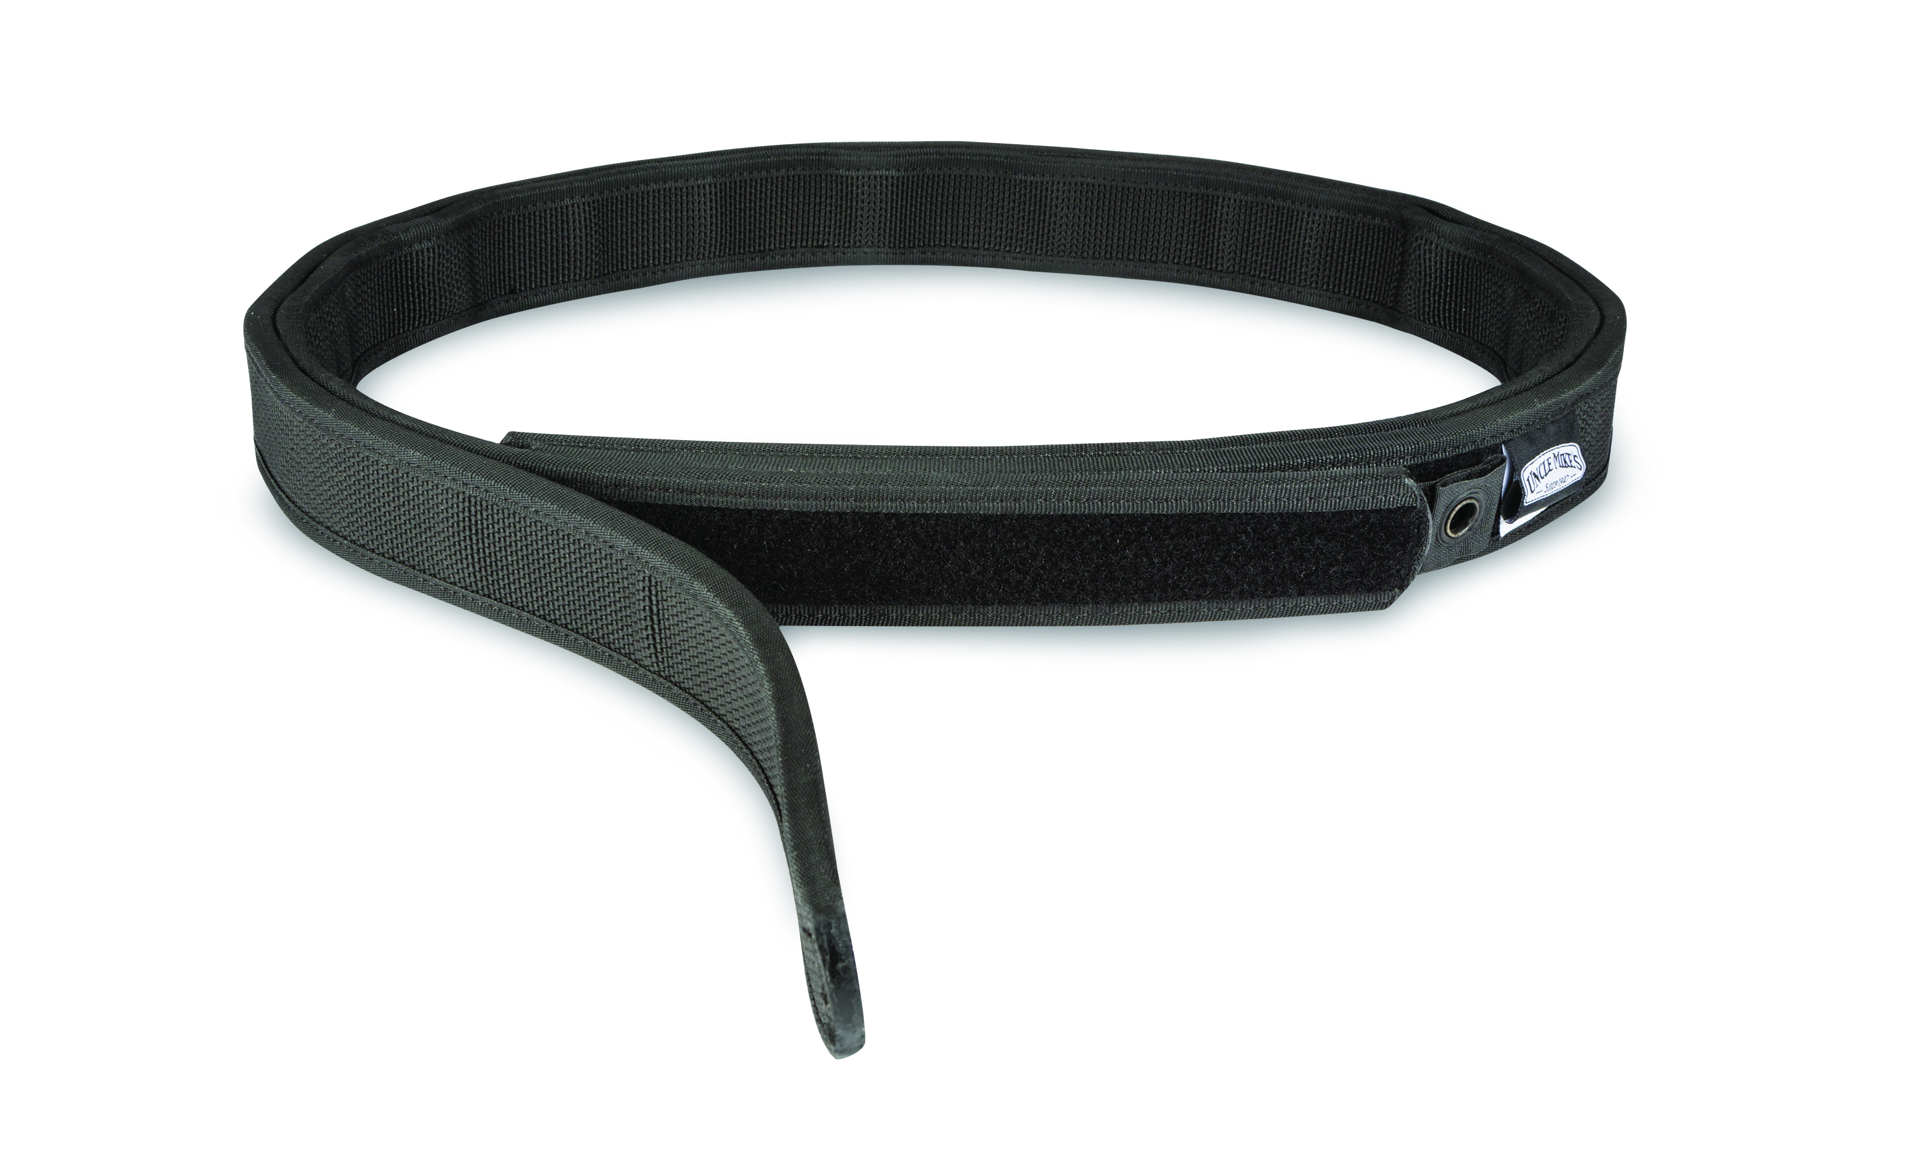
87714 Competition Belt-XXL 0 43699 87714 0 $28.95

