KASPA™ Tactical 3-12x44mm Mil/Mil Scope
Get spec ops performance at a price anyone can afford with the new Weaver® KASPA™ Tactical Series Mil/Mil riflescope. Featuring an Illuminated EMDR (Enhanced Mil-Dot Ranging) reticle, plus .1-mil click value adjustment, this scope is fully optimized for mil-dot ranging applications. The illuminated EMDR reticle is enhanced with hash marks at ½-mil increments as well as hollow dots that are .2-mil in diameter and feature a .1-mil open center. The reticle’s crosshairs offer a .2-by-.2-mil open subtension for easy target imaging. This advanced EMDR reticle rests within a rugged U.S. engineered design that offers crisp reset-to-zero, pull-up turrets and side focus parallax adjustment.

Features & Benefits
- EMDR reticle for tactical ranging needs
- Fully multi-coated lenses for edge-to-edge clarity
- Rugged one-piece tube construction
- Purged nitrogen-filled tube eliminates internal fogging
- Rugged 30mm tube
- Side-focus parallax adjustment for quick focus at any distance
- Illumination offers 11 intensity settings for easy visibility

Model No. Description UPC MSRP
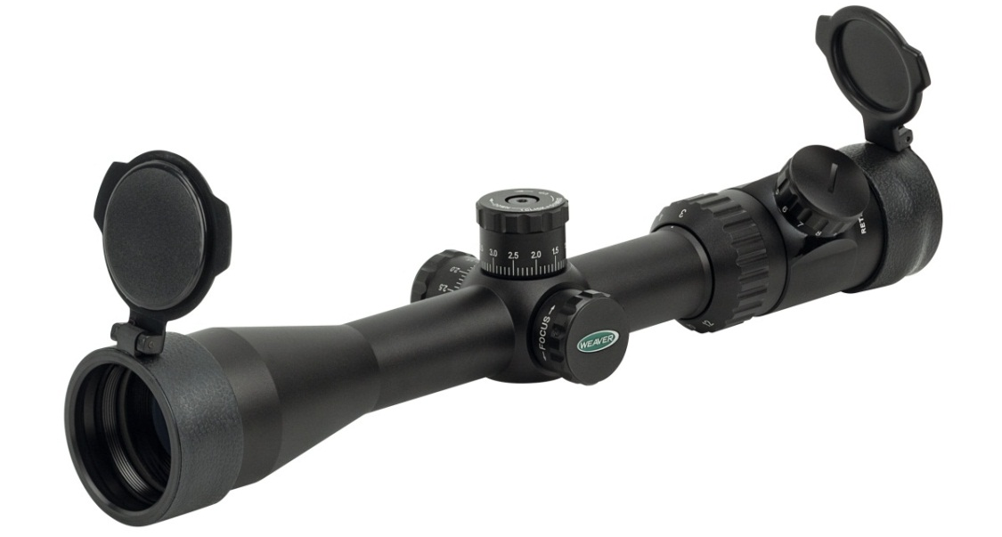
849821 KASPA Tactical 3-12x44mm Mil/Mil 0-76683-89821-0 $334.95

