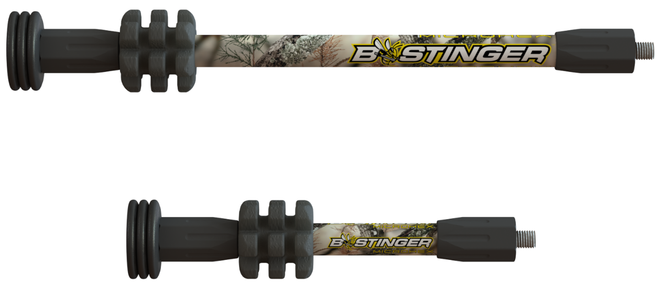
MicroHex Hunting Stabilizer

Micro Hex Hunting
You’re not into gimmicks, and neither are we. New for 2018, we introduce something the archery industry has never seen before. The Micro Hex, a wind-slicing micro-diameter stabilizer with Bee Stinger exclusive Countervail technology. Built with a layer of Countervail proprietary material right into the carbon bar – it may seem insignificant, but the data proves otherwise. Quicker damping and reduced recoil offer a smoother feel and quieter shot – without adding weight or sacrificing stiffness. Something you’ll appreciate when it’s time to send it.
- Countervail Technology- Dampens quick for less vibration
- Micro Diameter- Enhanced aiming for windy conditions
- Available in Matte Black, Lost XD, Realtree Xtra, Breakup Country, Sandstorm, Green & Red
- 6, 8, 10” lengths
- Counterslide Matte Black available in 10, 12 & 15”
- 3 Independent 1 oz end weights
- Fits all current Bee Stinger hardware mounts
- Available ATA 2018

MicroHex Stabilizer Line-Up

SKU | NAME | UPC | MSRP
MHX06BC | MicroHex 6” Breakup Country | 791331005818 | $74.99
MHX08BC | MicroHex 8” Breakup Country | 791331005825 | $84.99
MHX10BC | MicroHex 10” Breakup Country | 791331005832 | $94.99
MHX06GR | MicroHex 6” Green | 791331005849 | $74.99
MHX08GR | MicroHex 8” Green | 791331005856 | $84.99
MHX10GR | MicroHex 10” Green | 791331005863 | $94.99
MHX06XD | MicroHex 6” Lost XD | 791331008570 | $74.99
MHX08XD | MicroHex 8” Lost XD | 791331005887 | $84.99
MHX10XD | MicroHex 10” Lost XD | 791331005894 | $94.99
MHX06MB | MicroHex 6” Matte Black | 791331005900 | $69.99
MHX08MB | MicroHex 8” Matte Black | 791331008917 | $79.99
MHX10MB | MicroHex 10” Matte Black | 791331005924 | $89.99
MHX06RD | MicroHex 6” Red | 791331005931 | $74.99
MHX08RD | MicroHex 8” Red | 791331005948 | $84.99
MHX10RD | MircroHex 10” Red | 791331005955 | $94.99
MGX06SS | MicroHex 6” Sandstorm | 791331005962 | $74.99
MHX08SS | MicroHex 8” Sandstorm | 791331005979 | $84.99
MHX10SS | MicroHex 10” Sandstorm | 791331005986 | $94.99
MHX06XT | MicroHex 6” Xtra | 791331005993 | $74.99
MHX08XT | MicroHex 8” Xtra | 791331006006 | $84.99
MHX10XT | MicroHex 10” Xtra | 791331006013 | $94.99
MHXCS10MB | MicroHex Counter Slide 10” Matte Black | 7913311006020 | $134.99
MHXCS12MB | MicroHex Counter Slide 12” Matte Black | 791331006037 | $144.99
MHXCS15MB | MicroHex Counter Slide 15” Matte Black | 791331006044 | $154.99

