Legend® M Series
The new Legend M Series binoculars from Bushnell® take the Legend line to a whole new level with maximum brightness and clarity. Constructed on a lightweight, open-bridge magnesium chassis, these high-end 8x and 10x optics have 42mm objectives and provide 92 percent light transmission through the entire optical system using the very best dielectric prism coating. This coating reflects more than 99 percent of incoming light to allow for maximum light output at dusk and dawn. To push this technology to its highest level, Bushnell has paired it with ED Prime extra-low dispersion fluorite glass that brings out detail under low light, provides improved color resolution and contrast and practically eliminates chromatic aberration and color-fringing. Add in RainGuard® HD, improved eyecup resistance and a locking diopter, and the Legend M sets a new standard for maximum brightness, clarity and performance in the field.

Features & Benefits
- Dielectric prism coating assures high color reproduction
- Open-bridge design improves ergonomics and saves weight
- ED Prime glass provides amazing color resolution and contrast
- Locking eyepiece diopter
- Lightweight magnesium chassis for reliability in extreme environments
- RainGuard HD water-repellent coating allows continued use in wet weather
- Ultra Wide Band Coating is customized for every lens to allow maximum brightness and truer color across the light spectrum
- Lead-free glass

Part No. Description UPC MSRP
199842 Legend M Series 8x 42mm 0 29757 99842 2 $454.45
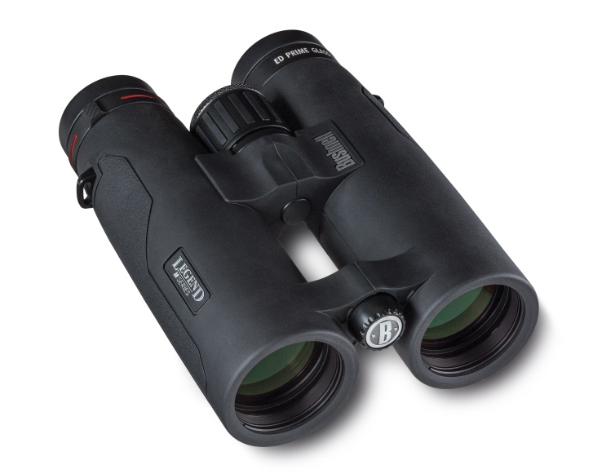
199104 Legend M Series 10x 42mm 0 29757 99104 1 $480.45

