PowerSync SolarWrap Mini-MAX
Charge your electronic devices anywhere you go. The new PowerSync™ SolarWrap Mini-MAX from Bushnell® is a solar-powered portable charging station that is lightweight and compact, yet durable for long-term reliability and performance. The unit quickly charges devices such as MP3 players, smartphones and cameras indoors and out. Unlike most solar devices, the SolarWrap Mini-MAX’s onboard battery holds a charge and continues to recharge in less than full sun. The unit is constructed with patented solar technology featuring amorphous silicon film. Unlike monocrystalline or polycrystalline solar technologies, the amorphous design is extremely lightweight, pliable and durable. Each solar cell operates independently, so damage to one cell won’t interrupt the performance of the device. In addition, PowerSync solar technology outperforms other solar platforms when full sunlight isn’t available. The device has an onboard, high-capacity lithium ion battery with a USB port for charging devices in the field, or charging the battery at home before you go. The onboard battery will recharge in 5 hours when plugged into a wall socket and will fully charge in 6 hours when using the solar panel in the sun. Each time the Mini-MAX is fully charged, it contains enough power to recharge a smartphone 1.25 times, MP3 player 2.5 times and a standard action camera three times.

Features & Benefits
- Amorphous silicon film with individual cells is durable yet pliable
- Compact, lightweight continuous roll for easy transport on the trail
- Clips to backpack for charging on the go
- Long-lasting lithium-ion battery built in to the unit
- 1x USB output and 1x Micro USB input
- 5-hour wall charge time; 6-hour sun charge time

Part No. Description UPC MRSP
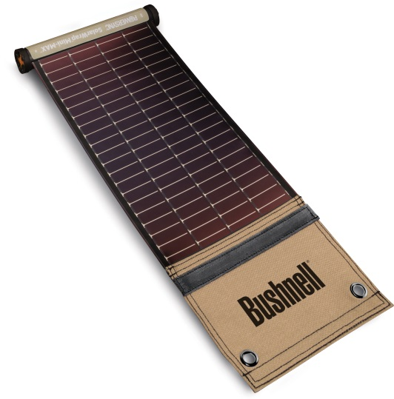
PP1015ML PowerSync SolarWrap Mini-MAX 0 29757 10170 9 $119.95

