SportZoom™ 8-24x 25mm
Bushnell’s new SportZoom binoculars put you in the game like never before. They allow you to see all the action with a wide view at 8x, but zoom up to 24x so you can read the quarterback’s lips in the huddle. The sleek, compact design can be stored in tight places and is great for packing along on outdoor adventures or bird watching treks. For sporting venues, they include a stadium-compliant clear carrying case and sharp, aggressive styling. They are available in eye-catching black, green and white.

Features & Benefits
- Unique zoom feature gives magnification from 8x to 24x
- Incudes stadium-compliant clear carry case
- Twist-up eye cups for comfort and use with eyeglasses

Part No. Description UPC MSRP
82425B 8-24x 25mm SportZoom, black 0 29757 82426 4 $194.95
82425G 8-24x 25mm SportZoom, green 0 29757 82424 0 $194.95
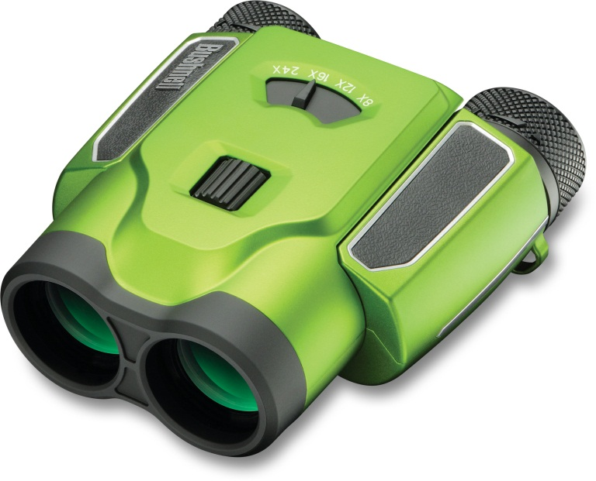
82425W 8-24x 25mm SportZoom, white 0 29757 82425 7 $194.95

