Stainless Steel High Output Single Burner Cooker
For boiling, brewing, frying, or whatever the job might be, this little stove has the power to get it done. Now you can use your favorite maximum output stove in humid and coastal climates without worrying about rust. The maximum output high-pressure burner system heats mass amounts of liquid in a hurry and will maintain it at boiling temperatures. It’s a great cooker for home canning, seafood boils, and brewing. Add this compact, powerful stove to your collection today.

Features & Benefits

- High output/High pressure
- Boils and heats water rapidly
- Removable/reversible legs for storage and portability
- Stainless steel construction to prevent rust
- Regulator and 3 ft. hose included
- Durable, rugged design built to last
- Cooking Area: 15" Diameter
- Output: 60,000 BTU

Part No. Description UPC MSRP
SHPRLSS Stainless High Output single cooker 0-33246-21435-1 $139.99

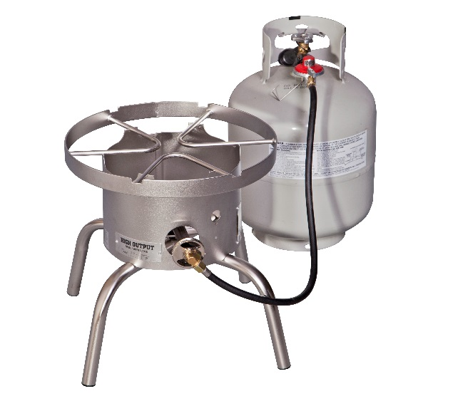

Stainless Steel Explorer
Enjoy the classic Explorer Two-Burner Stove, with a new build: stainless steel. Now you can use your favorite stove system in humid and coastal climates without worrying about rust. You get the same 30,000 BTU burners for cooking power and removable legs for portability. The new stainless steel design will look great on your back patio or the waterfront, wherever you need the Explorer to go. Bring the Explorer on your next adventure. As part of Camp Chef’s 14” cooking systems, the Explorer is versatile and can be equipped with many different Camp Chef accessories.

Features & Benefits

- Stainless steel construction
- Two 30,000 BTU cast-aluminum burners
- Three-sided windscreen
- Fully adjustable heat-control dials
- Removable/adjustable legs for storage/portability and setup on uneven ground
- Regulator and 3 ft. hose included for use with a bulk propane tank
- Out of the box, ready to cook in seconds
- Emergency preparedness recommended

Part No. Description UPC MSRP
EX60SS Stainless steel two-burner stove 0-33246-21392-7 $229.99
