SKU | NAME | UPC | MSRP
473115 | Forge Sport Dog Kennel | TBD | $349.99
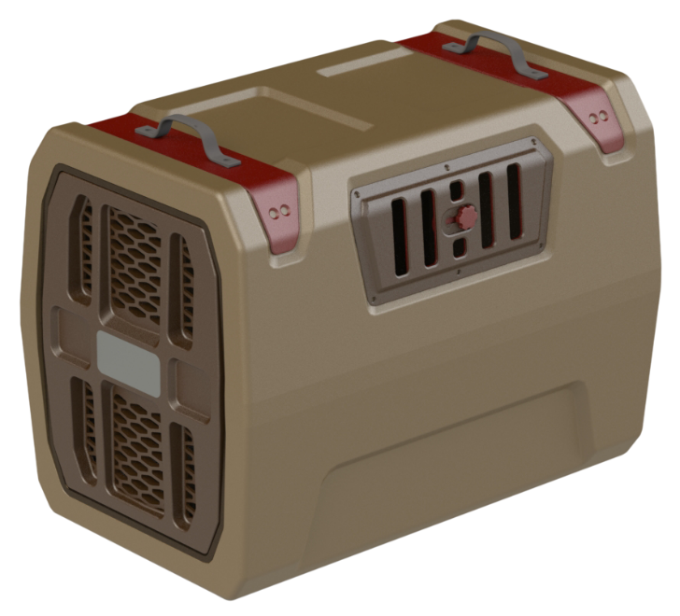
  - Single wall roto-molded construction​
  - High protection design​
  - Adjustable window vents​
  - Locking, escape proof door​
  - Clean out port​
  - Integrated tie downs

High quality kennel designed specifically for sporting dogs. Fills gap in the market between basic kennels designed for all dogs and premium sporting dog kennels. Further perpetuates FA as a premium waterfowl brand.
Forge Sport Dog Kennel

