SKU | NAME | UPC | MSRP
473204 | LiveCraft Floating Geese | TBD | $149.99
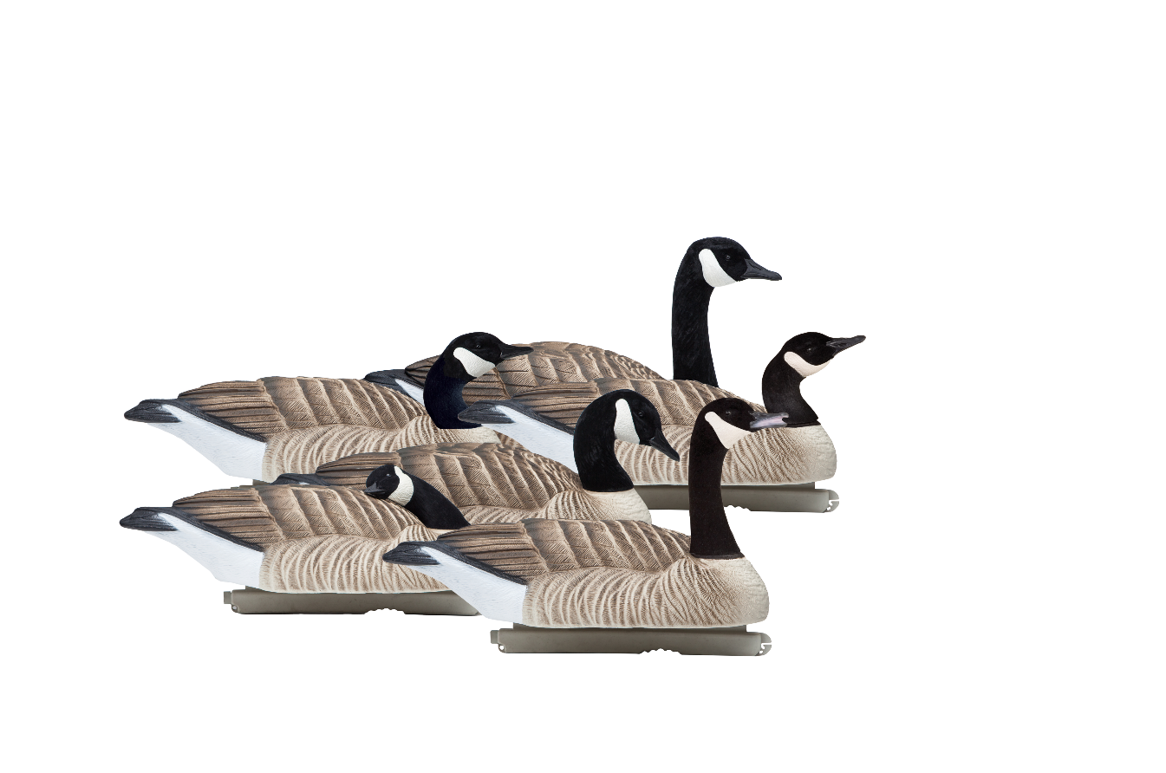
- Custom LiveCraft detailed carvings​
- Durable, realistic paint​
- Updated body material​
- Competitive price point

New LiveCraft floating Canadas to compliment the new Full Body Geese launched in 2017. The geese will have more detail added, a more realistic paint scheme and will be more durable due to a change in materials. Our current floating geese have not been updated in 10 years.
LiveCraft™ Floating Geese

