SKU | NAME | UPC | MSRP
473205 | Snow Goose Rags | TBD | $129.99
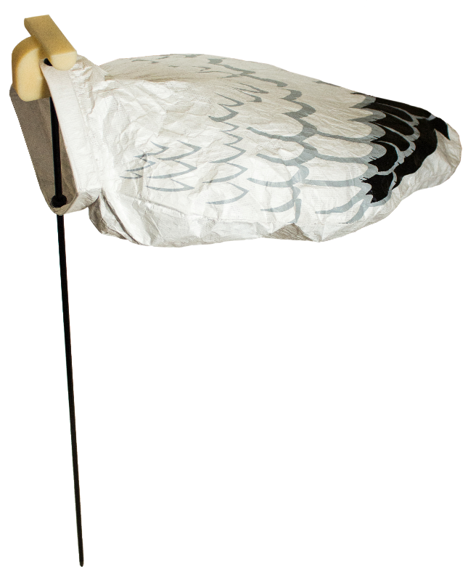
- Coated Tyvek material is easy to clean​
- Integrated, collapsible stake​
- 25 pack

Snow goose rags to fill out your spread when snow goose hunting. Completes FA field decoy offering Box of 25.

Snow Goose Rags

