SKU | NAME | UPC | AVG RETAIL
PS2910 | 3-N-1 Locator Call | 0-1013502910-4 | $15.95
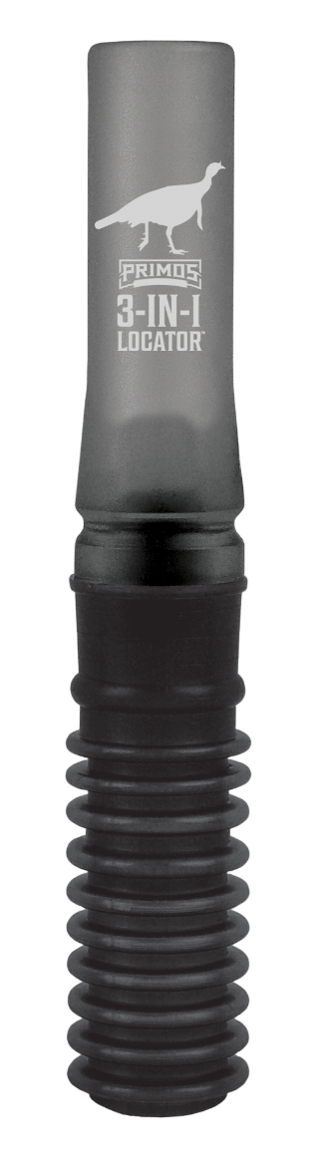
- Produces all three sounds from one call
- Able to pull gobbles out of pressured birds
- Pileated wood pecker calling is highly effective in eastern US
- Mimicking coyote sounds is highly effective in all parts of the country
- Available 5/1/19

The shrill cries of peacocks, pileated wood peckers, and coyotes are well known for driving gobblers crazy. Use the 3-N-1 Locator to produce any of these sounds and gobblers won’t be able to resist giving away their location. The 3-N-1 is Locator will pull a gobble out of even the most pressured birds. This easy-to-use call will help you find birds you would otherwise never know were near.

3-N-1 Locator Call

