Q&A: Primos Custom Mill Shop
A Discussion with Primos Call Shop Manager Anthony Foster
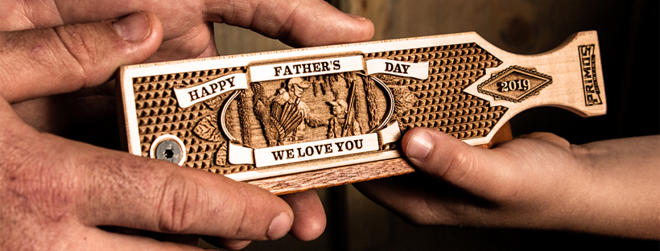
Primos Hunting, a leading innovator of game calls and accessories, recently launched an online Custom Mill Shop that allows hunters – or their family and friends – to order custom, personalized high-performance Primos Box Calls directly from Primos woodworks in Mississippi. The new online Custom Mill Shop can be found at https://www.primos.com/custom-mill-shop. There, users can design a customized, high-grade version of the original Primos Heart Breaker box call. From that proven base, users can select either Maple or Cherry lids, custom patterns and laser-etched hunting scenes, as well as custom inscriptions and messages. And while these calls are works of art worthy of display, they also produce a sound that only the finest, select, hand-tuned hardwoods can create.
Interview with Anthony Foster
Q: Tell us a little bit about the quality of this box call. What box call are we using here for a custom box call?
A: This particular box is originally the Heart Breaker series, the Little Heart Breaker to be exact. We've made some changes to it over the years from the original Heart Breaker. It was originally a purple heart lid on it. With this being a custom box – and the amount of engraving we're taking out of the box—we needed the weight on the lid to be just right (we're removing a lot of weight from the lid), so we changed some things internally in the box to give it the correct sound. It's basically the Little Heart Breaker with a Sapele box and a maple lid or a cherry lid, depending on what they choose. Both of them have somewhat the same properties. Cherry is a little bit heavier on some of the ones we've tested, but the sound is there from the front note to the back. Trying to control the early note and the late note is the most important thing. It's a $150 call, so it needs to sound amazingly good. You don't want it to be pretty, but sound horrible, so that was the whole focus behind it.
Q: So, most people are going to keep this on their shelf, but you built a call that can go in the woods?
A: We want it to go in the woods, definitely. We really don't let anything leave this shop that's not a usable hunting tool. I bet you several people take it and kill a bird with it, mark it and put it up on a shelf with a picture. That's what I would do. I might put a little notch in it somewhere and stick it on the shelf and show my one bird in the picture.
Q: Is there anything special in the process that you’d like to mention when we're talking about the custom box call manufacturing itself?
A: The amount of artwork—the detail— that goes into it. Chris Hall does an amazing job of hand-sketching the detail out of turkeys. We pioneered this on the laser to be able to do this, but it's not just as simple as push a button and it runs it. Each one of these logos and scenes that we're going to offer up on our website to add to a box call, it's exclusively artist drawn. We're doing that here in our building. Our graphic designer Brad Johnson provides the scene and the inspiration, and Chris Hall is sitting there hand-sketching every little feather and every little detail.
Q: So, it's not as simple as just scanning some picture off the internet and throwing it on the laser, because there's more that has to be done for art to translate to a good engraving?
A: There's some 40 hours worth of work in this artistic work. You're dealing with a grayscale that starts from the lightest white to the darkest black, and you may have 400 different scales of gray in order to form the arches and the shapes in the logos. Chris has to hand-sketch every single one of those little basket weaves, every feather on that turkey, and every little detail.
Q: How many different people touch the custom box call from the moment the person orders it to the moment it goes in the box?
A: It starts as a block of wood, so we're grading the lumber, which is the first person. Then, it goes to our router department where it gets cut. Once it's cut to scale, it goes to our shaping line. Then it goes to our slicking line. It goes to our buff line. Then, a fine check line, which is where we make sure that all the sanding is done before going to spray booth. From the spray booth, it comes in to assembly, and it's matched with a lid. From there, it goes to tuning, where each tuner tunes every call. From there, it goes to the laser engraving department in order to be engraved.
Q: How many different points of inspection does this go through?
A: The way we operate here, every single employee is an inspection point. We don't want anything making it too far down the assembly line prior to inspection. So from the grading of the lumber, to the guys that chop the saw, to the guy on the router that's looking for knots and defects, to the very first guy on the line that picks it up, all of them, their first job is to rotate it around and look at it and make sure there's no chips or defects. We do that all throughout the process.
Q: Okay. What does it mean when somebody signs this certificate of authenticity? What does that stand for?
A: You know, we're kind of looked at sometimes as a high-production company. But we want customers to understand that every single call we have in our facility is made by experienced craftsmen. I couldn't even tell you the combined amount of experience in this building. We have so many years of experience making sure the quality is there that I can’t even add it up. And when it makes it to your tuners, our Master Craftsmen, we want them to stamp it. They stamp it underneath the bottom. That is a Craftsman’s Mark. Even then, it’s still followed up by another checkpoint. And that final checkpoint—
before we know that the customer will actually put it in his hand and take it on a hunt— we're going to do an inspection and make sure that the notes are right, the sanding is right, there's nothing that we might have missed, or that it somehow along the way just slipped into a call that just isn't what we consider perfect. That’s the final test.

