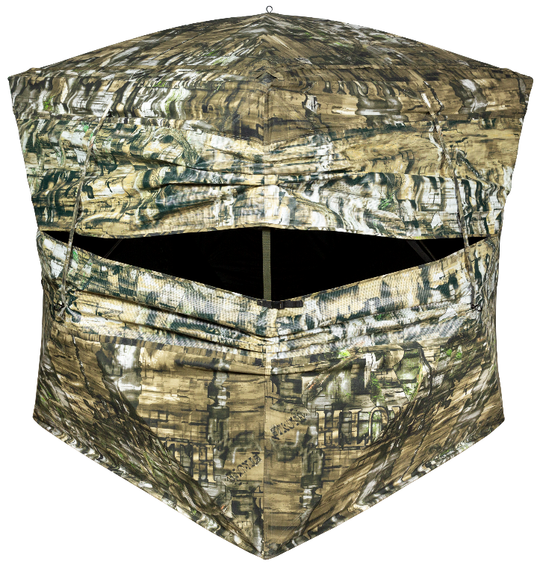
SKU | NAME | UPC | MAP
65162 | Double Bull SurroundView Double Wide Ground Blind | 0-10135 65162-6 | $499.99
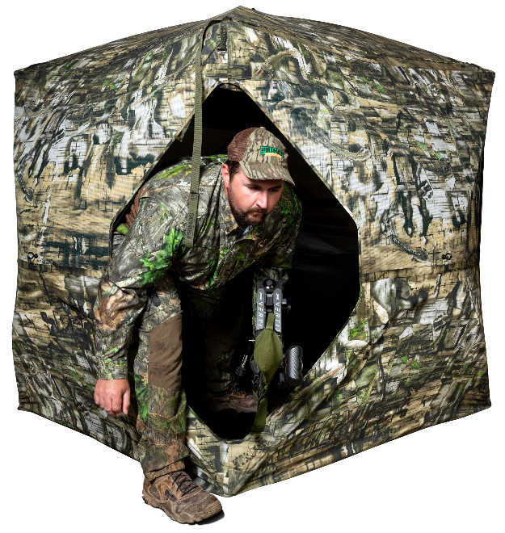
dOUBLE WIDE DOOR

The new Double Bull SurroundView Double Wide brings two of the best features to hit the ground blind market into one product; a 300° viewing capability utilizing our SurroundView material with the Double Wide door for quiet and easy entry and exit. Rounding off this blind with a built-in sun visor for early morning and late evening hunts and a limited lifetime warranty; this blind is a must have!
- Double Wide Door for silent entry and exit
- 180° Full front window with silent slide window closures
- 300° View with Sun Visor
- Limited Lifetime Warranty
- Hub to Hub: 70”; Height: 70”; Floor Space: 60”x 60”

Double Bull SurroundView™ Double Wide
Ground Blind

