SKU | NAME | UPC | AVG RETAIL
PS2960 | Foggy Bottom Box | 0-1013502960-9 | $49.45
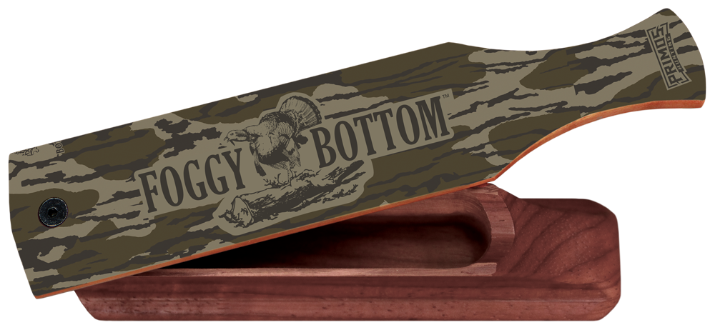
The Foggy Bottom™ Box Call with Mossy Oak Original Bottomland Camouflage is a double-sided box call that gives you the ability to sound like two different hens. This call is great for yelps, cuts, clucks and even purrs. The Foggy Bottom Box call is a new extension to our series of Foggy Bottom Pot calls and snuff tube call. This could be a great addition to your collection for all Mossy Oak Bottomland fanatics!

- Double-sided box call with two different tones
- Tuned and assembled by hand
- Decorated in Mossy Oak Original Bottomland
- Available 12/1/19

Foggy Bottom Box

