Heartbreaker Grand Slam Series Box Call
Primos® introduces the Grand Slam Series Heartbreaker Osceola Edition. It is the second in a four-year limited edition collection that features the four Grand Slam turkey subspecies. The 2015 edition features the Osceola wild turkey.

This limited edition series of 1,200 numbered and individually signed calls by founder Will Primos is hand-crafted from the finest hardwoods. The 2015 box call features a custom-engraved scene paying homage to the Osceola subspecies. The Heart Breaker Grand Slam Series will feature the Rio Grande in 2016 and Merriam subspecies in 2017.

Features & Benefits
- Single-sided Heartbreaker Box
- 3D laser engraved scene depicting the Osceola wild turkey
- Single billet box construction
- Crisp yelps and cuts
- Individually signed and numbered by Will Primos
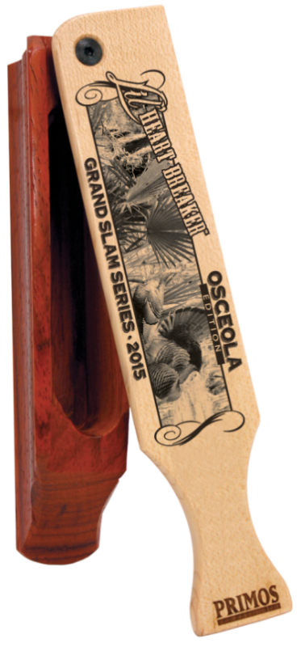
- Limited run of 1,200 calls

Part No. Description UPC MSRP
284 Grand Slam Box Call-Osceola 0-10135-00284-8 $69.95

