Primos TSS JellyHead Choke Tubes
SKU | NAME | UPC | Retail
69414 | TSS JellyHead Remington 12 GA | 0-10135-69414-2 | $79.99
69417 | TSS JellyHead Benelli/Beretta 12 GA | 0-10135-69417-3 | $79.99
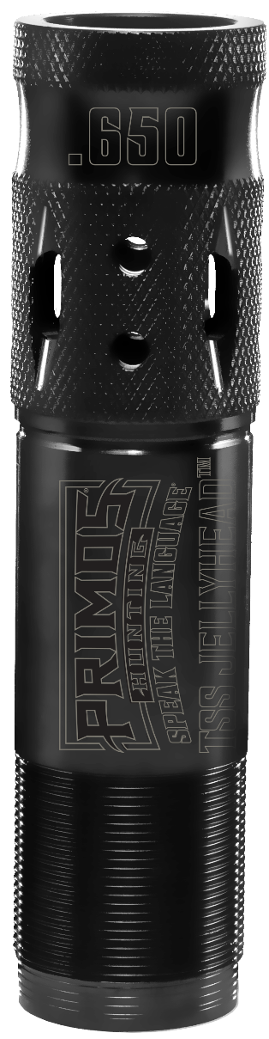
- Clean the threads in the muzzle and on the JellyHead TSS choke tube before installing. Use a good choke tube grease to coat the threads before installing.
- Screw the tube into the muzzle, be careful to not cross-thread. Grip the knurled end and hand-tighten only. No tools needed.
- DO NOT OVER TIGHTEN.
- Check tightness of tube every 3 to 5 shots to ensure a tight fit.
- Not to be used with Steel Shot.
Specifically designed for TSS loads that have become very popular with turkey hunters but will also shoot super tight patterns with HEVI-Shot, Copper Plated and Lead Shot. This extended choke tube allows for easy installation without the use of tools. ​

