SKU | NAME | UPC | MSRP
PS821 | Bottonlamd Wench | 0-1013500821-5 | $20.99
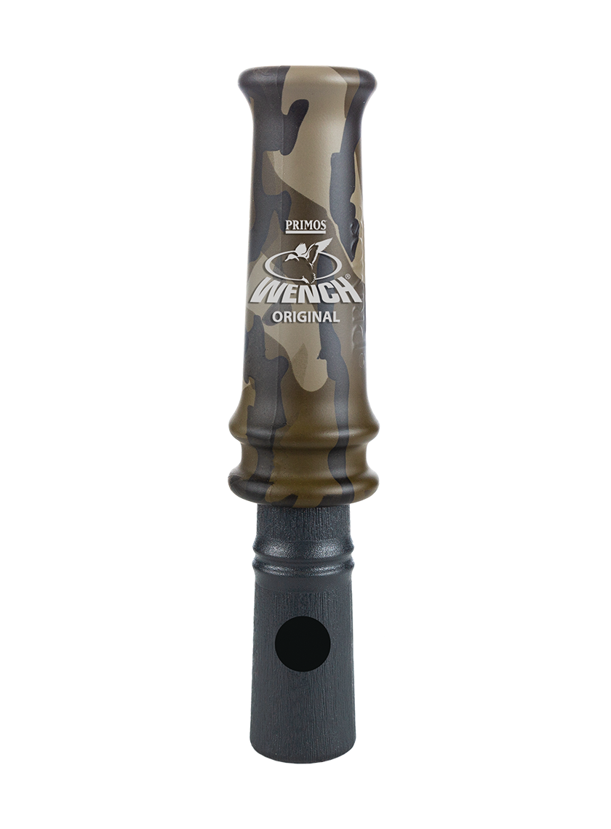
Wench® style duck calls have the patented “Tone Ridges” and “Tuning Ditches” on the sounding board which keep the reeds from sticking or freezing while giving the call its raspy highs and lows. The patented reed relocation system lets you take the call apart for cleaning and put it back together correctly every time. The internal parts are molded from graphite, the ideal sound conductor, giving the Wench® its unique pitch and range of tones.

In addition to ridges and ditches, the Original Wench® features a tuning hole in the bell or stopper, which allows you to change the pitch of the call and sound like two different ducks. Covered, the call is lower in pitch and uncovered it is higher. Perfect for timber and open water calling. You won’t be disappointed.

- Mossy Oak® Bottomland Camo
- Tuning hole in stopper/bell allows you to vary pitch. Covered, the pitch is lower; uncovered, the pitch is higher
- Super-hard polycarbonate barrel for intense volume
- The economical choice for any waterfowl hunter who seeks accuracy and versatility
Bottomland Wench

