Mewie Grande™ Micro Cow Call
Small in size but not in stature, the Mewie Grande is a compact open reed call with an enhancer that produces phenomenal range in tone and volume. From soft and mellow mews and chirps to louder more aggressive cow calls, the little Mewie Grande brings big bulls into range regardless of the distance.

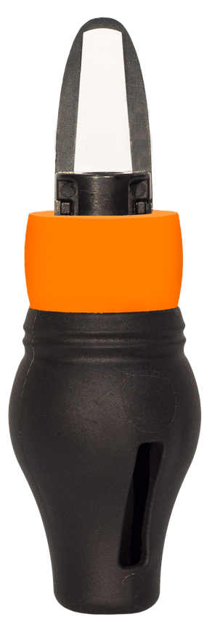
SKU | NAME | UPC | MSRP
950 | Mew Grande Micro Cow Call | 0-10135-00950-2 | $12.99
- Compact size
- Enhancer allows soft to loud calling range
- Easy to blow with little air pressure
- Can also be used hands-free

