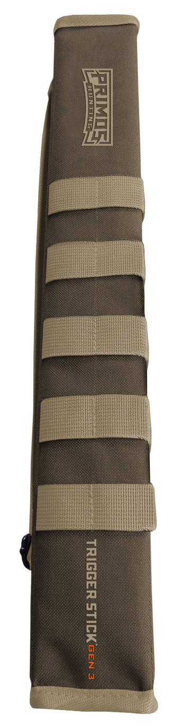
Trigger Stick Scabbard
SKU | NAME | UPC | MSRP
65819 | Trigger Stick Short Scabbard | 0-10135-65819-9 | $14.99
65820 | Trigger Stick Tall Scabbard | 0-10135-65820-5 | $19.99
- Hands free while walking in and out of woods​
- Protects Trigger Stick both while hunting and during storage
Two SKU's: 1 for Short Trigger Sticks; 1 for Tall Trigger Sticks. Allows user to protect and carry Trigger Stick over your shoulder with a sling or attach to belt or backpack with use of molle. Will also include pocket(s) to store Trigger Stick accessories. ​

