GAME LOADS
No matter your pursuit, Game Loads level the equation with small game-stopping surety. Available in a selection of gauges, and .410 bore, and lead shot size options ranging from BB's all the way down to #9.
FEATURES
• Available in 12, 16 and 20 gauge and various shot sizes
• Suitable for everything from quail to farm predators
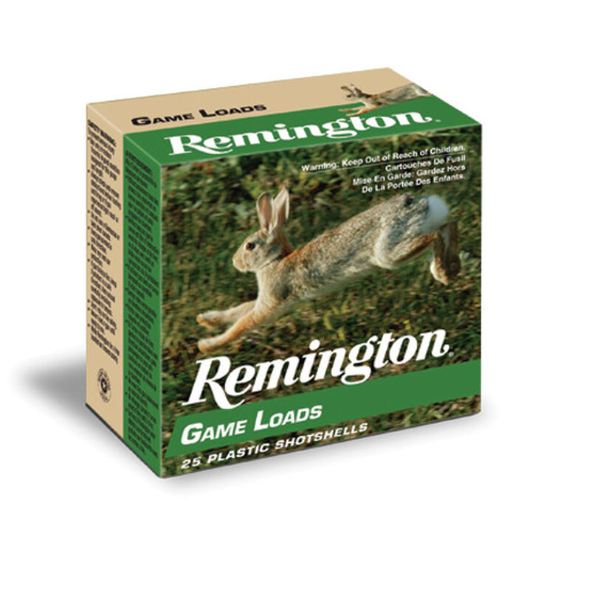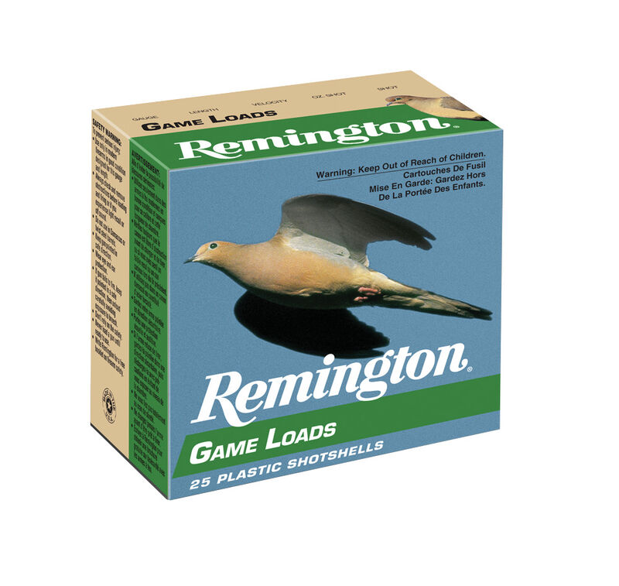
ORDER # | DESCRIPTION | UPC | MSRP
20028 | 12GA 2-3/4IN 1OZ 6 | 0-47700-03960-2 | $12.99
20030 | 12GA 2-3/4IN 1OZ 7.5 | 0-47700-03970-1 | $12.99
20032 | 12GA 2-3/4IN 1OZ 8 | 0-47700-03980-0 | $12.99
20034 | 16GA 2-3/4IN 1OZ 6 | 0-47700-03990-9 | $18.99
20036 | 16GA 2-3/4IN 1OZ 7.5 | 0-47700-04000-4 | $18.99
20038 | 16GA 2-3/4IN 1OZ 8 | 0-47700-04010-3 | $18.99
20040 | 20GA 2-3/4IN 7/8OZ 6 | 0-47700-04020-2 | $12.99
R20042 | 20GA 2-3/4IN 7/8OZ 7.5 | 0-47700-04030-1 | $12.99
20044 | 20GA 2-3/4IN 7/8OZ 8 | 0-47700-04040-0 | $12.99
R20014 | 410GA 2-1/2IN 1/2OZ 6 | 0-47700-15250-9 | $17.99

