SPORTSMAN HI-SPEED STEEL

All the dependability and performance you'd expect from Remington ammunition without breaking the bank. Sportsman® Hi-Speed® Steel's sealed primer, high quality steel shot, and consistent muzzle velocities combine to provide reliability in adverse weather, while delivering exceptional pattern density and retained energy. An economical, high-speed steel load that's ideal for short-range high-volume shooting during early duck seasons, or over decoys.
FEATURES

- High-quality steel shot
- Consistent muzzle velocities and exceptional pattern density
- Sportsman® Steel works equally well in upland situations that require the use of non-toxic shotshells

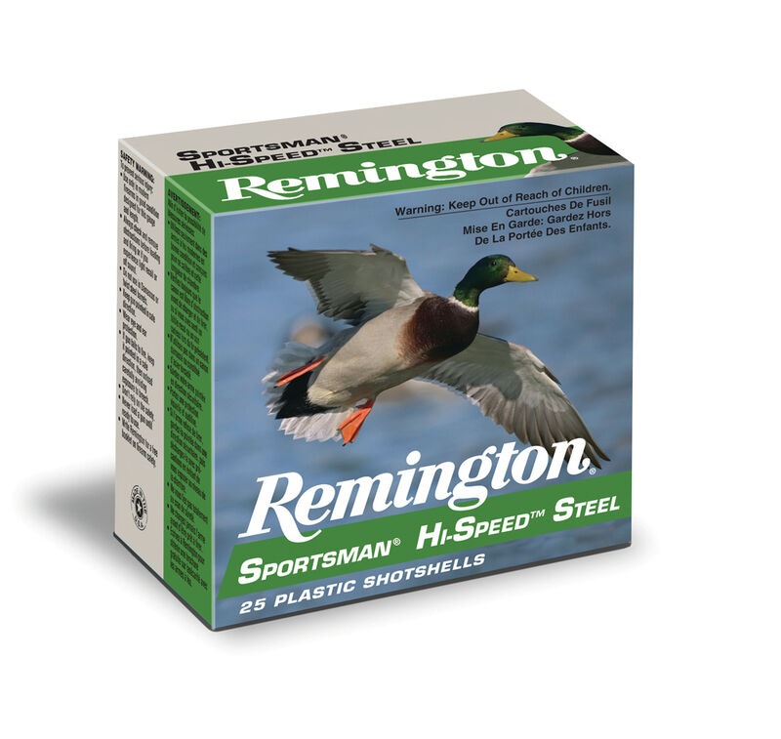

ORDER # | DESCRIPTION | UPC | MSRP
R20904 | 12GA 3IN 1-3/8OZ 2 | 0-47700-31700-7 | $24.99
20936 | 12GA 2-3/4IN 1-1/8OZ 4 | 0-47700-31260-6 | $22.99
20977 | 12GA 3IN 1-1/8OZ 2 | 0-47700-33070-9 | $24.99
R20009 | 20GA 2-3/4IN 3/4OZ 7 | 0-47700-31300-9 | $19.99
20991 | 12GA 3IN 1-1/4OZ 4 | 0-47700-33110-2 | $24.99
20989 | 12GA 3IN 1-1/4OZ 2 | 0-47700-33100-3 | $24.99
20900 | 12GA 3IN 1-3/8OZ BB | 0-47700-31690-1 | $24.99
26607 | 10GA 3-1/2IN 1-3/8OZ 2 | 0-47700-33991-7 | $51.99
20934 | 12GA 2-3/4IN 1-1/8OZ 2 | 0-47700-31250-7 | $22.99
20997 | 12GA 3-1/2IN 1-3/8OZ BB | 0-47700-33120-1 | $34.99
R20007 | 12GA 2-3/4IN 1OZ 7 | 0-47700-31290-3 | $19.99
20881 | 20GA 3IN 1OZ 4 | 0-47700-52690-4 | $21.99
20973 | 12GA 3IN 1-1/8OZ BB | 0-47700-33060-0 | $24.99
20879 | 20GA 3IN 1OZ 2 | 0-47700-52680-5 | $25.99
20999 | 12GA 3-1/2IN 1-3/8OZ 2 | 0-47700-33130-0 | $34.99
20005 | 12GA 2-3/4IN 1OZ 6 | 0-47700-31280-4 | $19.99
20981 | 12GA 3IN 1-1/8OZ 4 | 0-47700-33080-8 | $24.99
20987 | 12GA 3IN 1-1/4OZ BB | 0-47700-33090-7 | $24.99
20791 | 12GA 3IN 1-1/4OZ 1 | 0-47700-34111-8 | $24.99
R26605 | 10GA 3-1/2IN 1-3/8OZ BB | 0-47700-33980-1 | $51.99
20795 | 12GA 3IN 1-1/4OZ 3 | 0-47700-34131-6 | $24.99

