UMC RIFLE

Value-priced for high-volume shooting, our UMC centerfire rifle ammunition is made right here in the USA and available in 10 popular cartridges, including the 308 Win, 300 AAC Blackout and 30 Carbine. And for all the varmint hunters out there, the 45 and 50-grain jacketed hollow point loads in 223 Remington and 22-250 Remington are ready to deliver. UMC centerfire is also available in 6.8mm Remington SPC, 30-06 SPRG, 303 British and now the 450 Bushmaster. More value. More performance. It’s a win-win situation.
FEATURES

- Optimized for high volume shooting
- Performs choice of either FMJ or JHP in several popular calibers

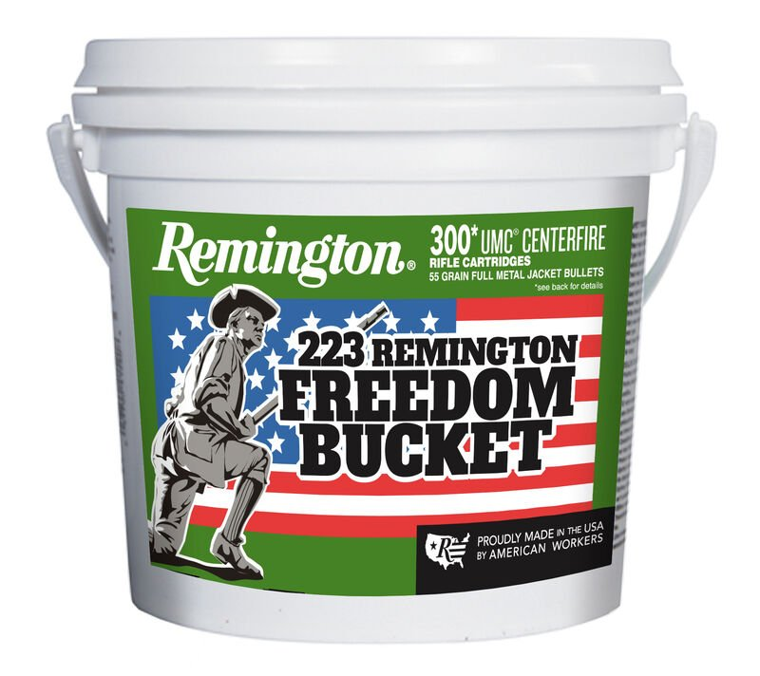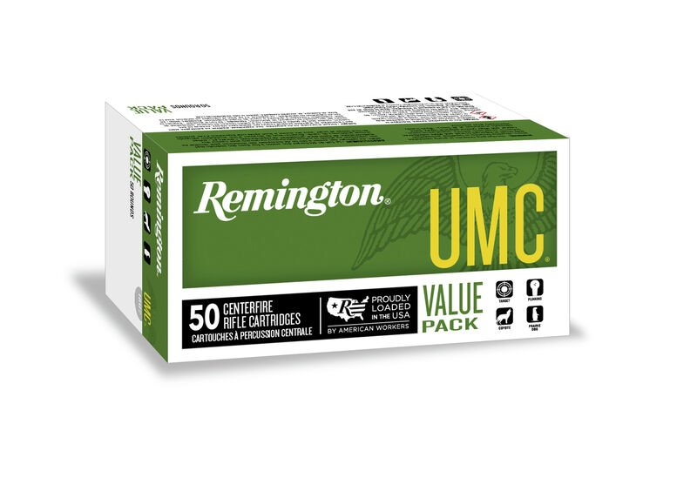

ORDER # | DESCRIPTION | UPC | MSRP
23711 | 224 REM 55GR FMJ | 0-47700-06700-1 | $19.99
23748 | 223 REM 45GR JHP | 0-47700-35450-7 | $29.99
23812 | 223 REM 50GR JHP | 0-47700-38570-9 | $29.99
23750 | 22-250 REM 45GR JHP | 0-47700-35460-6 | $34.99
23813 | 22-250 REM 50GR JHP | 0-47700-38580-8 | $34.99
R24035 | 6.8 REM SPC 115GR FMJ | 0-47700-40610-7 | $31.99
23712 | 30 CARBINE 110GR FMJ | 0-47700-06710-0 | $57.99
23715 | 308 WIN 150GR FMJ | 0-47700-06720-9 | $37.99
23699 | 30-06 SPRG 150GR FMJ | 0-47700-17070-1 | $33.99
21422 | 300 AAC BLACKOUT 220GR OTFB | 0-47700-41480-5 | $35.99
26854 | NEW 300 AAC BLACKOUT 150GR FMJ | 0-47700-48640-6 | $35.99
23701 | 303 BRITISH 174GR FMJ | 0-47700-17080-0 | $37.99
23661 | 450 BUSHMASTER 260GR FMJ | 0-47700-47910-1 | $32.99
23769 | 22-250 REM 45GR JHP – 40 COUNT | 0-47700-36310-3 | $70.99
23783 | 22-250 REM 50GR JHP – 40 COUNT | 0-47700-38480-1 | $70.99
23971 | 308 WIN 150GR FMJ – 40 COUNT | 0-47700-40310-6 | $75.99
23906 | 223 REM 45GR JHP | 0-47700-47030-6 | $74.99
23908 | 223 REM 50GR JHP – 50 COUNT | 0-47700-47040-5 | $74.99
R23966 | 223 REM 55GR FMJ | 0-47700-39840-2 | $48.99
23683 | 223 REM 55GR FMJ – 200 COUNT | 0-47700-39810-5 | $195.99
23897 | 223 REM 55GR FMJ – 300 COUNT | 0-47700-47140-2 | $293.99
23895 | 223 REM 55GR FMJ – 1000 COUNT | 0-47700-47021-4 | $978.99
24026 | 300 AAC BLACKOUT 220GR OTFB – 50 COUNT | 0-47700-49010-6 | $80.99
26855 | 300 AAC BLACKOUT 150GR FMJ – 50 COUNT | 0-47700-48650-5 | $89.99
23775 | 223 REMINGTON 45GR JHP – 200 COUNT | 0-47700-36450-6 | $298.99
20107 | 300 AAC BLACKOUT 150GR FMJ – 200 COUNT | 0-47700-48750-2 | $358.99
26857 | NEW 300 AAC BLACKOUT 150GR FMJ | 0-47700-48660-4 | $286.99
20111 | NEW 300 AAC BLACKOUT 220GR OTFB – 160 COUNT | 0-47700-48744-1 | $286.99
20109 | NEW 300 AAC BLACKOUT 220GR OTFB – 200 COUNT | 0-47700-48760-1 | $358.99

