For Media Inquiries:
Willie Vernon
Senior Director of Marketing
willie.vernon@vistaoutdoor.com

Blackhawk™ Releases Knife Collaboration with Custom Knifemaker Andrew Arrabito
Blackhawk has announced its latest product to arrive on the market: a line of five blades designed by custom knifemaker Andrew Arrabito, a former Navy SEAL (ret.) most well-known as the founder of Half Face Blades™.
The line of blades consists of a Combat Filet, EDC, Field Knife, Karambit, and Combat Dagger with very limited quantities – only 10 per style – available for sale during the initial launch. Customers wishing to purchase one of these limited blades can do so directly through www.blackhawk.com as of Wednesday, May 29 at 10:00AM Eastern Time.
The blades are made from CPM ® (Crucible Particle Metallurgy) 154CM steel with a Rockwell steel hardness of 59-60 HRC. Each blade varies in length and all feature a stone-washed finish with skeletonized black G10 textured grips and full tang construction. One side of the blade is etched with the Blackhawk trident logo while the other is etched with Andrew Arrabito’s name, marking these knives as part of this exclusive collaboration. Included with each knife is a friction-fit sheath.
For additional details and to purchase one of these Blackhawk + Andrew Arrabito knives, visit www.blackhawk.com.
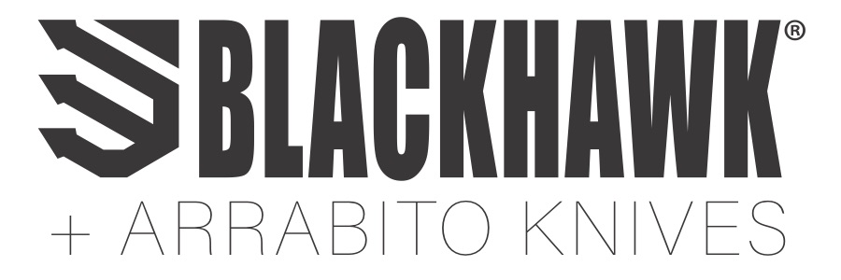
In 1990, a Navy SEAL was navigating a minefield when his pack failed. As his gear tumbled to the ground, he vowed that if he got out of there alive, he would make gear the right way. Today, this obsession with quality applies to everything we do. We’re constantly researching, refining and perfecting every detail to provide gear that won’t let you down. Because we’re not just making stuff. We’re honoring a vow.

