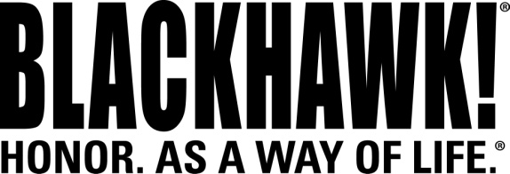

2014 NEW Products
Holsters

Coyote Tan SERPA® CQC® Concealment Holsters
Featuring a unique speed-cut design, the BLACKHAWK!® CQC® Holster has forged a strong reputation for a fast, smooth draw and easy re-holster without slowing you down. The patented SERPA Auto Lock™ release delivers unparalleled weapon security and is automatically positioned to facilitate a correct drawing motion, making it the perfect Level 2 retention holster for concealed carry. New for this year, BLACKHAWK!® adds six models with Coyote Tan finish to increase style, concealment under light clothing and to match your other tan gear.

Features & Benefits
- Coyote Tan color to match other tactical gear
- Passive retention detent adjustment screw and SERPA® Auto Lock™ release
- Reinforces full master grip and superior draw technique
- Immediate retention and audible click upon re-holster for security
- Speed-cut design allows rapid draw, target acquisition and re-holster while keeping eyes on target
- Includes belt loop and paddle platform
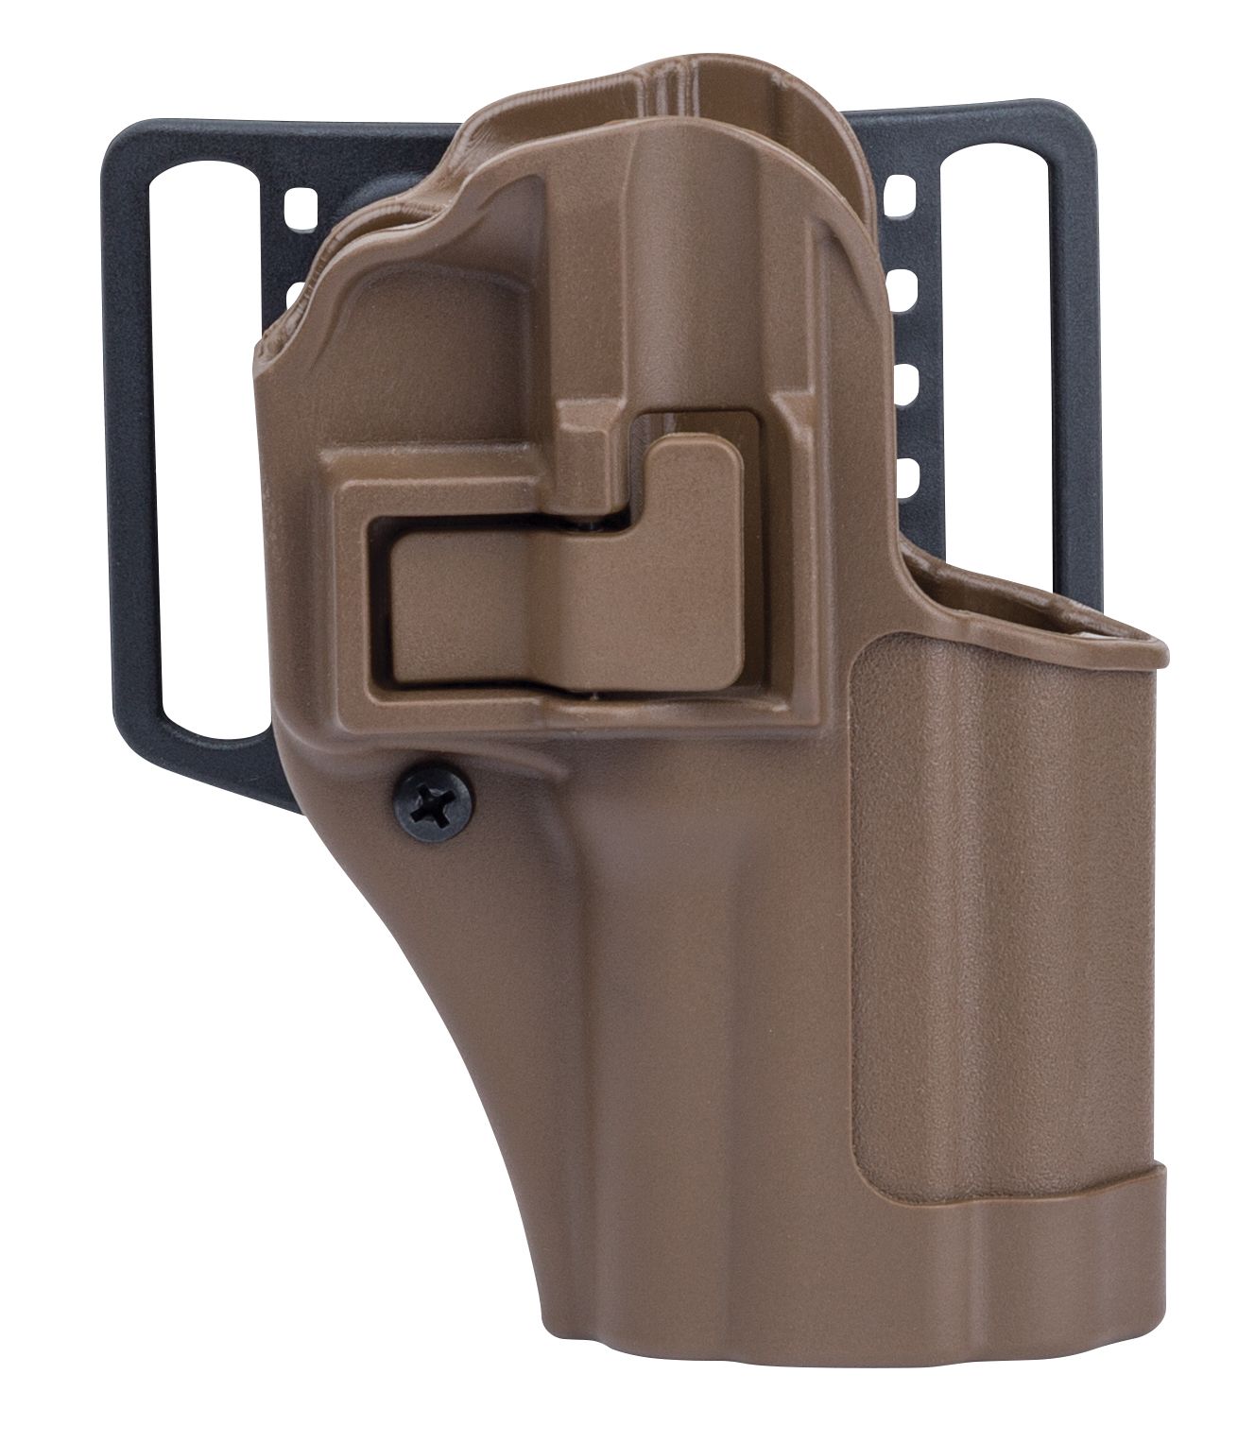

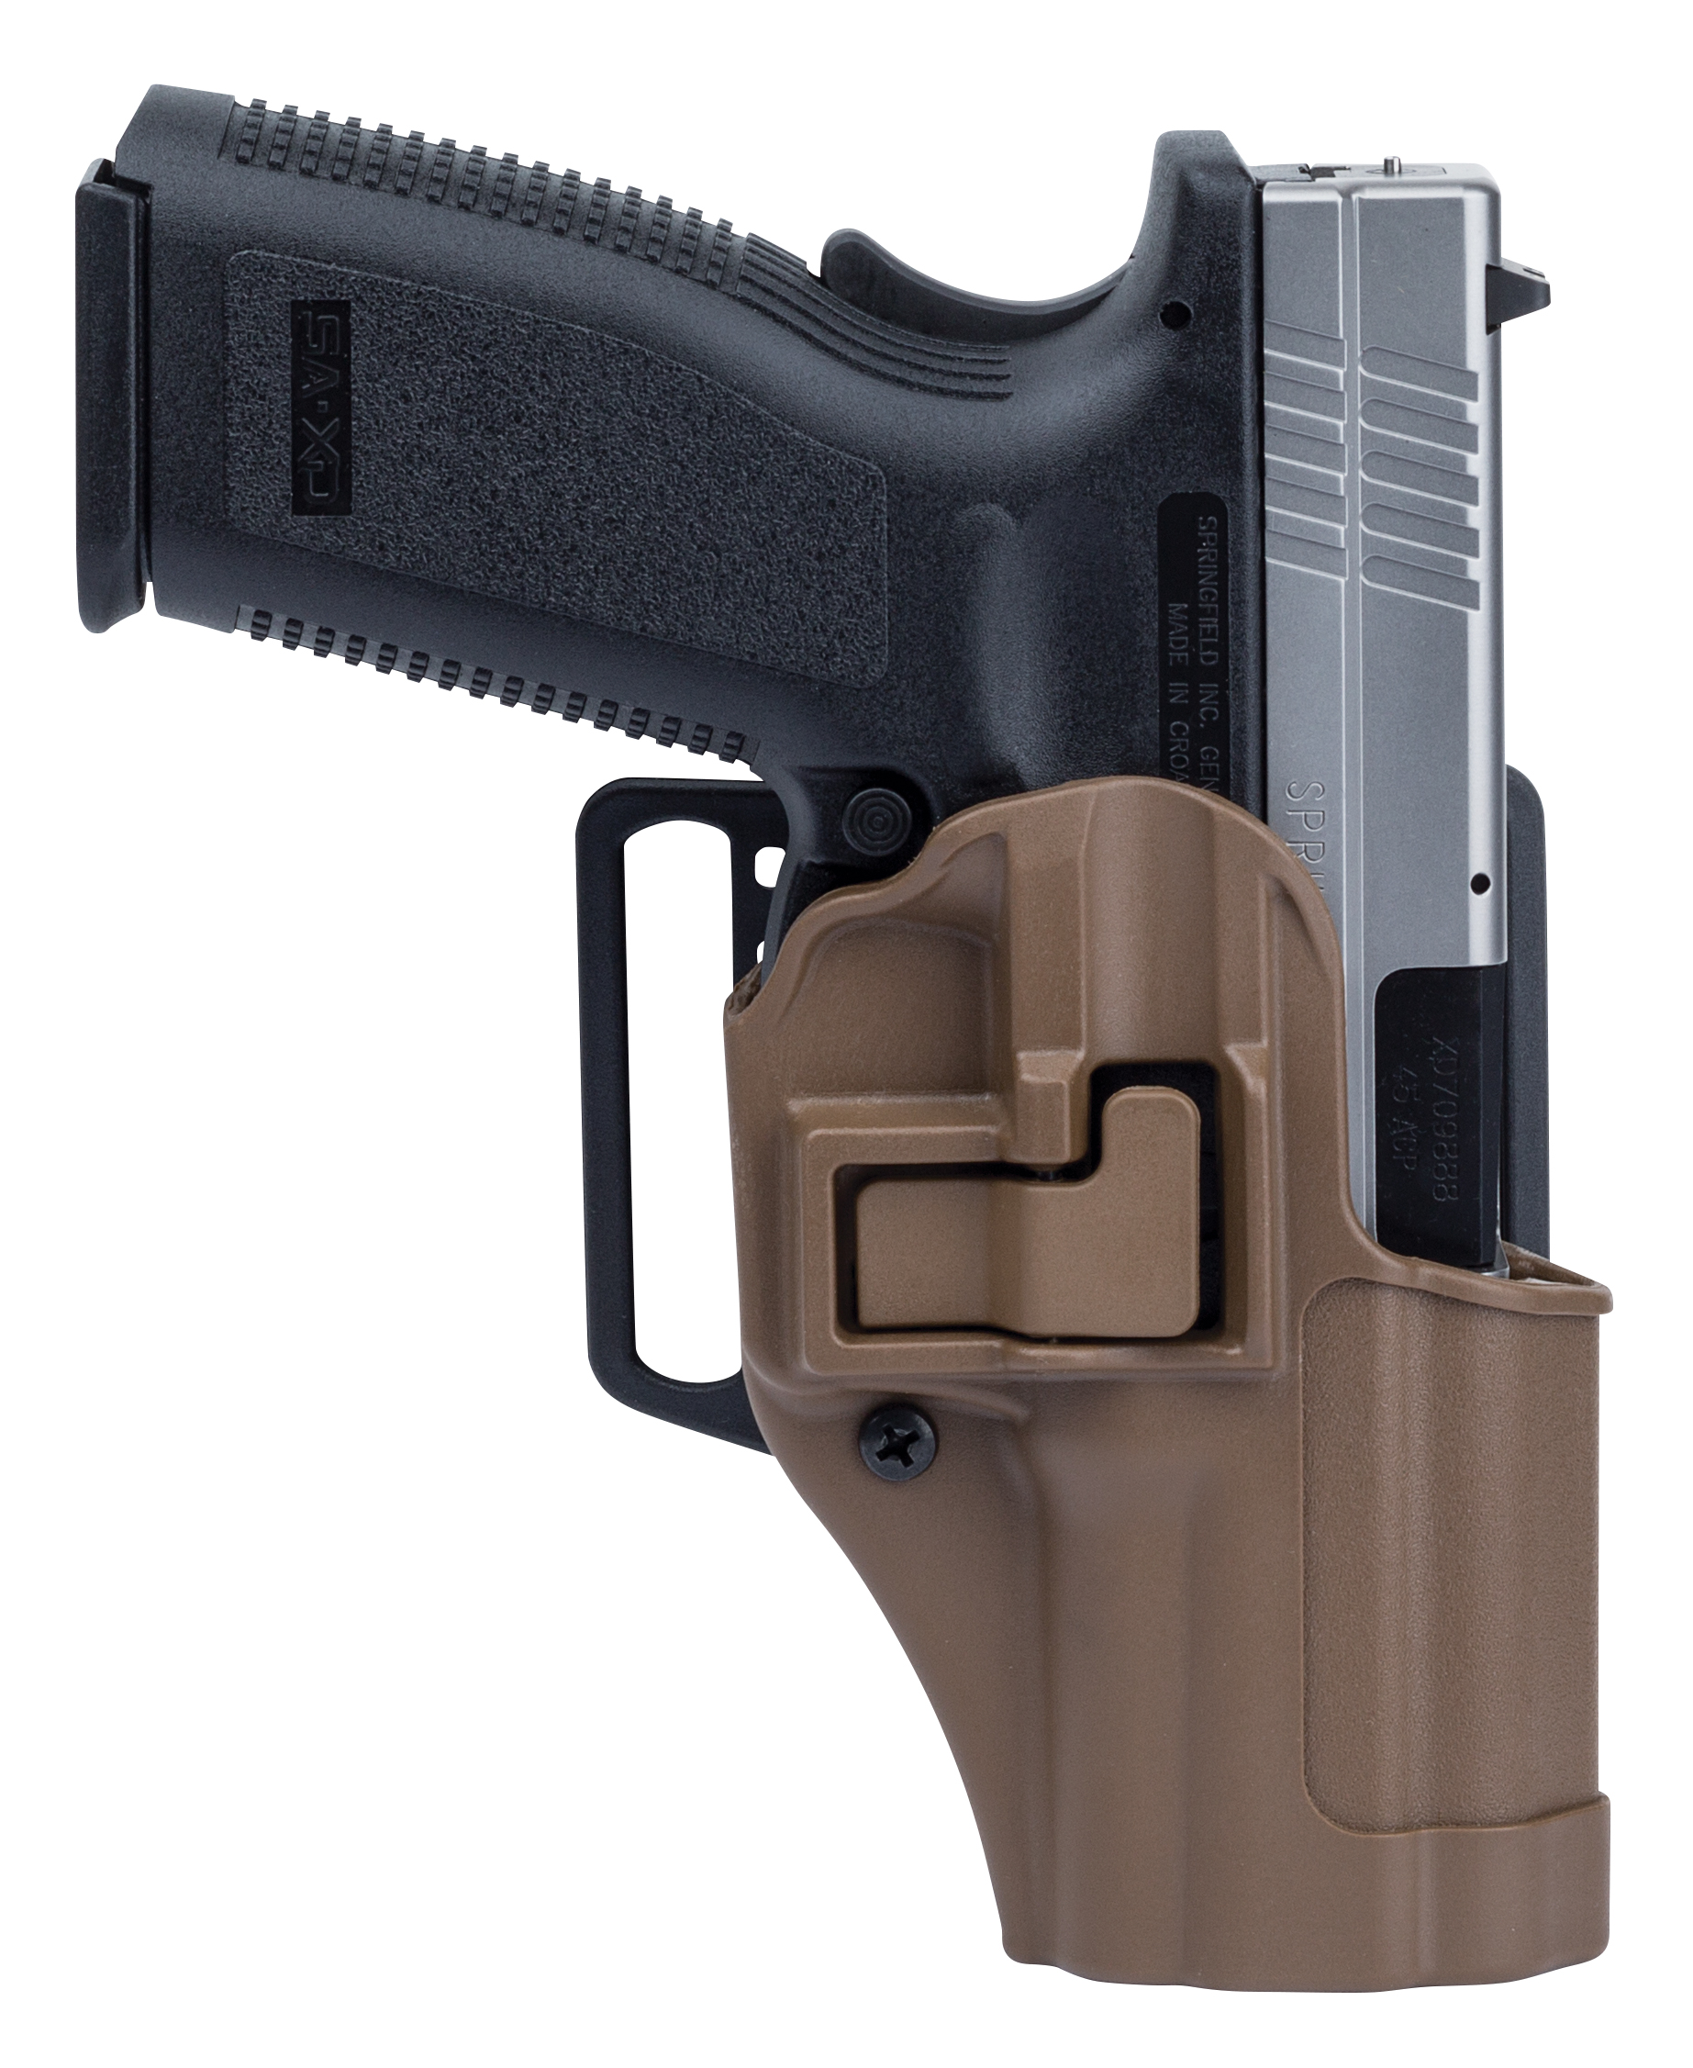
Part No. | Description | UPC |  | MSRP
410500CT-R | Glock 17/22/31 | 648018009389 |  | $49.99
410502CT-R | Glock 19/23/32/36 | 648018009235 |  | $49.99
410507CT-R | Springfield XD Compact and 4” Service | 648018014697 |  | $49.99
410513CT-R | Glock 20/21/37, S&W M&P .45, 9/.40 Pro | 648018014963 |  | $49.99
410514CT-R | H&K USP Full Size 9/.40 | 648018143786 |  | $49.99
410525CT-R | S&W M&P 9/.40 and Sigma | 648018220517 |  | $49.99

