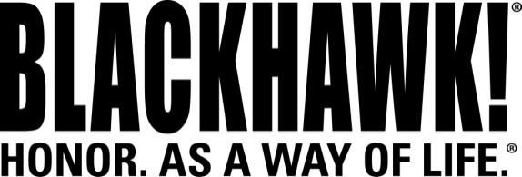

2015 NEW Products
Holsters

GripBreak™ Nylon Holster

The new BLACKHAWK!® GripBreak Nylon Holster combines all the advantages of nylon with the security of a locking retention system. The patented automatic locking system of the GripBreak offers a unique retention experience in a sturdy nylon package. It securely holds the firearm in place while a simple thumb release lever helps you maintain a strong master grip for a quick, smooth draw.

Features & Benefits
- Constructed of thermo-bonded, three-layer laminate with 1000D CORDURA® nylon for hard-wearing performance
- Inner injection-molded copolymer shell for added security and durability
- Patented automatic locking system secures firearm in place
- Fits belts up to 1.75” wide
- Sturdy injection-molded copolymer release guard

Part No. Description UPC MSRP
40GB03BK-L GripBreak Nylon Holster, Glock 6 48018 18351 5 $47.45
40GB03BK-R GripBreak Nylon Holster, Glock 6 48018 18350 8 $47.45
40GB28BK-L GripBreak Nylon Holster, S&W M&P 6 48018 18353 9 $47.45
40GB28BK-R GripBreak Nylon Holster, S&W M&P 6 48018 18352 2 $47.45
